Quick reference

Commands

Check which ports are used
netstat -ano | findstr :8080

Kill processes of certain port
$processId = (Get-NetTCPConnection -LocalPort 5500 -State Listen).OwningProcess; if ($processId) { taskkill /f /pid $processId }
Or
for /f "tokens=5" %a in ('netstat -ano ^| findstr :5500 ^| findstr LISTENING') do taskkill /f /pid %a

Windows server password
@Jleu121212

Remote desktop login
mtrcompute.asuscomm.com
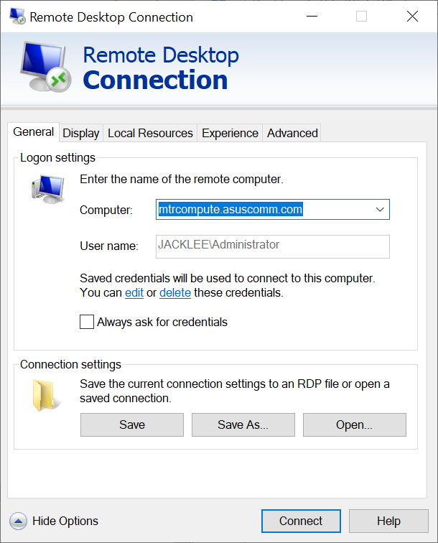
JACKLEE\Administrator
or
SUPERCOM1\ Administrator
@Jleu121212

Alternative login
mtrcompute.asuscomm.com
SUPERCOM1\lauralau
Laurasuccess88#

Asus router login
http://192.168.50.1
jleu3482
@Jleu121212

Thingsboard
http://localhost:8080/
admin@mtrsensorcloud.com
121212
tenant@mtrsensorcloud.com
121212

TBMQ
http://localhost:8083/
sysadmin@thingsboard.org
sysadmin or jleu1212

Wowza
http://localhost:8088/
Jleu3482
Jleu1212

Cerberus FTP
https://192.168.50.123:8443
admin
jleu1212

Installing windows server and router

Make bootable image for windows 2022 server
Windows 2022 server has highest security and impossible to crack login.

Use rufus-4.3 to format and convert ISO image into two partitions: a) FAT32 boot info and b) NTFS data

Install windows server datacenter (desktop experience)
Windows Server 2022 Datacenter: WX4NM-KYWYW-QJJR4-XV3QB-6VM33

Activate using HEU KMS Activator
Use KMS38 manual method

Make dynamic DNS name
Use ASUS router
192.168.50.1
Sign in -> if forgot password, hold the button at the back of the router for 5-10 s until your power LED light starts to flash.
None of the LED lights should be on at this time. It is normal due to the router restarting.
Wait until the LED lights turns on again as the below picture, and it means that the reset completes.
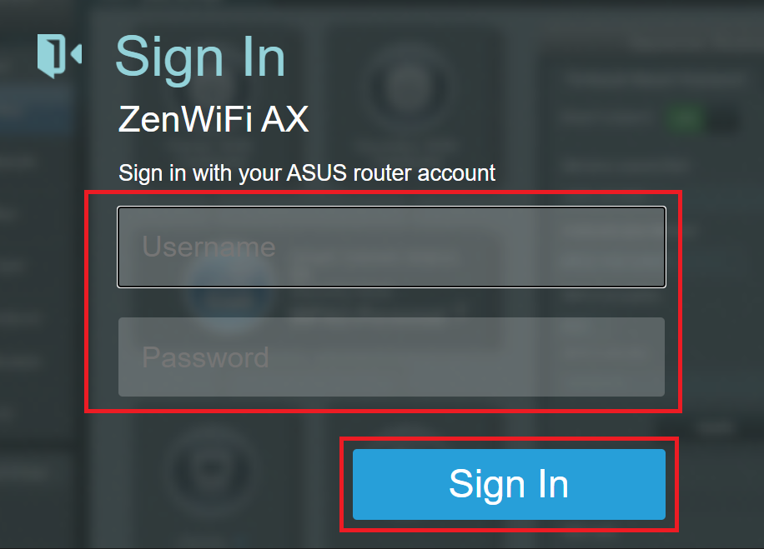

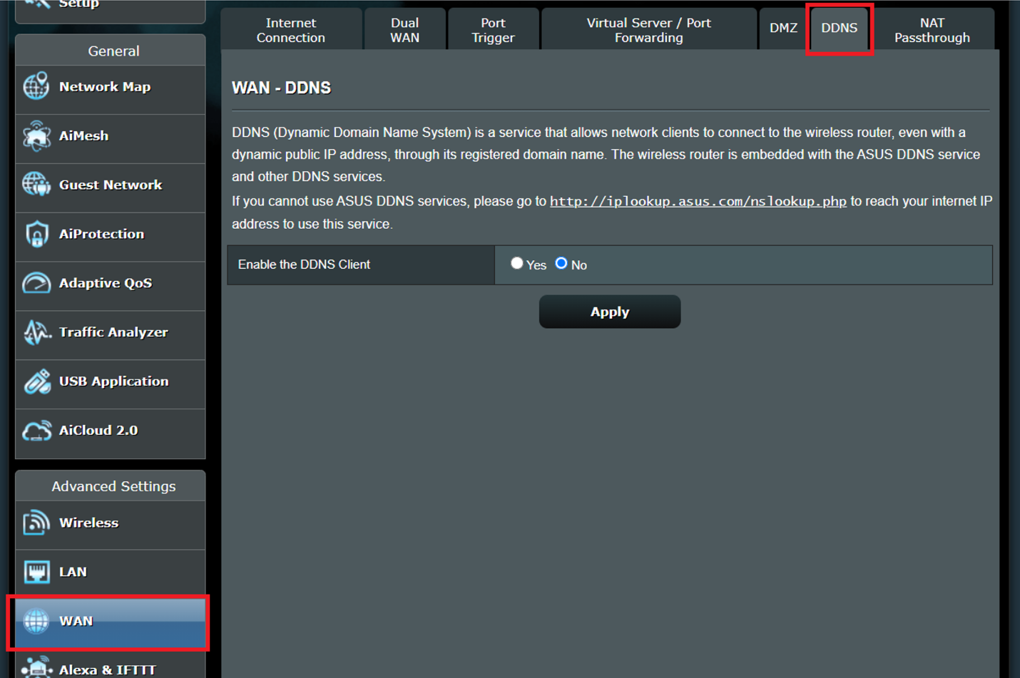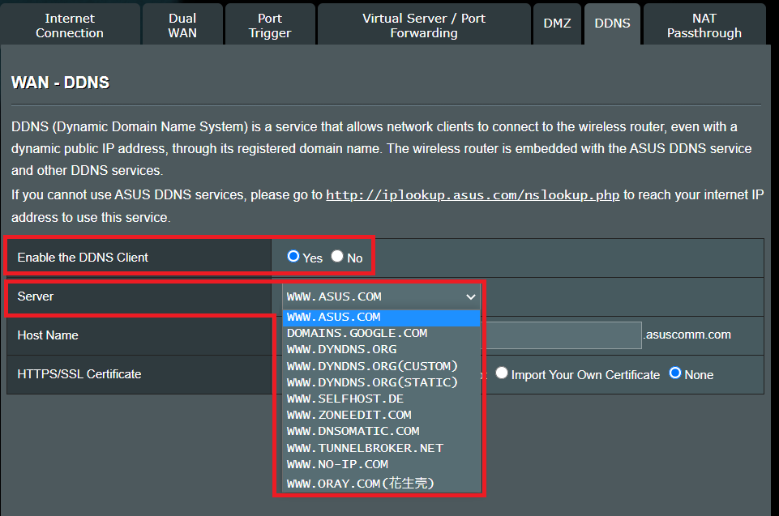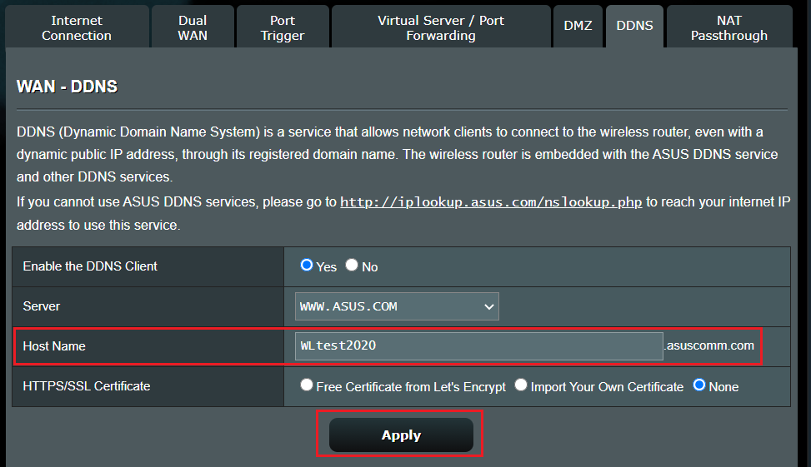

You can also add free certificate.
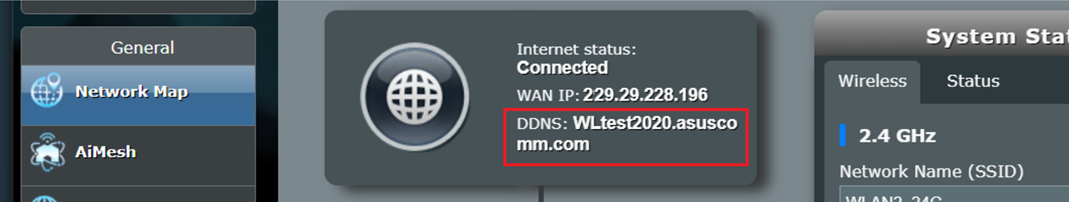

Port forwarding: Go to virtual server / port forwarding tab & setup firewall
Add port forwarding for TCP for ports:
80 (web)
21 (ftp server)
22 (SSL)
443 (SSL)
8080 (thingsboard)
9988 (matlab web server)
9910 (matlab production server)
9090 (matlab production server dashboard)
3389 (remote desktop)
1889 (MQTT server)
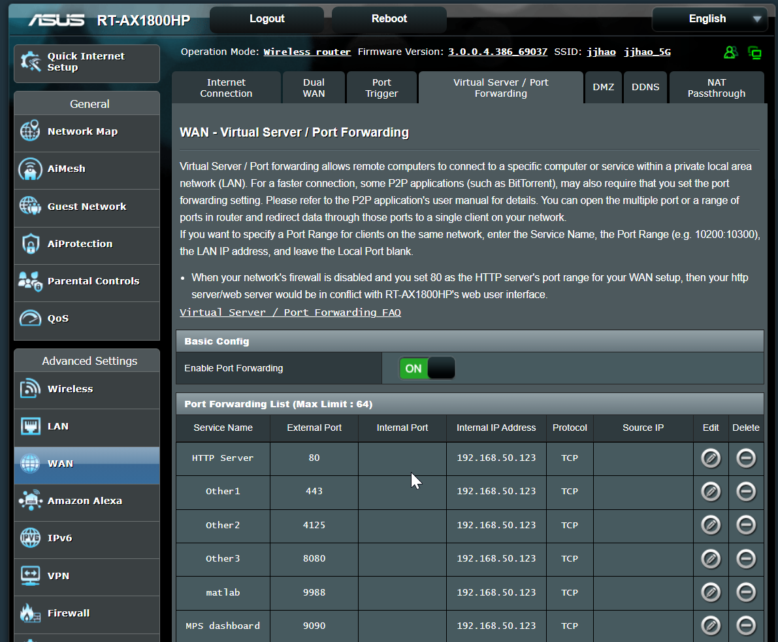
Add firewall rules
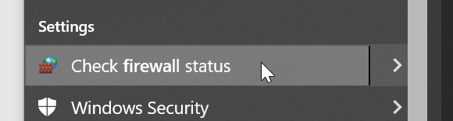
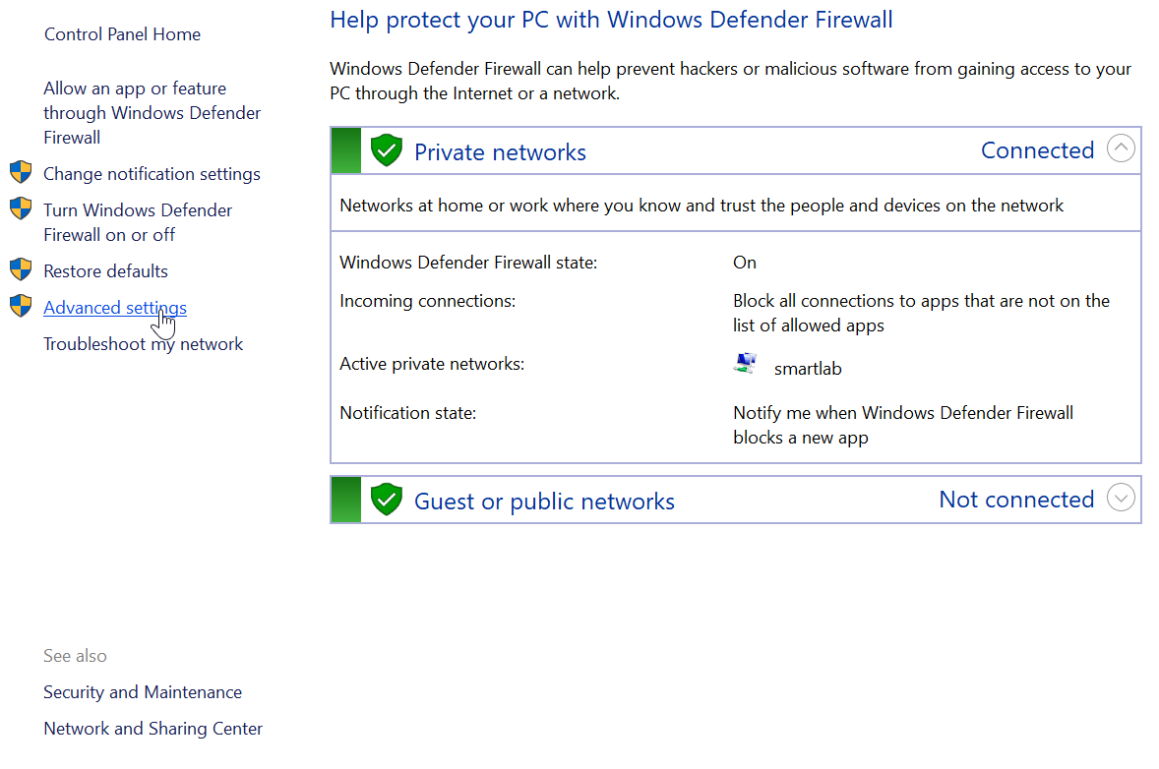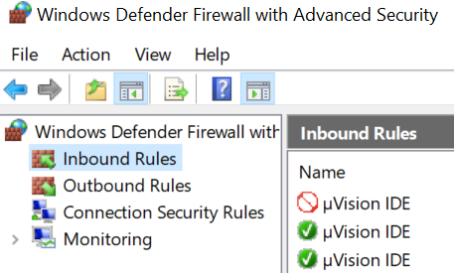
Add both inbound and outbound port unblock rules for TCP.

Use domain name pointing to DNS name
https://www.namecheap.com/support/knowledgebase/article.aspx/9678/2237/how-to-redirect-subdomain-to-a-certain-ip-address-along-with-a-port/

To set up port forwarding (port mapping), perform the following actions:
1. Sign in to your Namecheap account (The Sign In option is available in the header of the page).
2. Select Domain List from the left sidebar and click on the Manage button next to your domain:
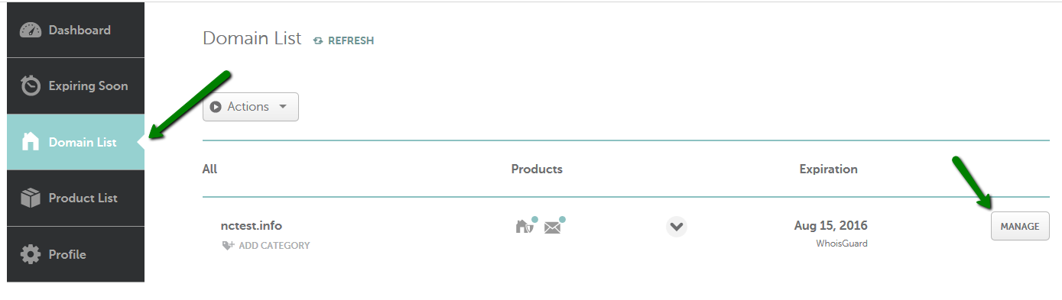
3. Navigate to the Advanced DNS tab at the top of the page and find the Host records section:
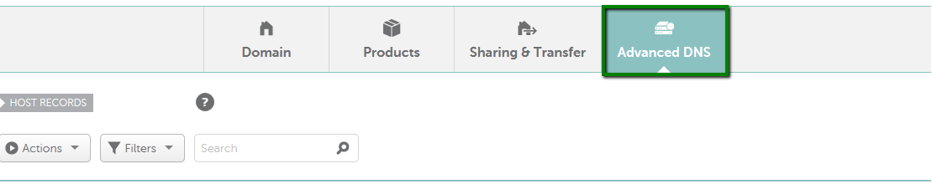
4. Click on the Add New Record button
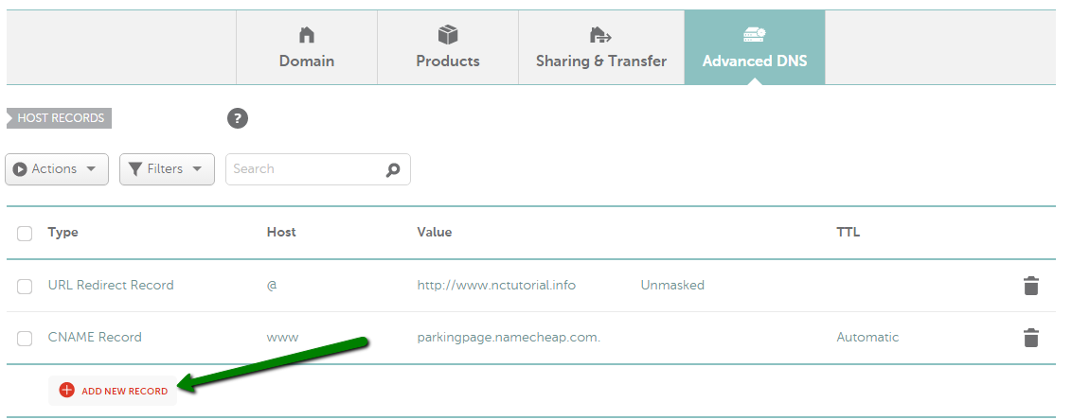
5. Select URL Redirect Record from the drop-down menu for Type, put @ (your bare domain e.g., yourdomain.tld) for Host and use http://ipaddress:port for Value (IP address and port should be replaced with actual values):
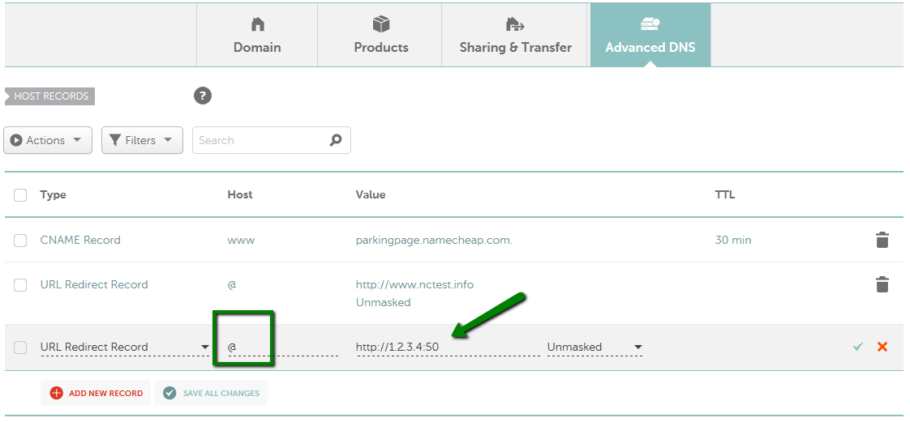
Do not mask the URL otherwise when loading on mobile phone can have problem.
http://mtrcompute.asuscomm.com:8080

Setup remote desktop

Enable remote desktop
start -> settings -> search remote desktop settings -> enable remote desktop
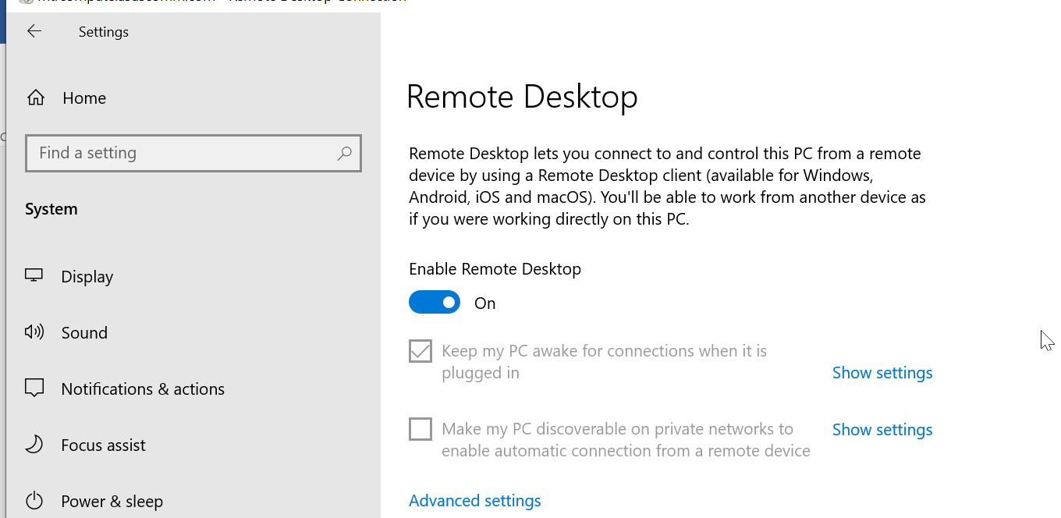

Open ports in router
Open port 3389

Open firewall
Unblock port 3389

Disable private network firewall while keeping others on
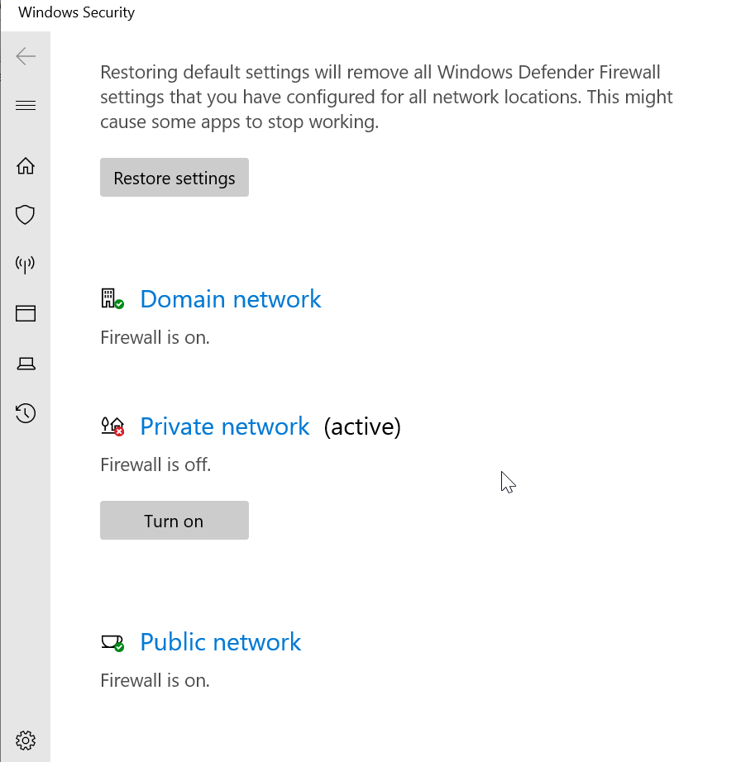

Disable group policy for login
Settings > Edit Group Policy
Group Policy > Computer Configuration > Windows Settings > Security Settings > Account Policies > Account Lockout Policy > Account Lockout Threshold = 0

Add new users for remote access
Add new login account.
Make sure you allow him with Admin rights.

If remote connection does not work, try this:
Run -> secpol.msc
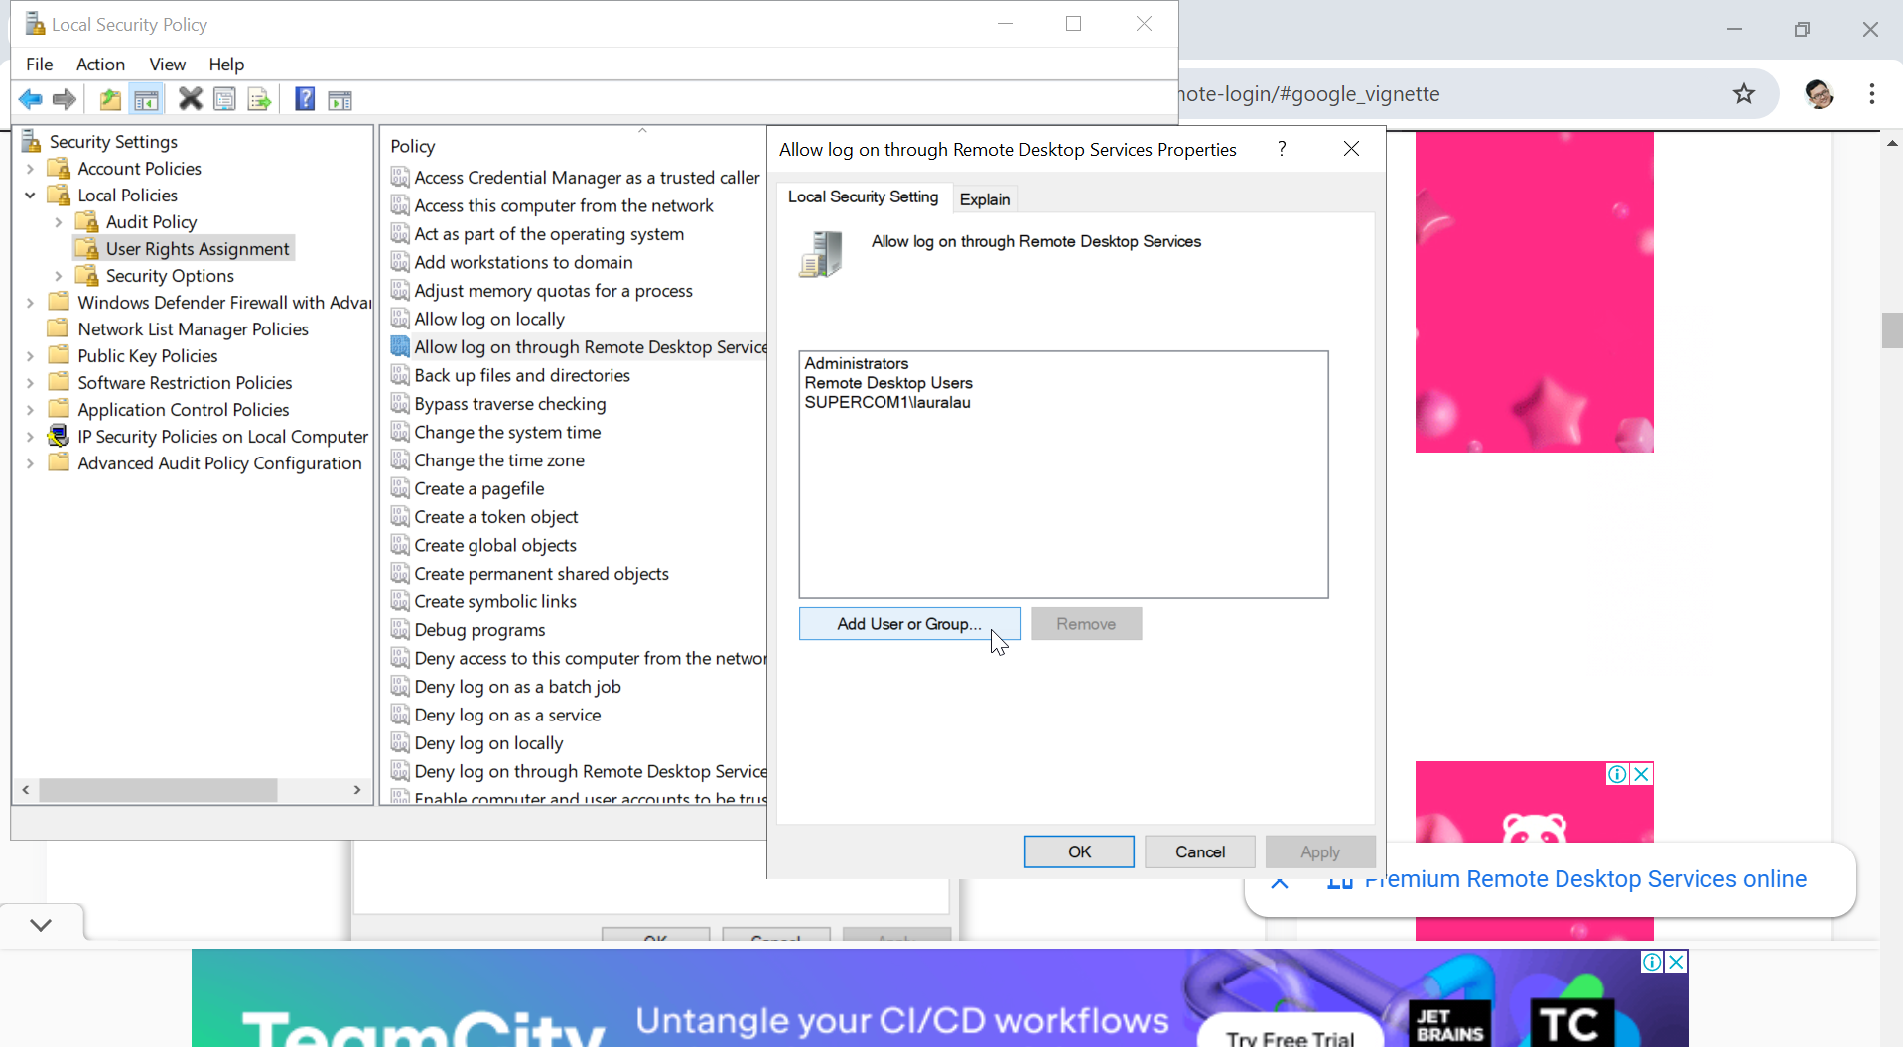

Right click cmd -> run as admin
gpupdate /force

Connect
search -> remote desktop connection -> mtrcompute.asuscomm.com

Recovery
Setup a shortcut in desktop for task manager as you can’t trigger this in remote desktop.
C:\Windows\System32\Taskmgr.exe

Energy saving and Temperature Reduction

BIOS setting

Reduce CPU voltage without affecting speed
Purpose: make AMD AM5 Ryzen CPU cooler for windows server.
- Press DEL to enter in bios before windows startup.
- Set the CPU SOC voltage from 1.25V to 1.17V (absolute minimum stable voltage is 1.15V).

Enable C-states so CPU will reduce frequency when idle
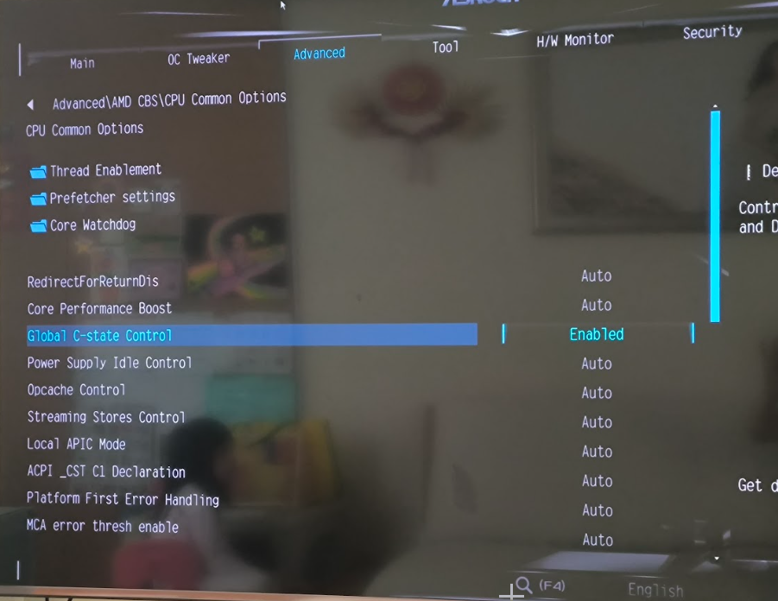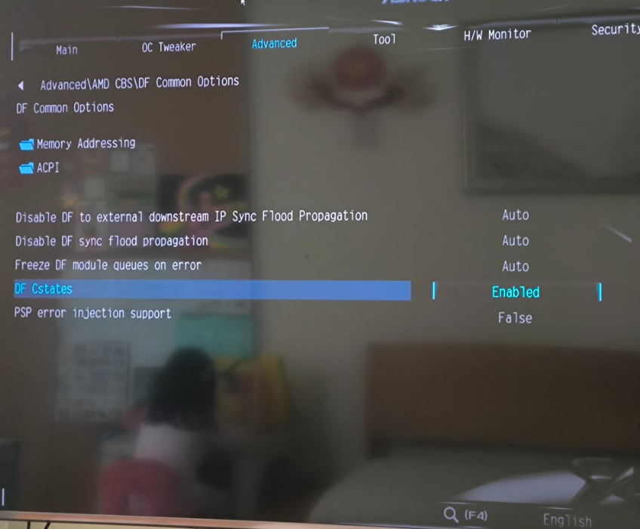

AMD fan tuning software
A-tuning
Set fans to be max speed when above 65 degrees C (CPU max temp is 100degrees, but 80 degrees have some problem with thermal paste or case cooling).
Apply All (apply to all fans)
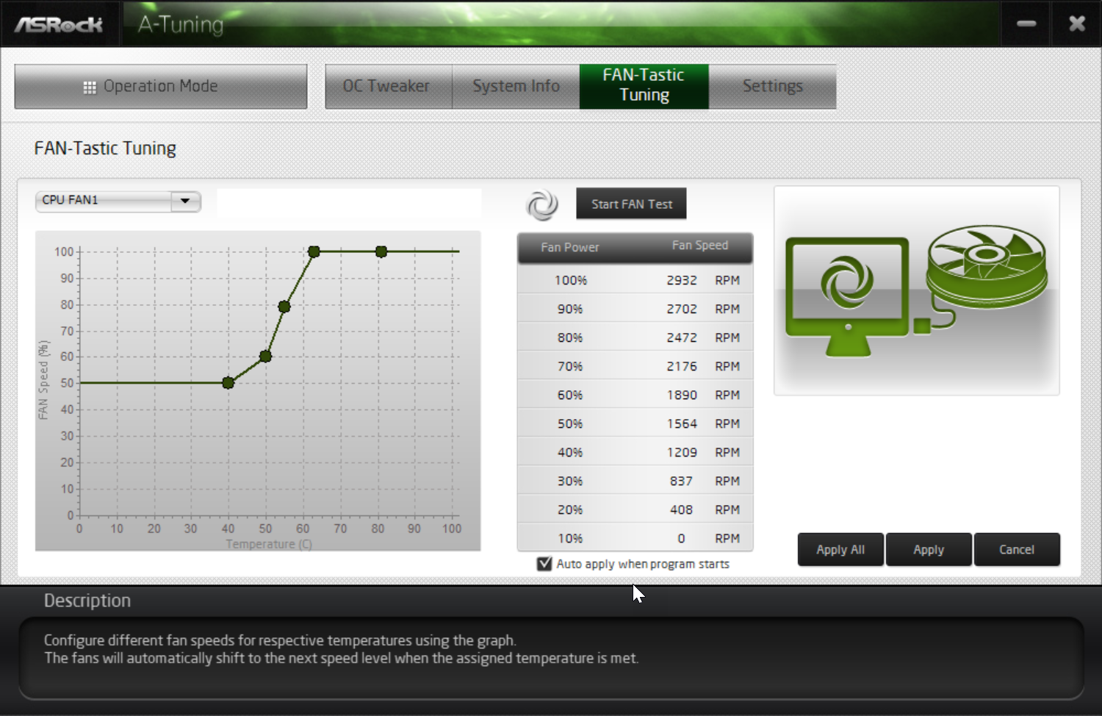
Auto apply when program starts
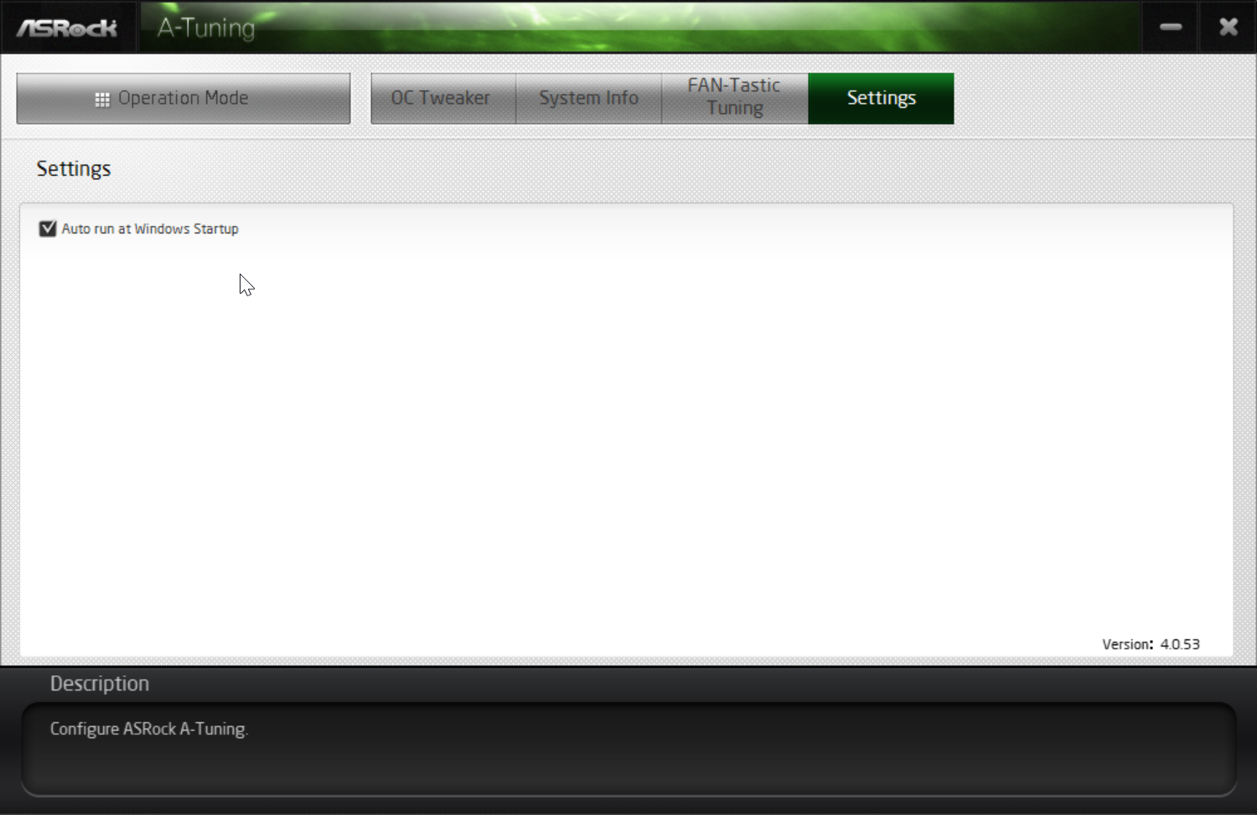
Autorun at windows startup

Windows setting
Choose energy saving plan – Balanced (because this auto adjusts CPU frequencies)
Change plan settings -> change advanced power settings
Switch to minimum processor state = 0%
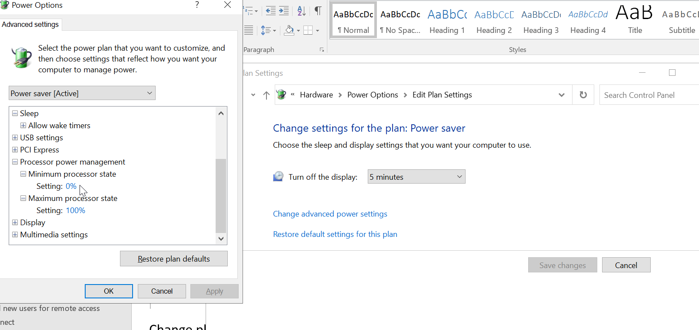
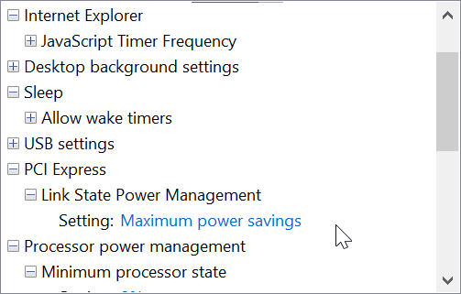

Park cores not in use
Run ParkControl software.

Run Quick CPU
Set state when CPU cores are idle
Core parking
Frequency scaling
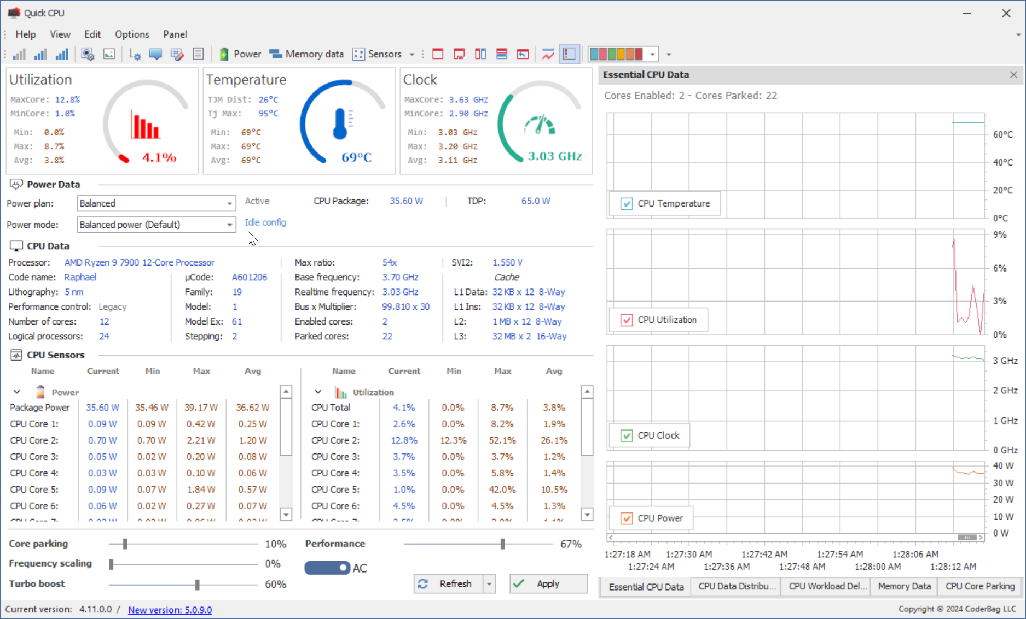

Monitor CPU frequencies
Use HWInfo64
Active Clock shows the core frequencies changing dynamically
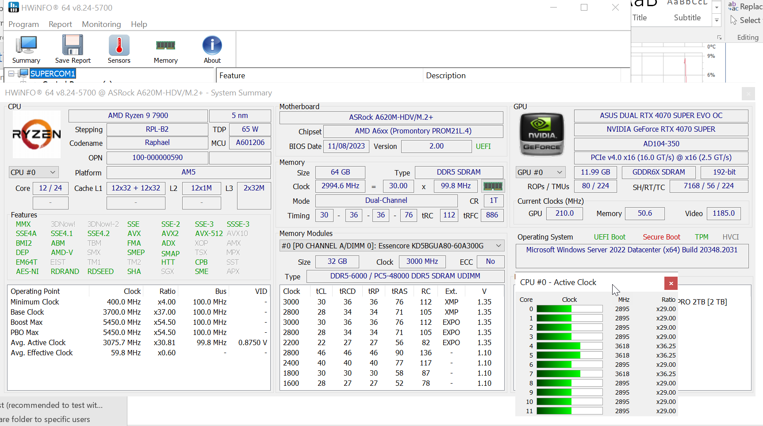

Setup FTP

Option 1 – use Cerbertus FTP (more stable)
Refer to another tutorial.

Option 2 – use IIS ftp

https://unihost.com/help/how-to-set-up-ftp-server-on-windows-server-2019/?gad_source=1&gclid=CjwKCAjwuMC2BhA7EiwAmJKRrJCFB3UhNNSnhTSVSenkBLXKKnMx6ZFxWEFzfu1-bcVXbdjQxRLV2RoCodEQAvD_BwE

https://hostman.com/tutorials/how-to-set-up-ftp-server-on-windows-server-2019/

Install ftp package

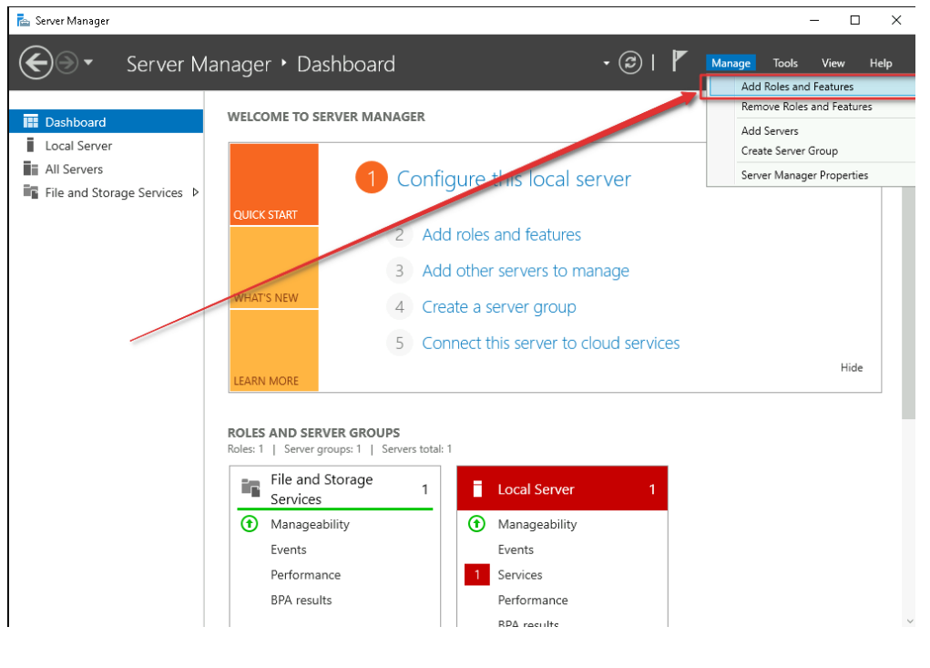
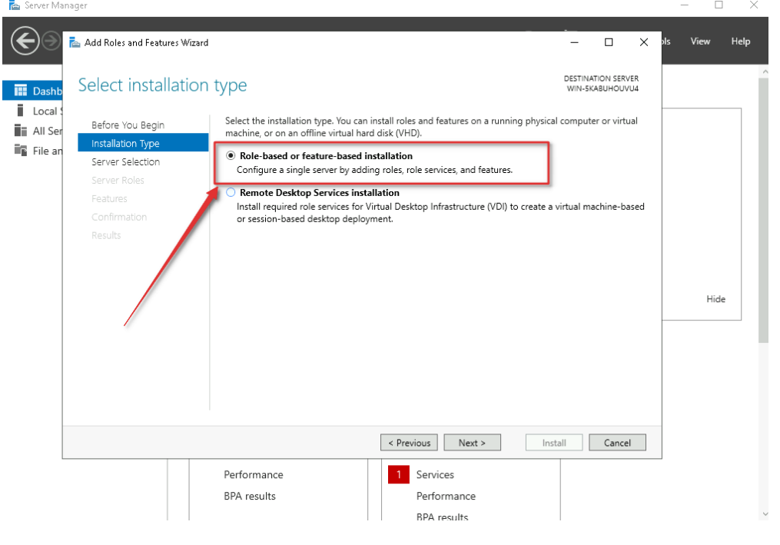
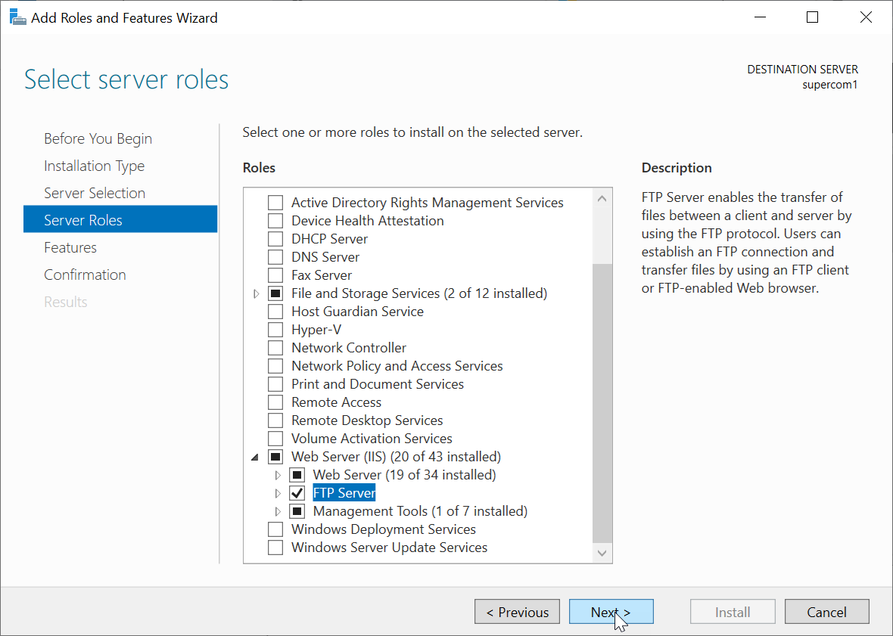

Make another computer user account
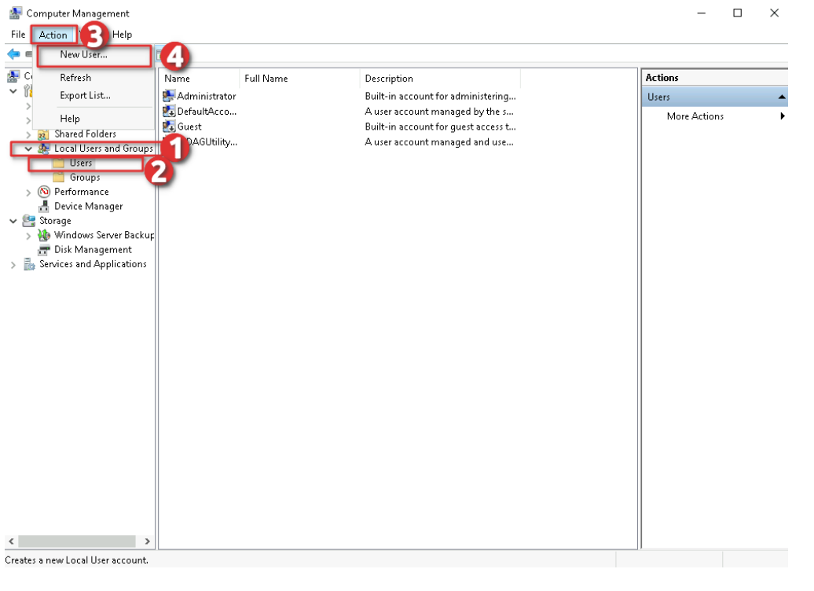
ftp1
@Jleu3482

Enable login rights
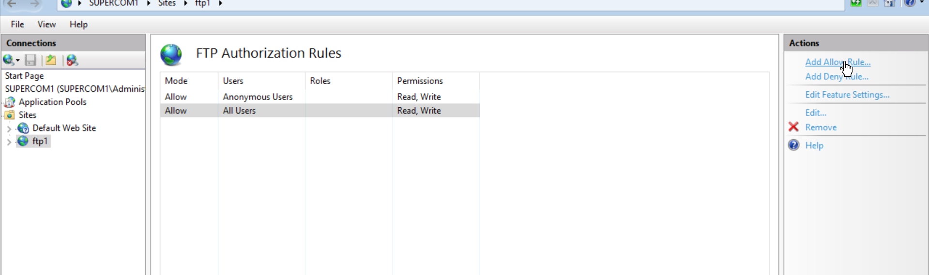

Add ftp site
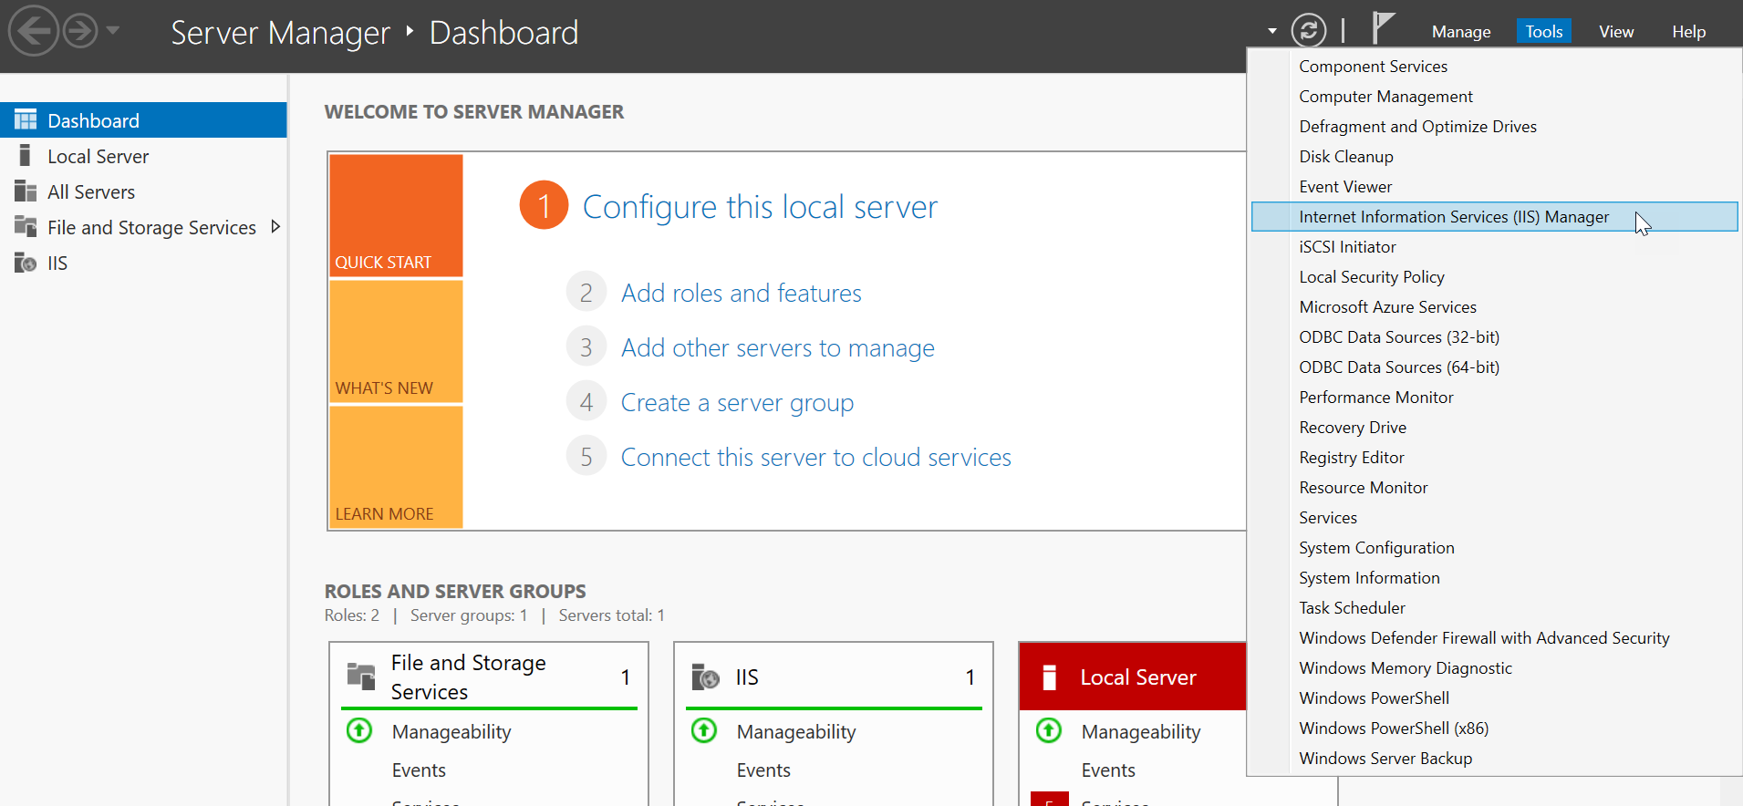
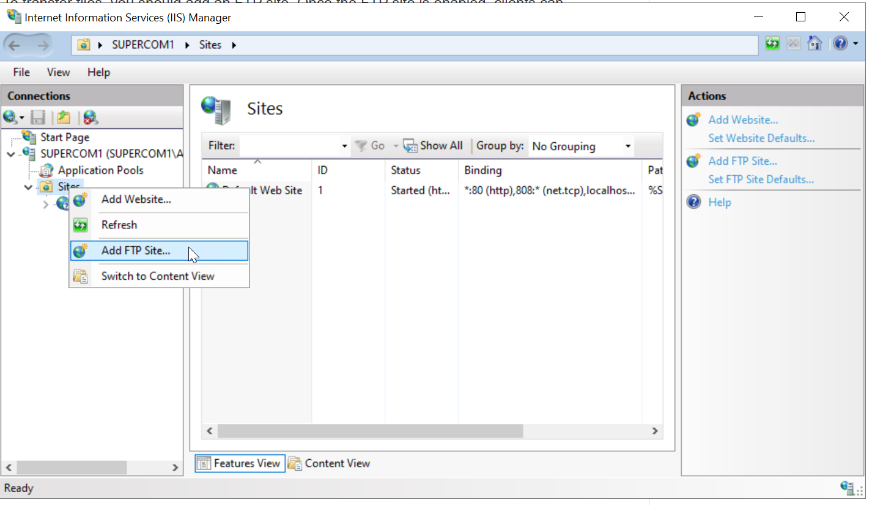
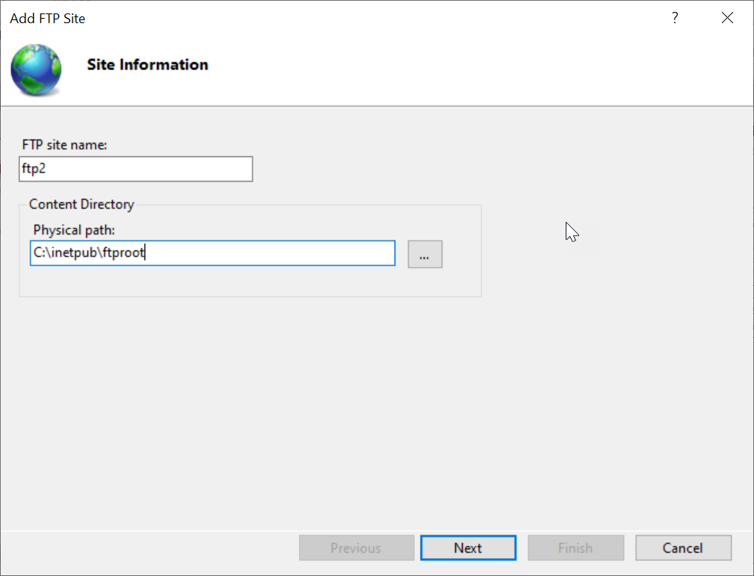
Must be this directory:
C:\inetpub\ftproot
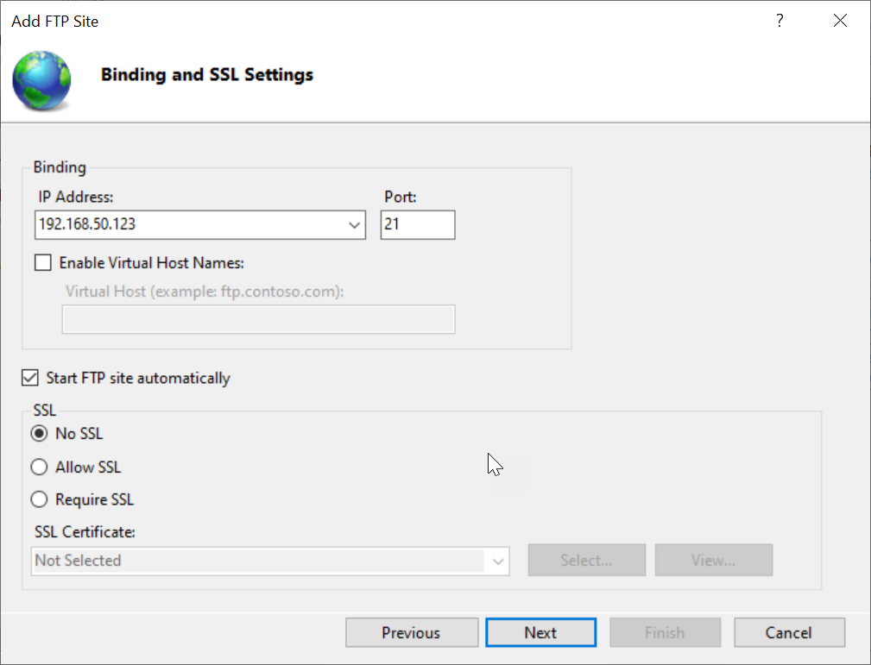

Anonymous users means users from outside
Basic users means the computer login users
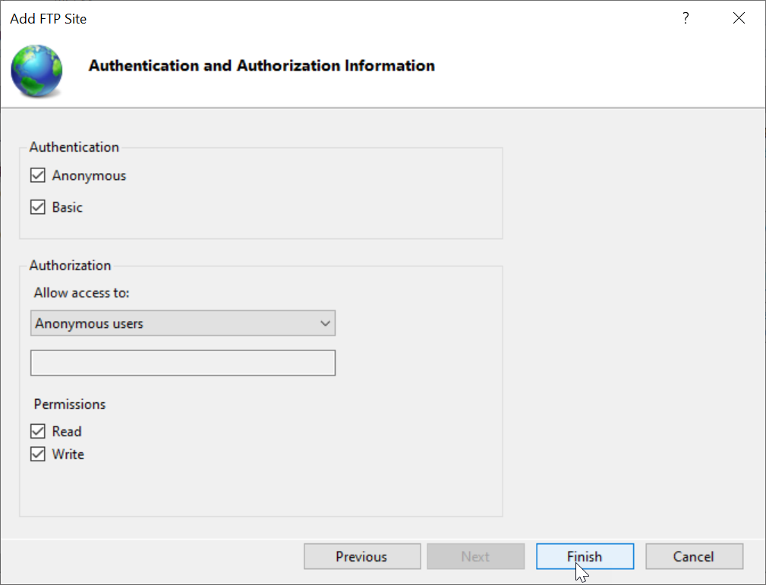

Check login accounts:
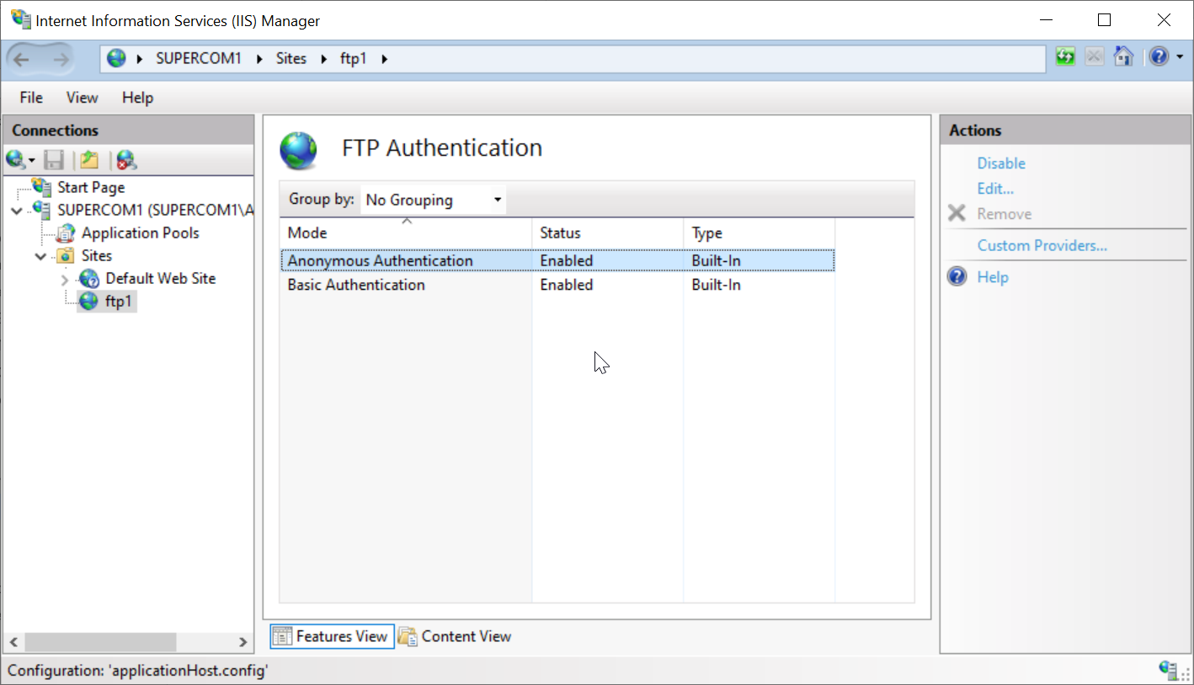

Open up ports in router for port 21

Open up Firewall inbound rules
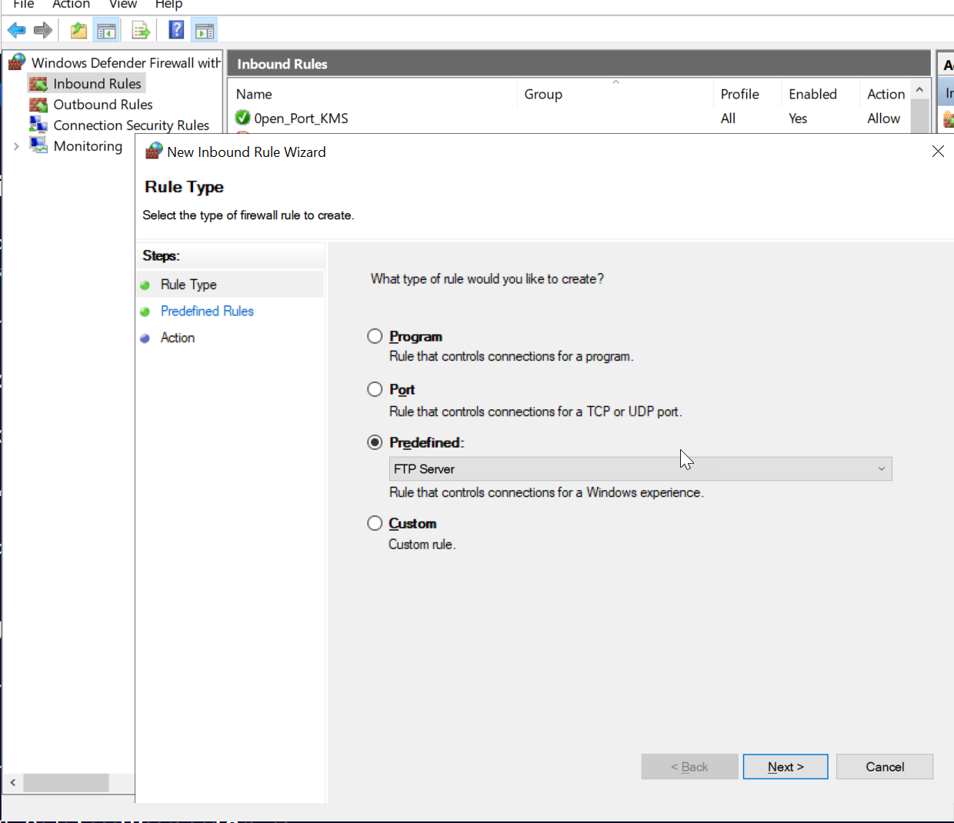

Test (recommended to test with firewall turned off first)
You can only test on a different computer, you cannot test ftp using localhost.
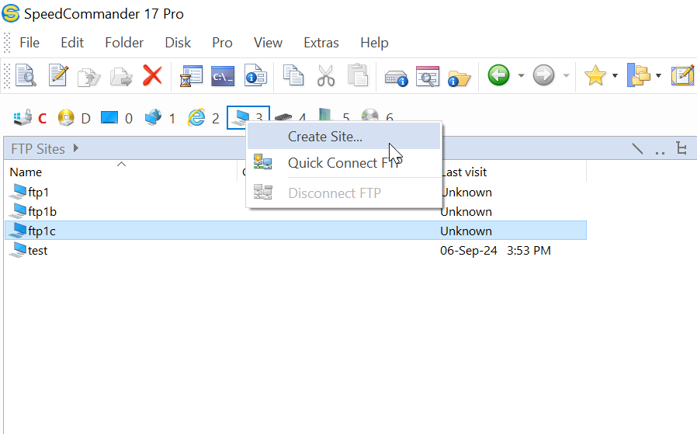
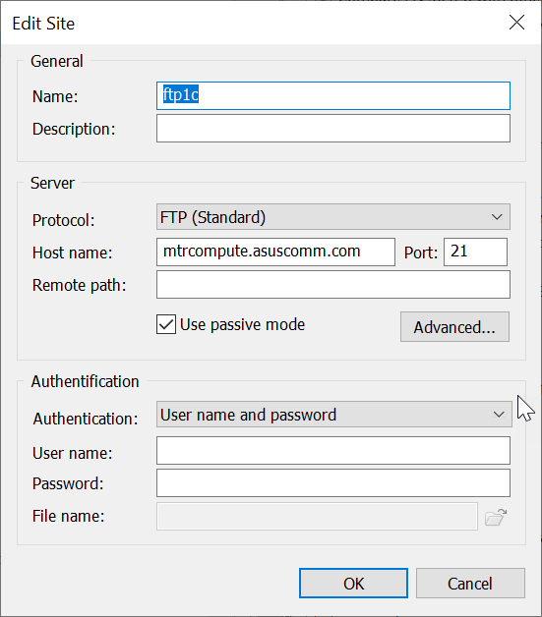

Share folder to specific users
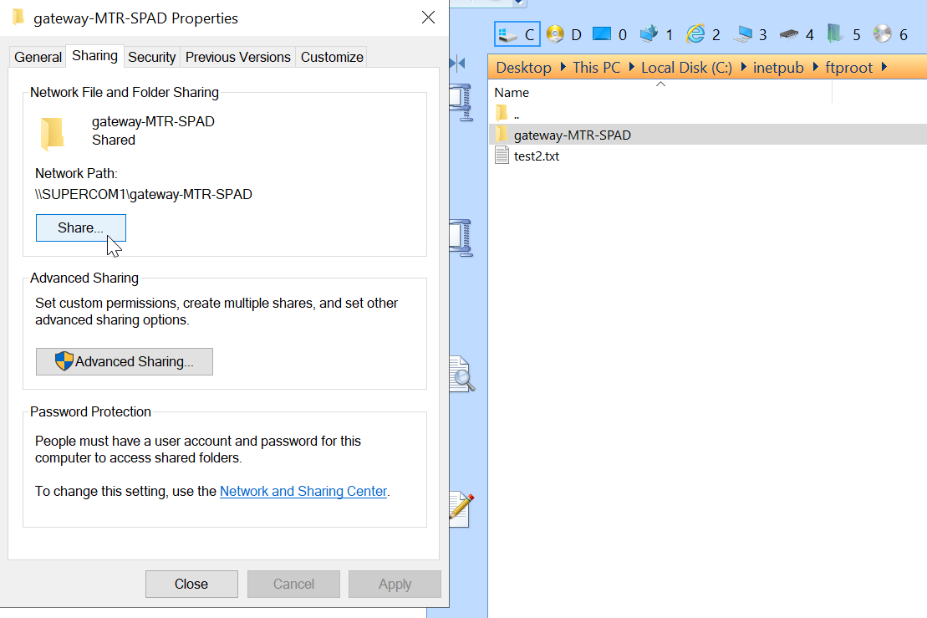

Copy files remotely
Note that ftp is blocked by MTR firewall.
Use WINSCP software.
Or use speedcommander like this:
Setup ftp settings:-
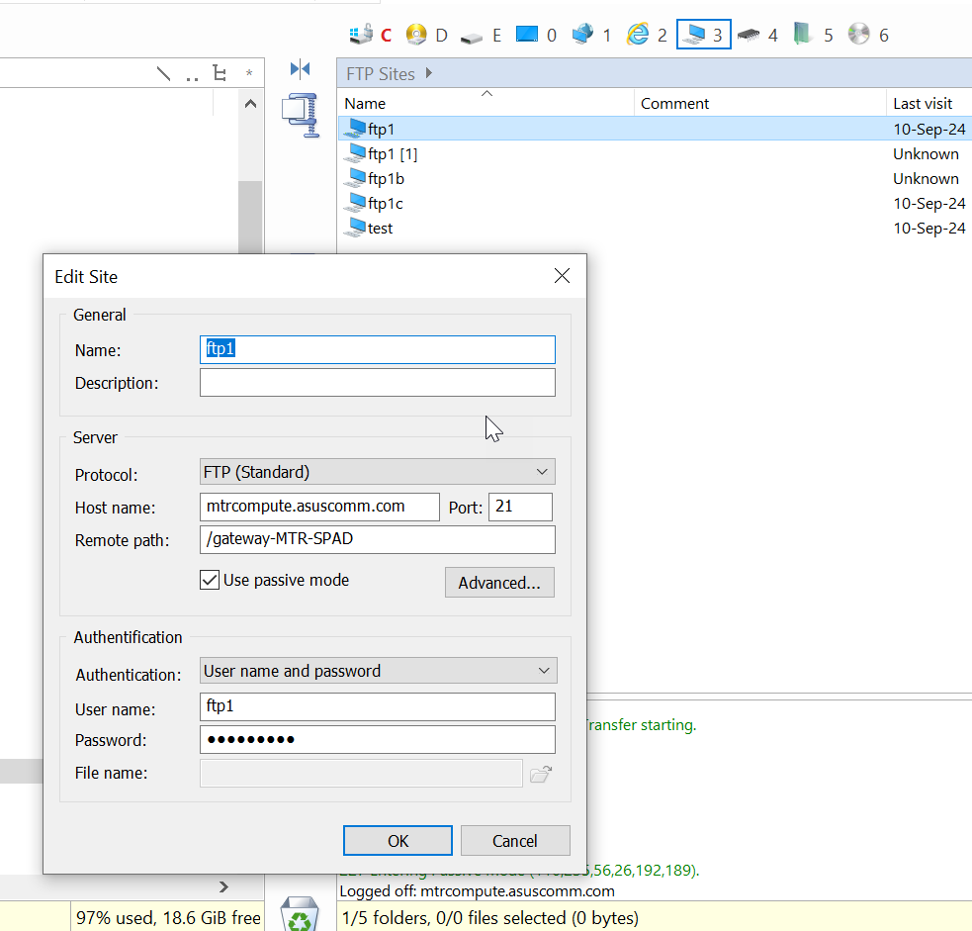

Open ftp folder in passive mode:
Click the arrow to open
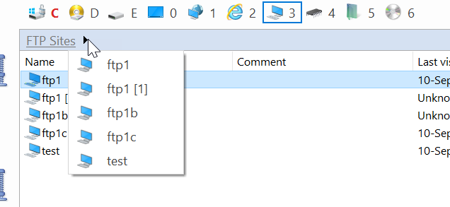

Setup thingsboard server
Refer to windows version instructions.
In services in windows, ensure the service thingsboard is automatic started and started.

Setup MATLAB webapp server

This provides full rendering of the website/app, so is slower than MATLAB production server.

Install MATLAB 2023a with webapp serial.
Install the MATLAB MCR for the app generated version of matlab
In cmd,
cd C:\Program Files\MATLAB\MATLAB Web App Server\R2023a\script
webapps-setup.cmd
Licence: C:\Program Files\MATLAB\license.lic
Press enter twice if you see the login credentials (to use default)
webapps-start.cmd
The app can be launched in localhost:9988

Setup MATLAB production server

This provides data using REST API i.e. does not render full website/app.
Also, the workers CPU cores load the matlab runtime in advanced so that you don’t need to load the runtime and save 30s.

cmd
cd C:\Program Files\MATLAB\MATLAB Production Server\R2023a\dashboard
mps-dashboard.bat setup
set working directory: C:\aaSTORAGE\mps

mps-dashboard.bat start
http://localhost:9090/
admin
admin
set new instance = test
click on the new instance -> settings -> licence -> paste: C:\Program Files\MATLAB\license.lic
Set the runtime location: C:\Program Files\MATLAB\MATLAB Runtime\R2023a,C:\Program Files\MATLAB\MATLAB Runtime\v912
threads = 6 (half of workers)
workers = 12
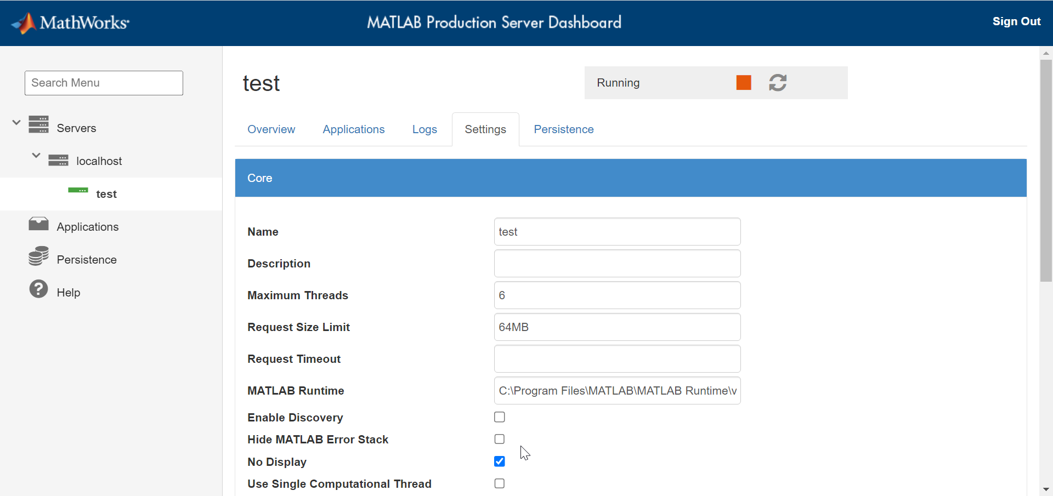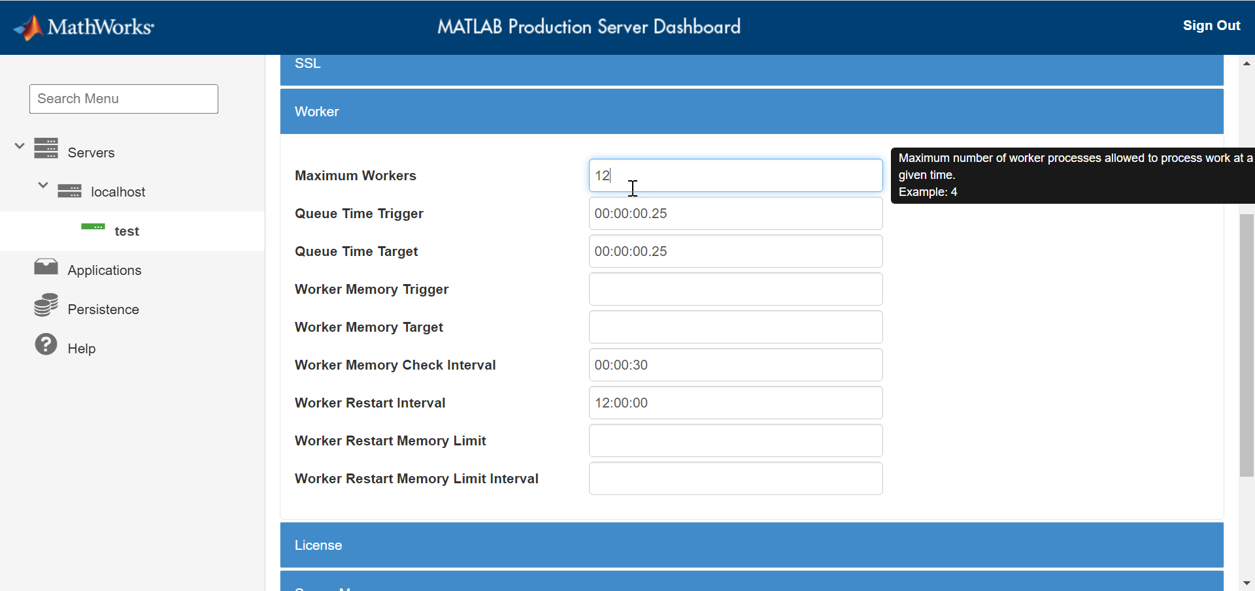
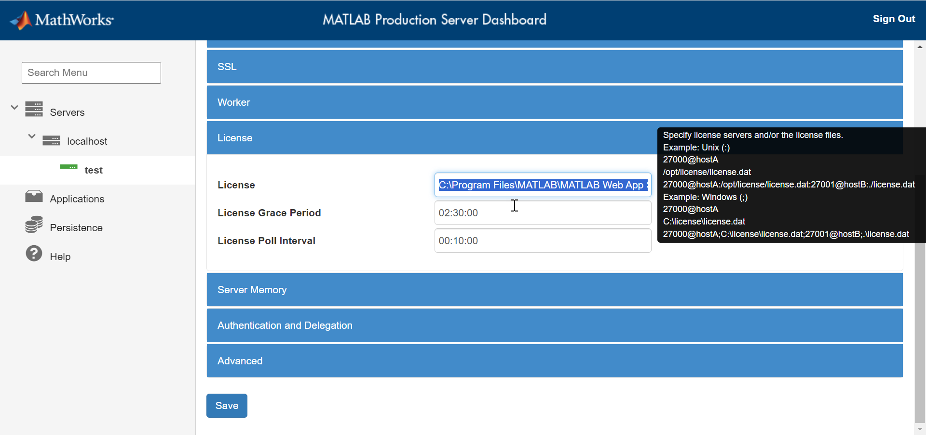

Press play
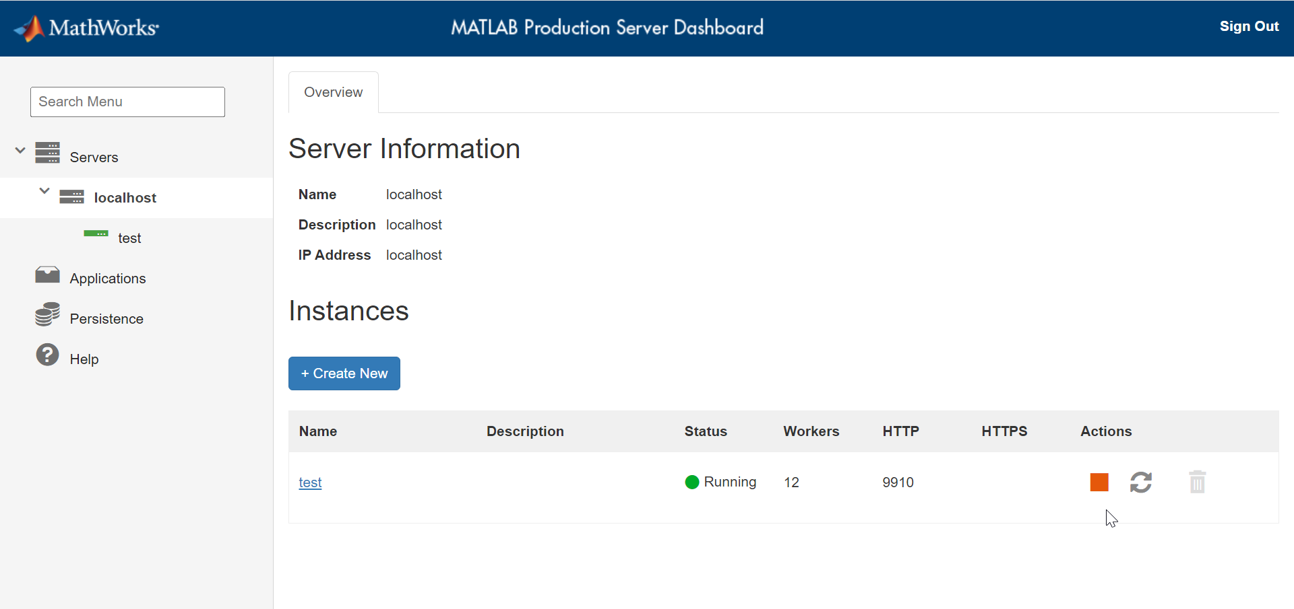

Make app as service
mps-new C:\TEMP\server --service

Docker for windows
Docker is used for installing linux software into windows.

Install Docker Desktop on Windows (separate tutorial).

Setup docker to start on windows login:
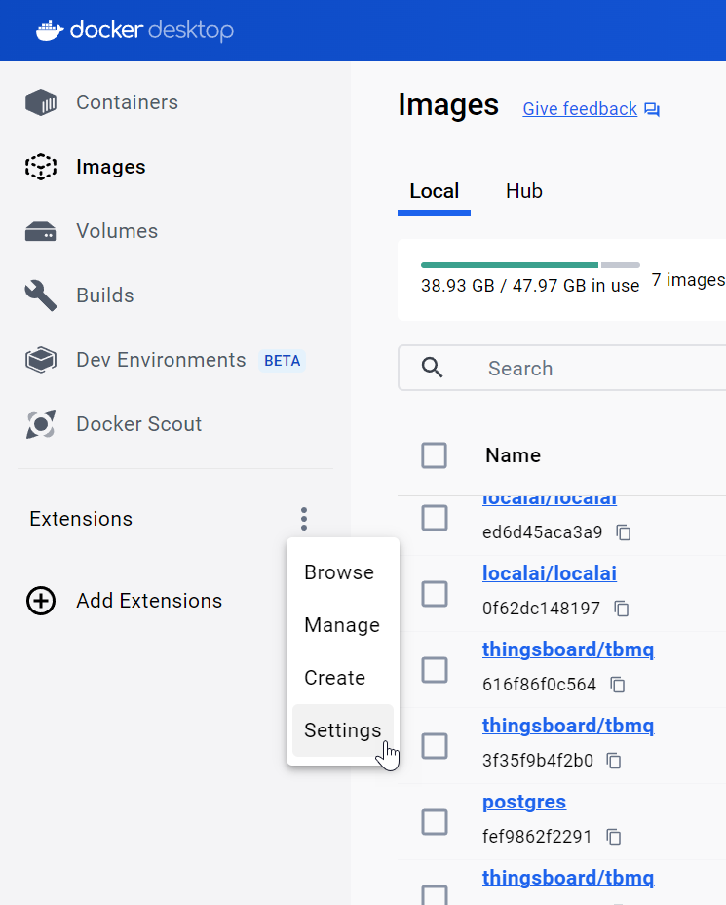
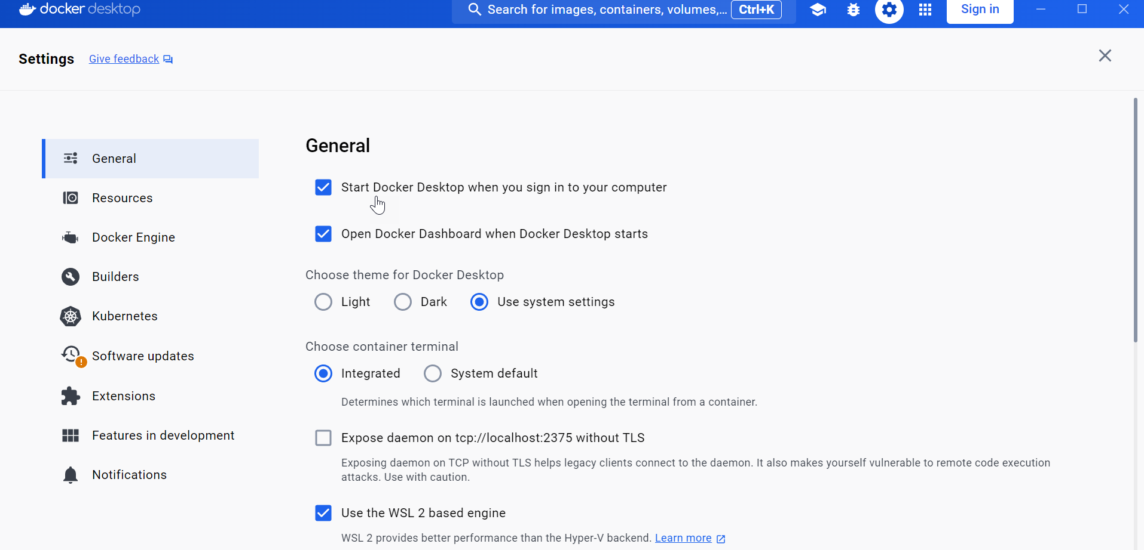

Problem: Docker windows could not run unless somebody has signed in and run the docker for windows.
Solution:
Creating another local admin user
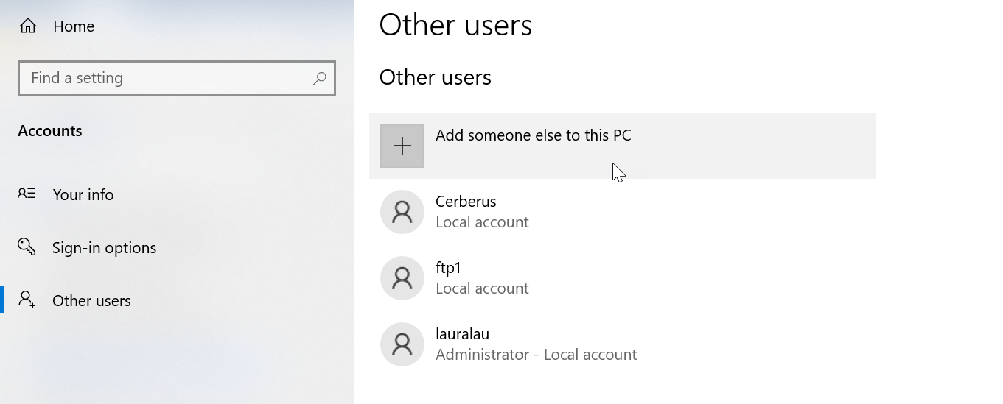
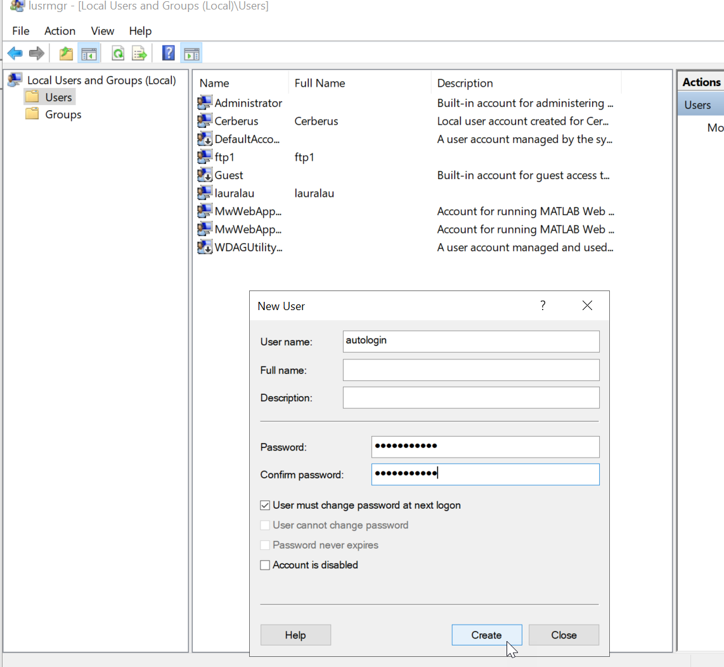
autologin
@Jleu121212

https://github.com/docker/roadmap/issues/515
https://learn.microsoft.com/en-us/windows-server/identity/ad-ds/manage/component-updates/winlogon-automatic-restart-sign-on--arso-

Go to group policy -> path: Computer Configuration > Administrative Templates >Windows Components->Windows Logon Options
Enable these 2 settings:
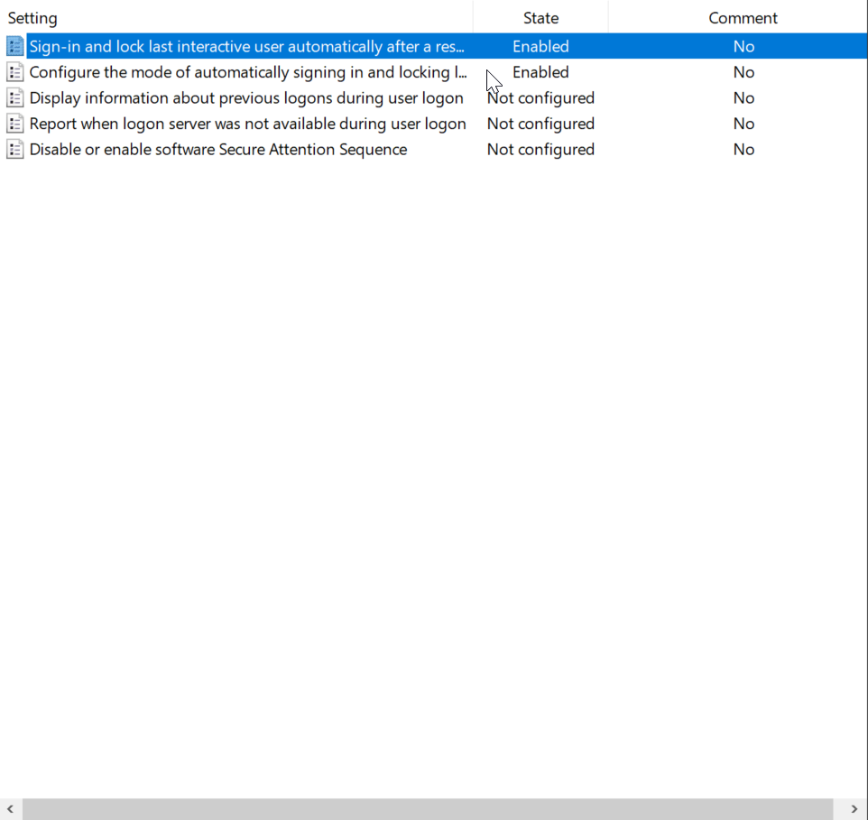
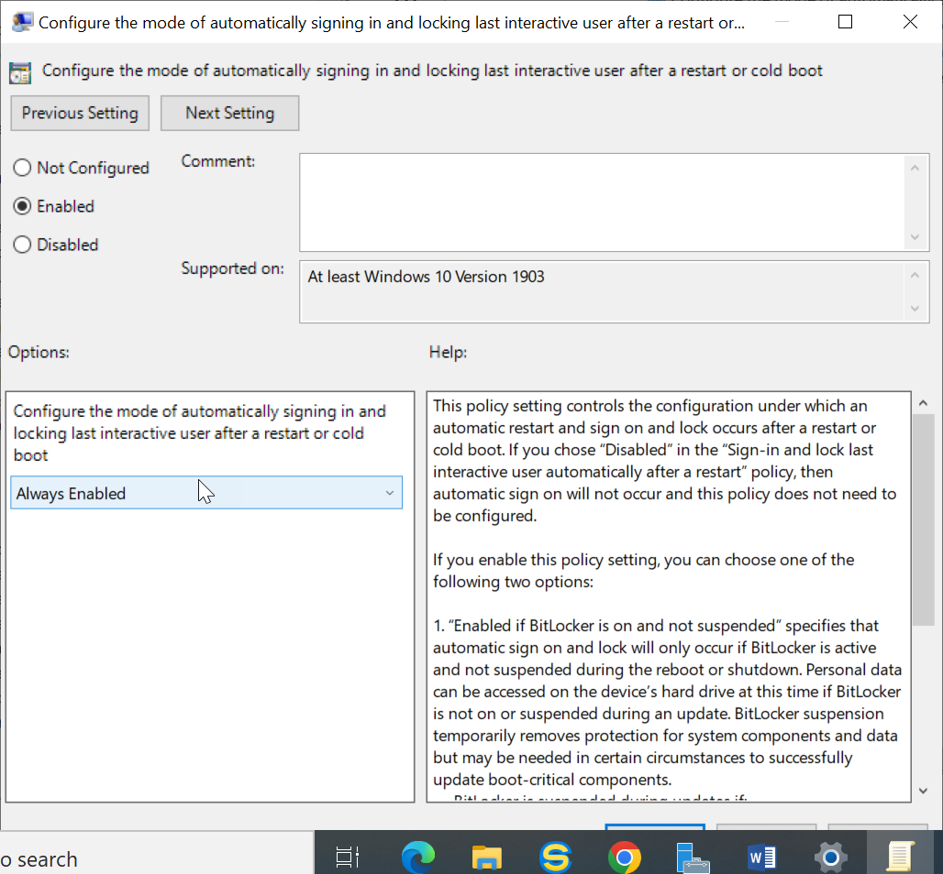

Warning
It doesn't work if last login was made via RDP.
After physically logging into server, it started working.

Testing
Now restart your PC to try out the automatic login. Windows will automatically log in the last user.
Event Viewer Logs:
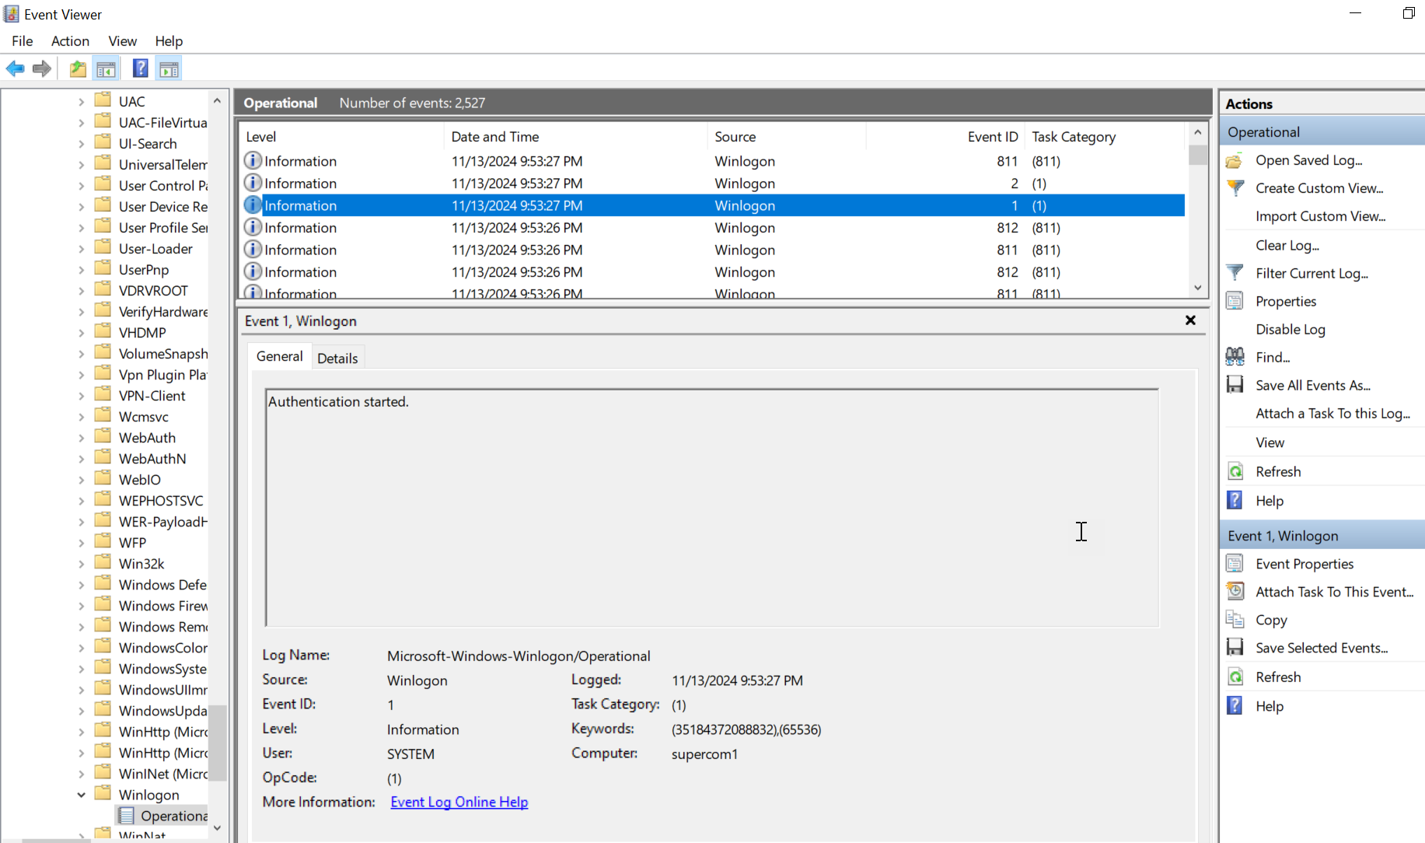
Check Applications and Services Logs > Microsoft > Windows > Winlogon > Operational in Event Viewer for the following Winlogon events:
Expand table
Event ID | Event description | Event source
1 | Authentication started. | Winlogon
2 | Authentication stopped. Result 0 | Winlogon
The status of an ARSO configuration attempt is stored in the LSA event log. Check Applications and Services Logs > Microsoft > Windows > LSA > Operational in Event Viewer for the following LSA events:
Expand table
Event ID | Event description | Event source
320 | Automatic restart sign on successfully configured the autologon credentials for: Account name: <accountName> Account Domain: <accountDomain> | LSA
321 | Automatic restart sign on successfully deleted autologon credentials from LSA memory | LSA
322 | Automatic restart sign on failed to configure the autologon credentials with error: <errorText> | LSA

Setup nodejs

Using node-windows with Different Node.js Versions
Once you have set up nvm-windows and installed multiple versions of Node.js, you can utilize node-windows to run scripts or applications with the specific version of Node.js you need.

Installing node-windows
- Install node-windows:
  - In your desired project directory, install node-windows via npm (make sure to use the correct version of Node.js):
bash
npm install node-windows
- Creating a Windows Service:
  - You can create a Windows service using node-windows. Here’s an example script to create a service:
javascript
const Service = require('node-windows').Service;

// Create a new service object
const svc = new Service({
name: 'MyService',
description: 'My Node.js Service',
script: 'C:\\path\\to\\your\\script.js', // Path to your script
nodeOptions: [
'--harmony',
'--max-old-space-size=4096' // Example options
]
});

// Listen for the "install" event, which indicates the service is available
svc.on('install', function() {
svc.start();
});

svc.install();
- Running Your Script with Specific Node Version:
  - Ensure that you switch to the desired Node.js version using nvm use <version> before running your script or creating your service.
By following these steps, you can effectively manage multiple Node.js versions on Windows using nvm-windows, while also leveraging node-windows for running scripts as services or applications tailored to specific project requirements. This setup allows for flexible development environments accommodating various project needs without conflicts between different Node.js versions.

Setup windows backup
https://4sysops.com/archives/install-and-configure-windows-server-backup-in-windows-server-2022/

Install Windows Server Backup
In the first step, you need to install Windows Server Backup on your Windows Server 2022. You can do it via Server Manager (GUI) or PowerShell by executing Install-WindowsFeature Windows-Server-Backup.
To do so using Server Manager:
- Open Server Manager and click Add Roles and Features.
- Under Before you begin, click Next.
- Under Select installation type, click Next.
- Under Select destination server, select the server, and then click Next.
- Under Select server roles, click Next.
- Under Select features, select Windows Server Backup, and then click Next.
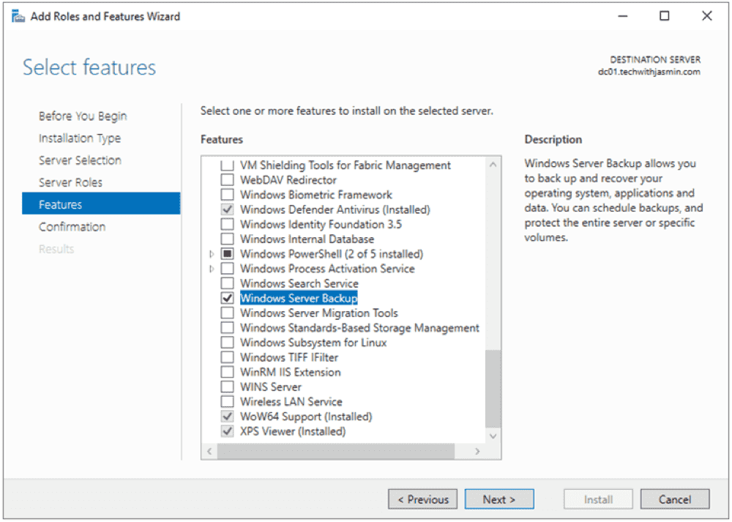
Add feature Windows Server Backup
- Under Confirm installation selections, click Install, and wait until the feature is installed.
- Once done, click Close.

Manual backup
Start a manual backup whenever you feel that a copy of your system is required, for instance, when you are planning major changes.
To configure a manual backup in Windows Server 2022:
- Open Server Manager on Windows Server 2022.
- Click Tools in the top right corner of the window, and then select Windows Server Backup.
- Right-click Local Backup and then select Backup Once.
- Under Backup Options, select Different options, and click Next. Choose this option if you have not created a scheduled backup or want to specify a location or items for this backup that are different from the scheduled backup.
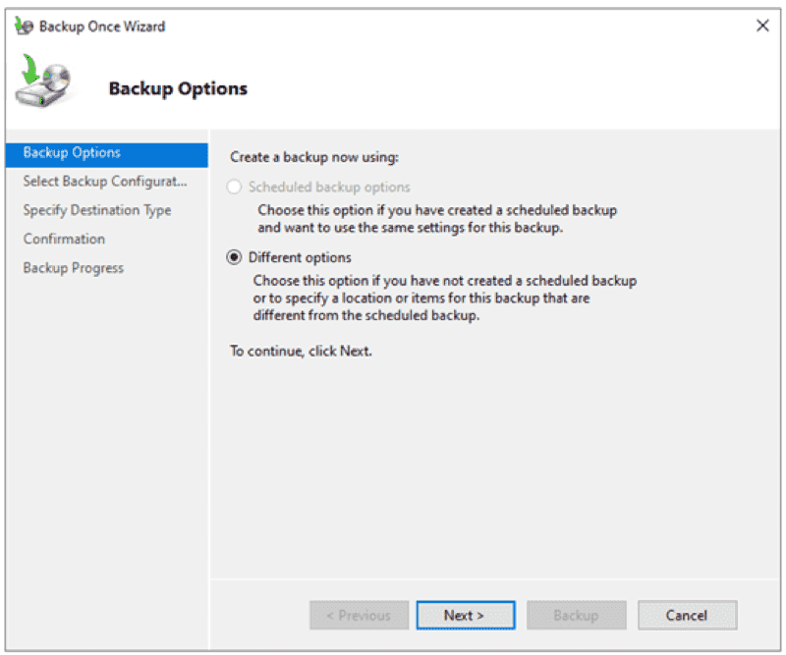
Backup options backup once
- Select the type of configuration you want to schedule: Full server (recommended) or Custom. The full server backup will back up all your server data, applications, and system state. Use the custom backup to select what you want to back up.
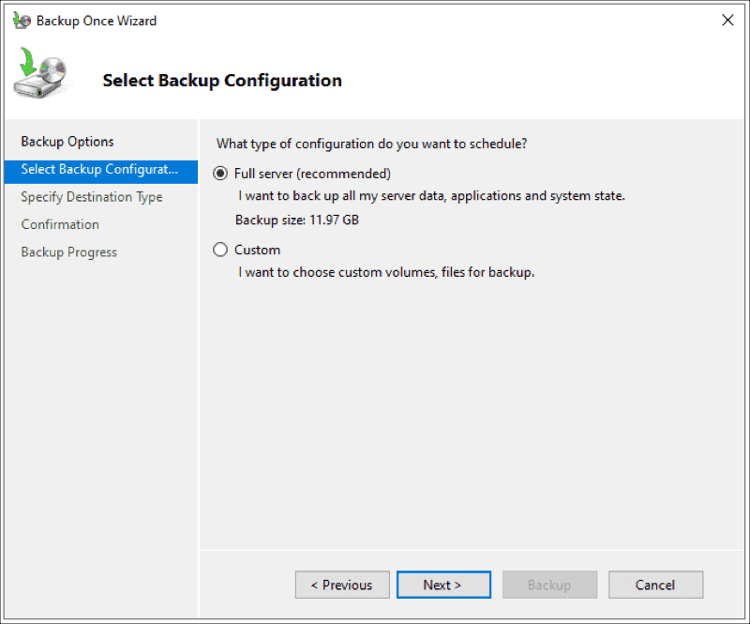
Select Backup Configuration backup once
- Under Specify Destination Type, choose the type of storage to back up, and click Next. There are two options available: Local drives or Remote shared folders. For demonstration purposes, I use a remote shared folder.
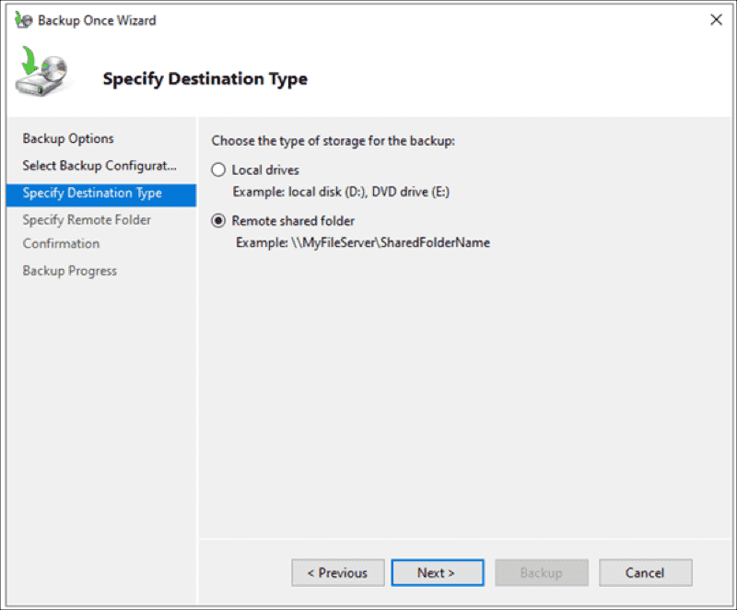
Specify Destination Type backup once
- Under Specify Remote Folder, enter a location, and click Next.
e.g. \\SUPERCOM1\aaSTORAGE
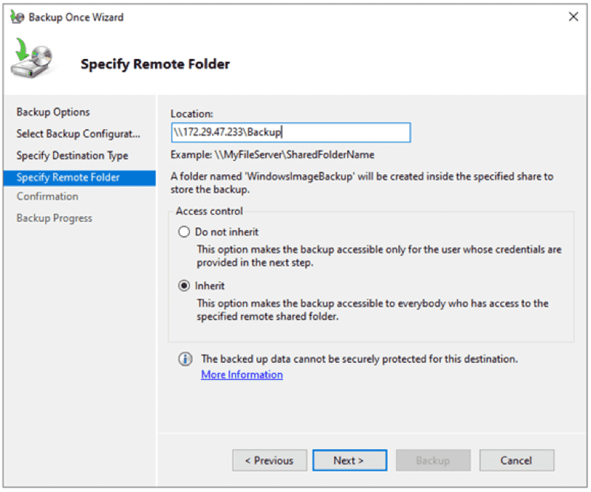
Specify Remote Folder backup once
- Under Confirmation, click Backup.
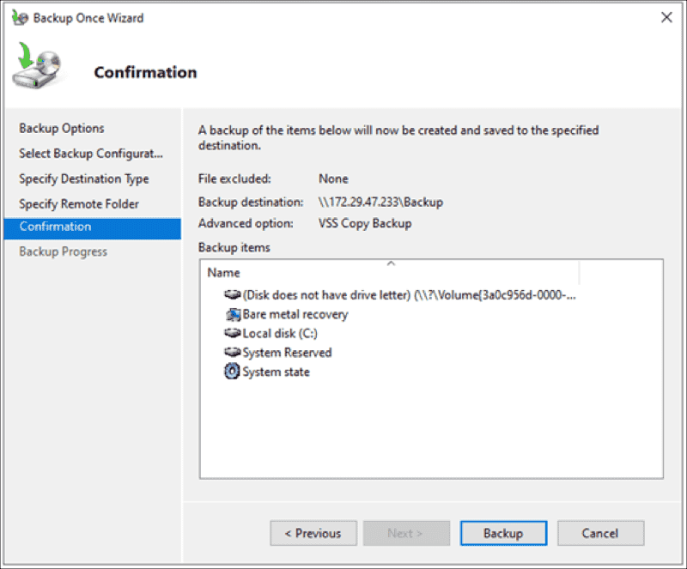
Confirmation window backup once
- Wait until the backup is done.
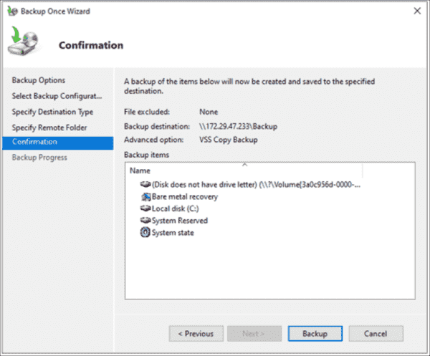
Confirmation window (backup once)
Once a backup is done, you will see the status message: Successful.
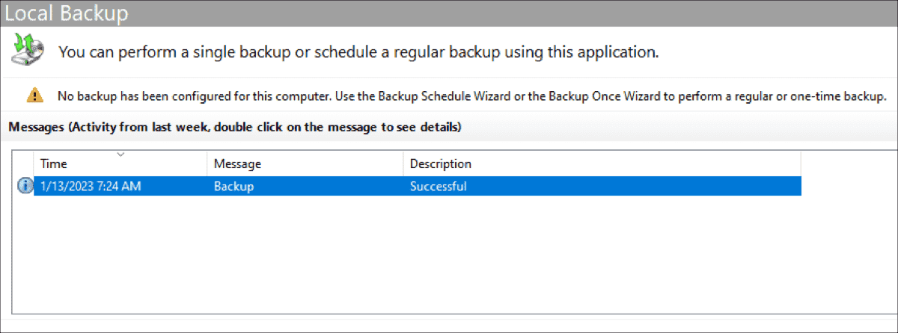
Backup is done backup once

Scheduled backups
Scheduled backups are convenient, and ensure that your data is regularly backed up without requiring manual intervention. To create a backup schedule, you should decide what to back up, when, and how often to back up your server, and where to store the backups. Here is how.
- Open Server Manager on Windows Server 2022.
- Click Tools in the top right corner of the window, and select Windows Server Backup.
- Right-click Local Backup, and select Backup Schedule.
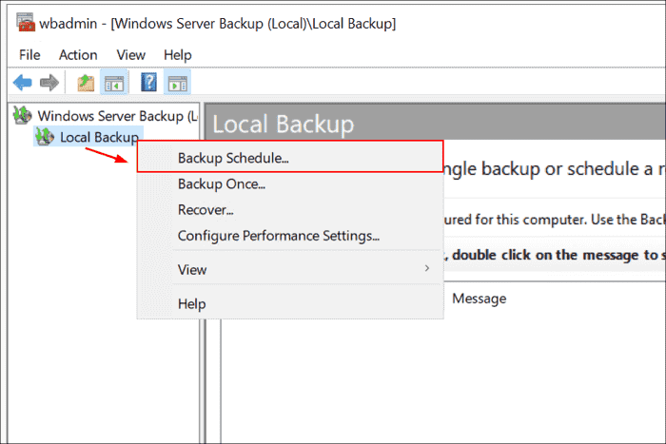
Backup schedule
- Click Next.
- Select the type of configuration you want to schedule: Full server (recommended) or Custom. The full server backup will back up all your server data, applications, and system state. Use the custom backup to select what you want to back up.
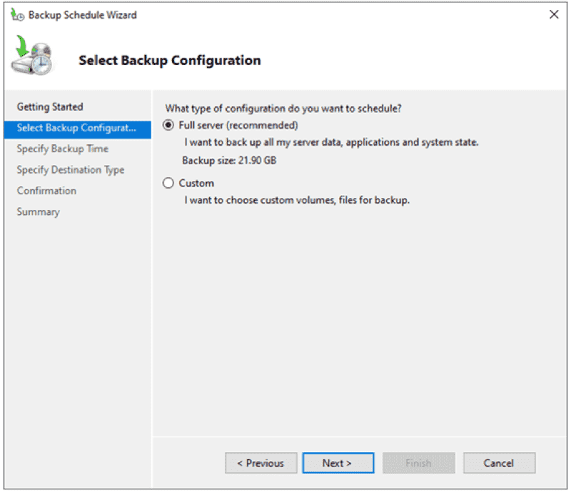
Select Backup Configuration schedule backup
- Under How often and when you want to run backups, click Once a day, and then click Next. You can also choose whether you want to run a backup more than once a day.
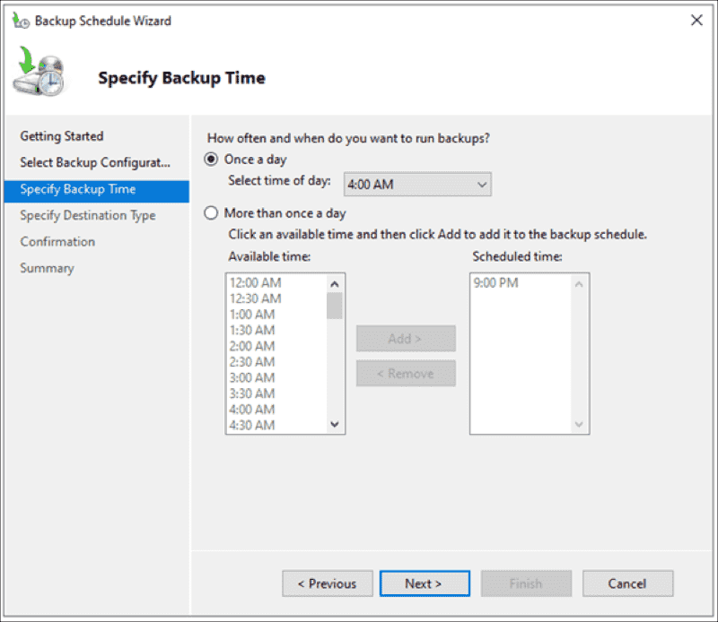
Specify Backup Time schedule backup
- Under Specify Destination Type, select Back up to a shared network folder, and click Next. You can also choose:
- Back up to a hard disk that is dedicated to backups (recommended)
- Back up to a volume
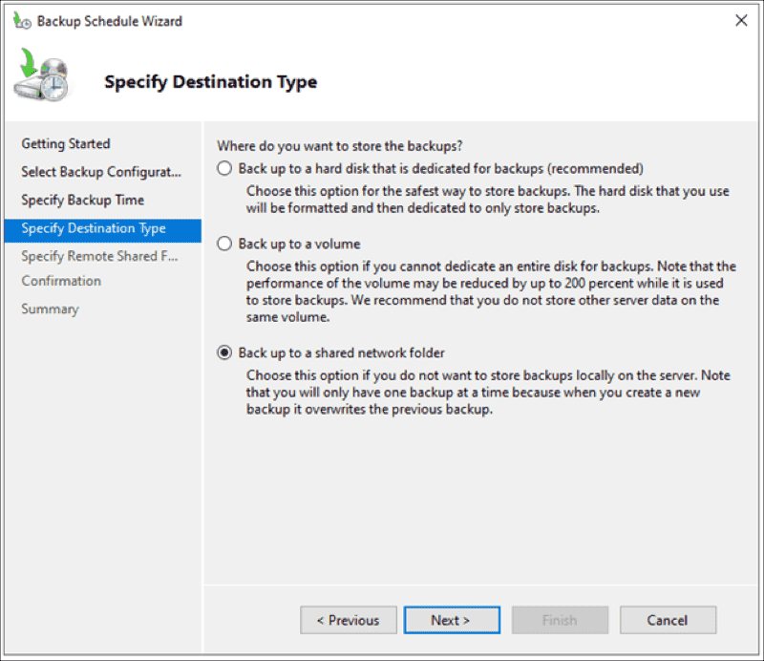
Specify Destination Type schedule backup
Note that you use a remote shared folder as the storage destination for scheduled backups. Each backup will erase the previous backup, and only the latest backup will be available.
- Under Specify Remote Share Folder, add a remote location, and click Next. Note that to schedule backups, you will need to provide usernames and passwords.
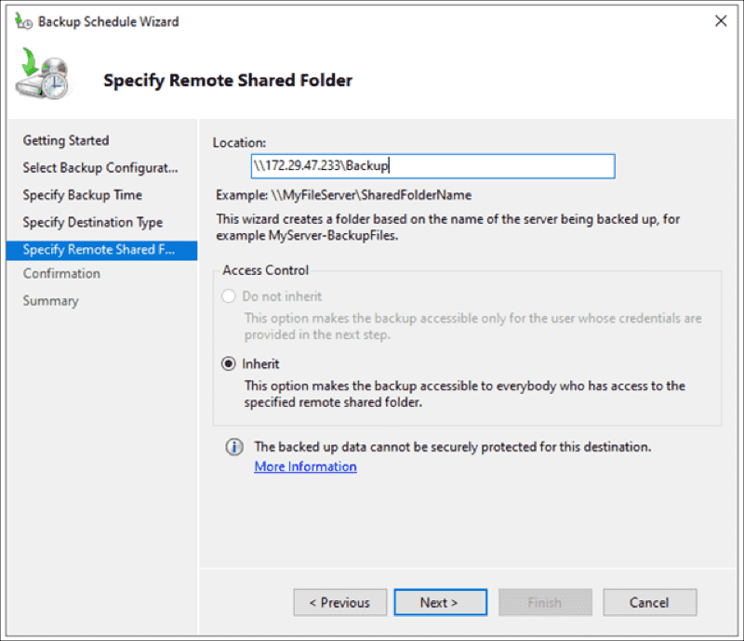
Specify Remote Share Folder schedule backup
- Under Confirmation, click Finish.
- Click Close to close the window. You will see that a new scheduled backup is configured on the server.
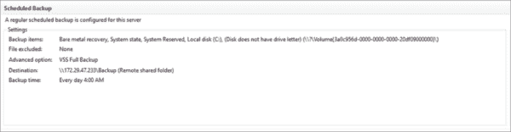
A regularly scheduled backup is configured for this server

Restore a backup
In case of any issues with your Windows Server, you will need to restore your data. I'll show you how to restore the system image backup (full backup). You can apply the same procedure to other backups as well.
- Open Server Manager on your Windows Server 2022.
- Click Tools in the top right corner of the window, and then select Windows Server Backup.
- Right-click Local Backup, and then click Recover.
- Under Getting Started, select the location where the backup is stored, and click Next. As I did a backup to a remote location, I'll choose A backup stored on another location.
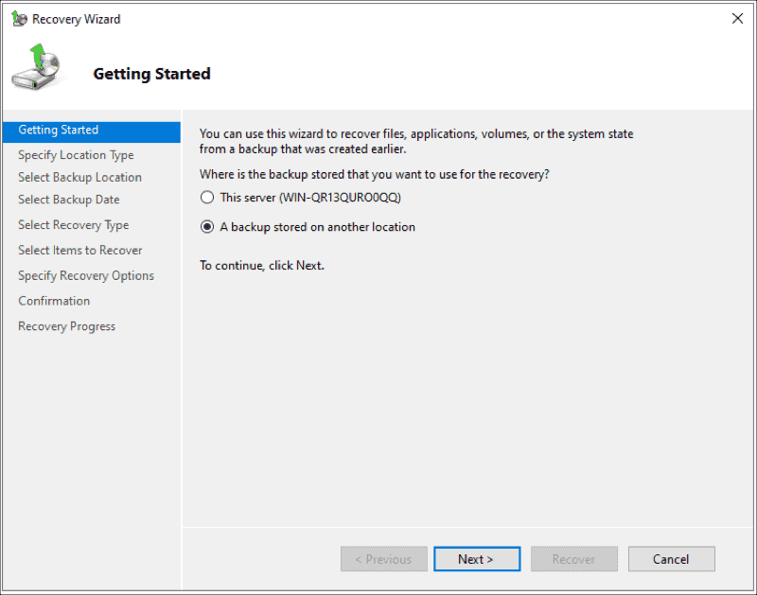
Backup stored at another location
- Under Specify Location Type, select the location type, and click Next. In my case, it is a Remote shared folder.
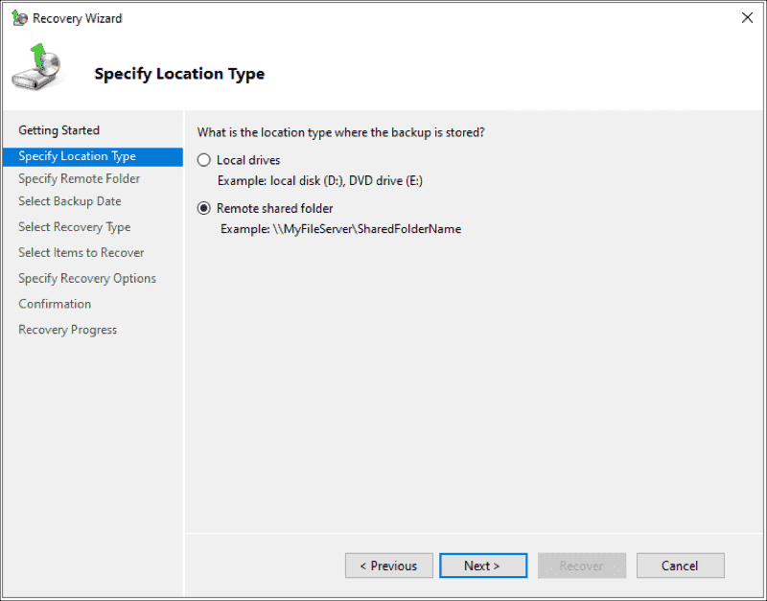
Specify Location Type
- Under Specify Remote Folder, type the backup path, and click Next.
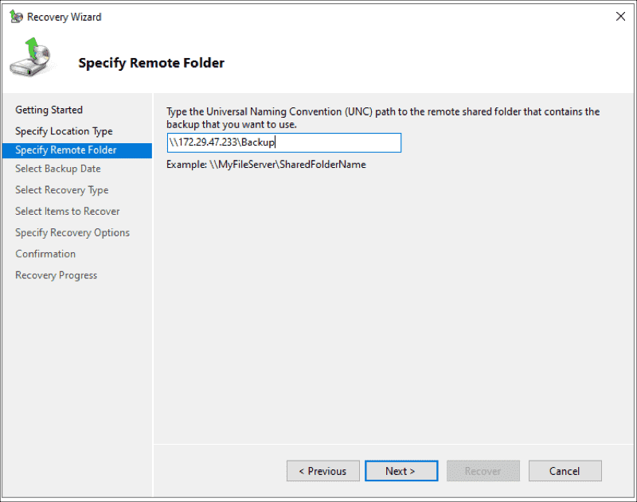
Specify Remote Folder
- Under Select Backup Date, select the date of the backup you want to use for recovery, and click Next.
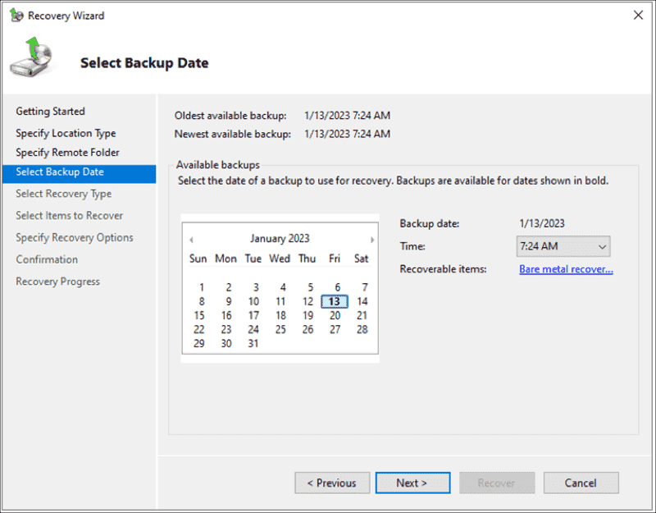
Select Backup Date
- Under Select Recovery Type, select what you want to recover, and click Next. You can choose files and folders, volumes, applications, and system states.
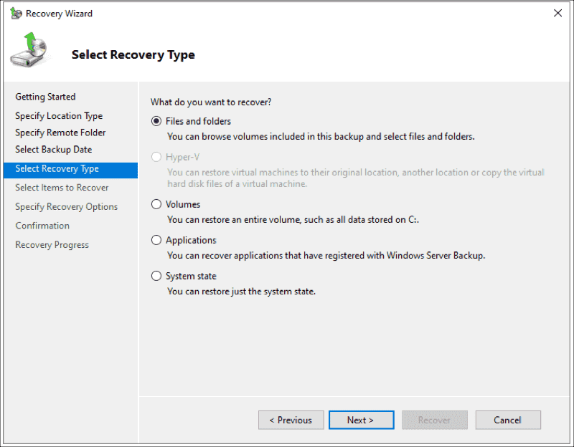
Select Recovery Type
- Under Select Items to Recover, browse the tree, and select the files and folders you want to recover.
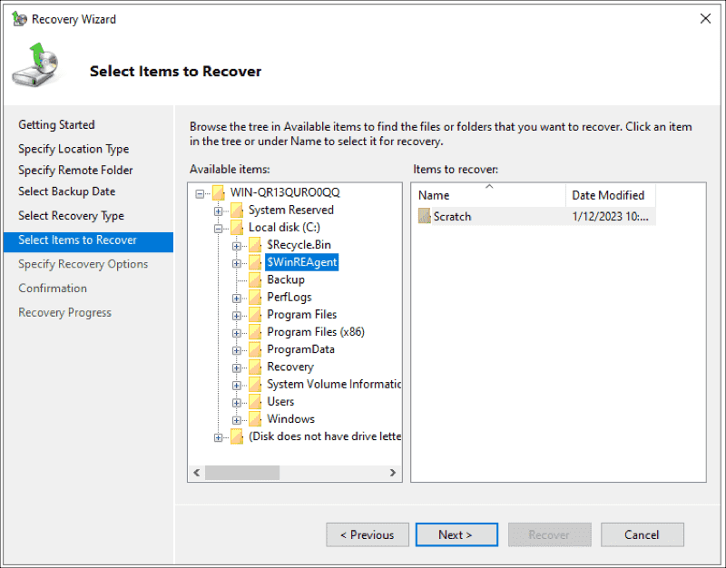
Select Items to Recover
- Under Choose Recovery Options, select the recovery destination, and click Next.
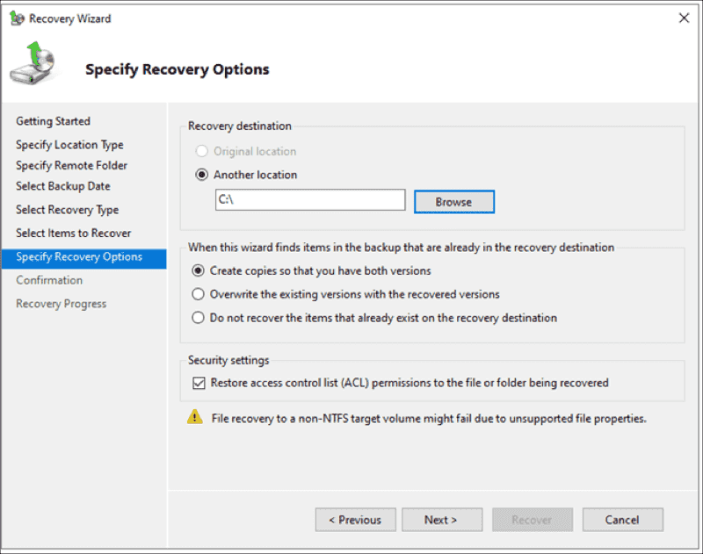
Specify Recovery Options
- Confirm by clicking Recover.
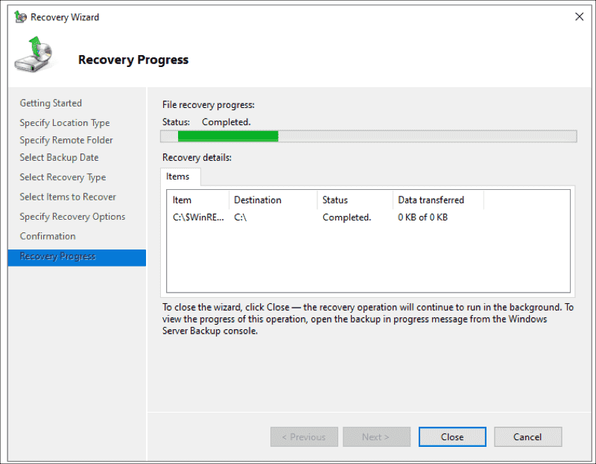
Recovery progress
You're done. Go to the location where you restored the data and access it.

Setup reverse proxy web address to localhost port

Buy domain from namecheap

Namecheap setup dynamic DNS settings

Enable dynamic DNS
Repeat for www
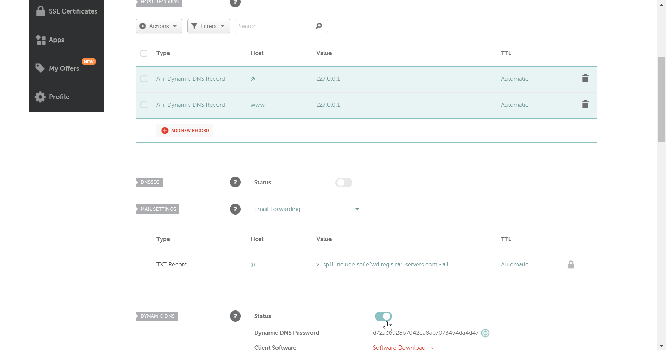

- Create an A Record:
  - Still in the Advanced DNS tab, add a new record:
    - For Host, enter @
    - For Value, you can input any dummy IP address (like 127.0.0.1), as this will be updated automatically later.

DDNS Client setup dynamic DNS settings
  - You can use Namecheap's Dynamic DNS client or configure a third-party client (like DDClient or your router's built-in DDNS settings).
  - If using the Namecheap client:
    - Download and install it from their support page.
    - Open the client and create a new profile:
      - Enter the host as @
      - Enter your domain name (e.g., eatzycook.com).
      - Use the Dynamic DNS password generated earlier.
      - Choose "Auto detect my IP address" and set how often you want it to update.
      - Repeat this with host www
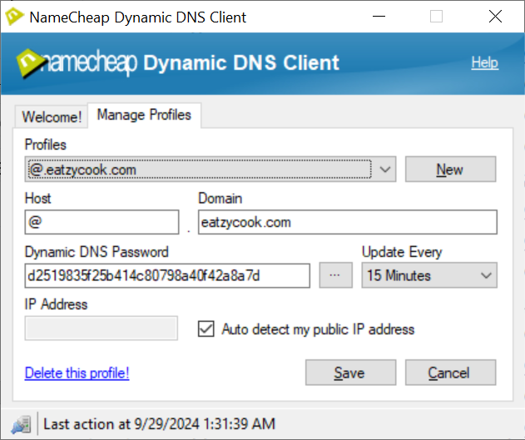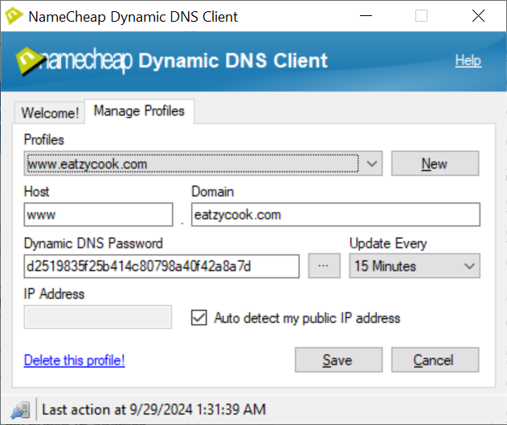

Use Task Scheduler in windows to start the program on computer startup (without logging in)
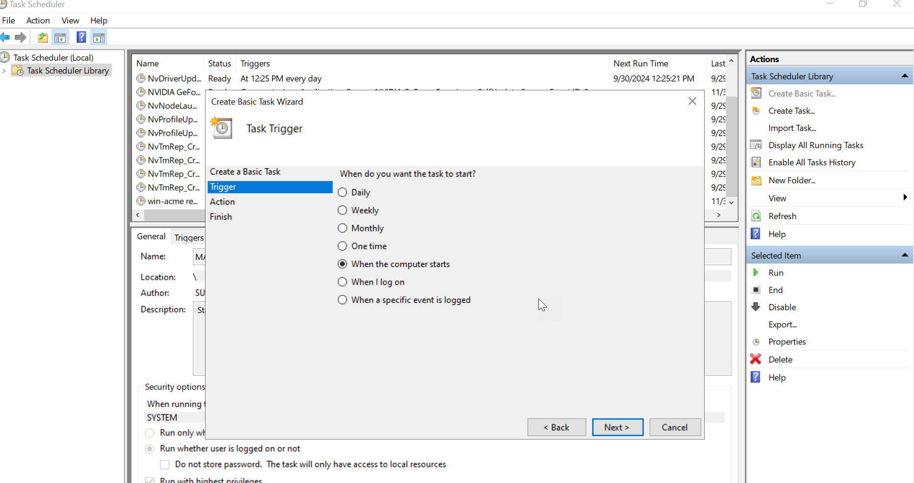
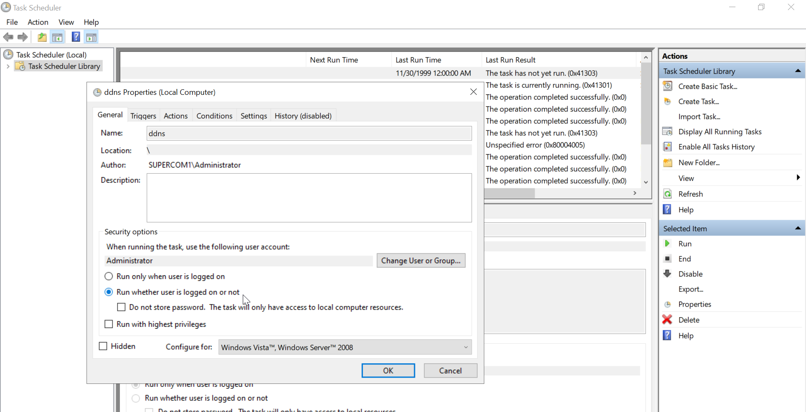

Option 1 – Use Nginx (preferred)
Better as it works faster than IIS and supports websockets (needed for thingsboard).
Refer to Nginx setup instructions.

Option 2 - Windows server IIS (use if you want for address:8081 not port 80 or 443)
Easier to setup.

Windows server settings
Open ports in your router to port 80. (do for other ports as well)
Create application pool.
In server -> iis site -> right click sites -> add website:
For physical path, choose a dummy location such as: C:\inetpub\wwwroot\mtrcompute
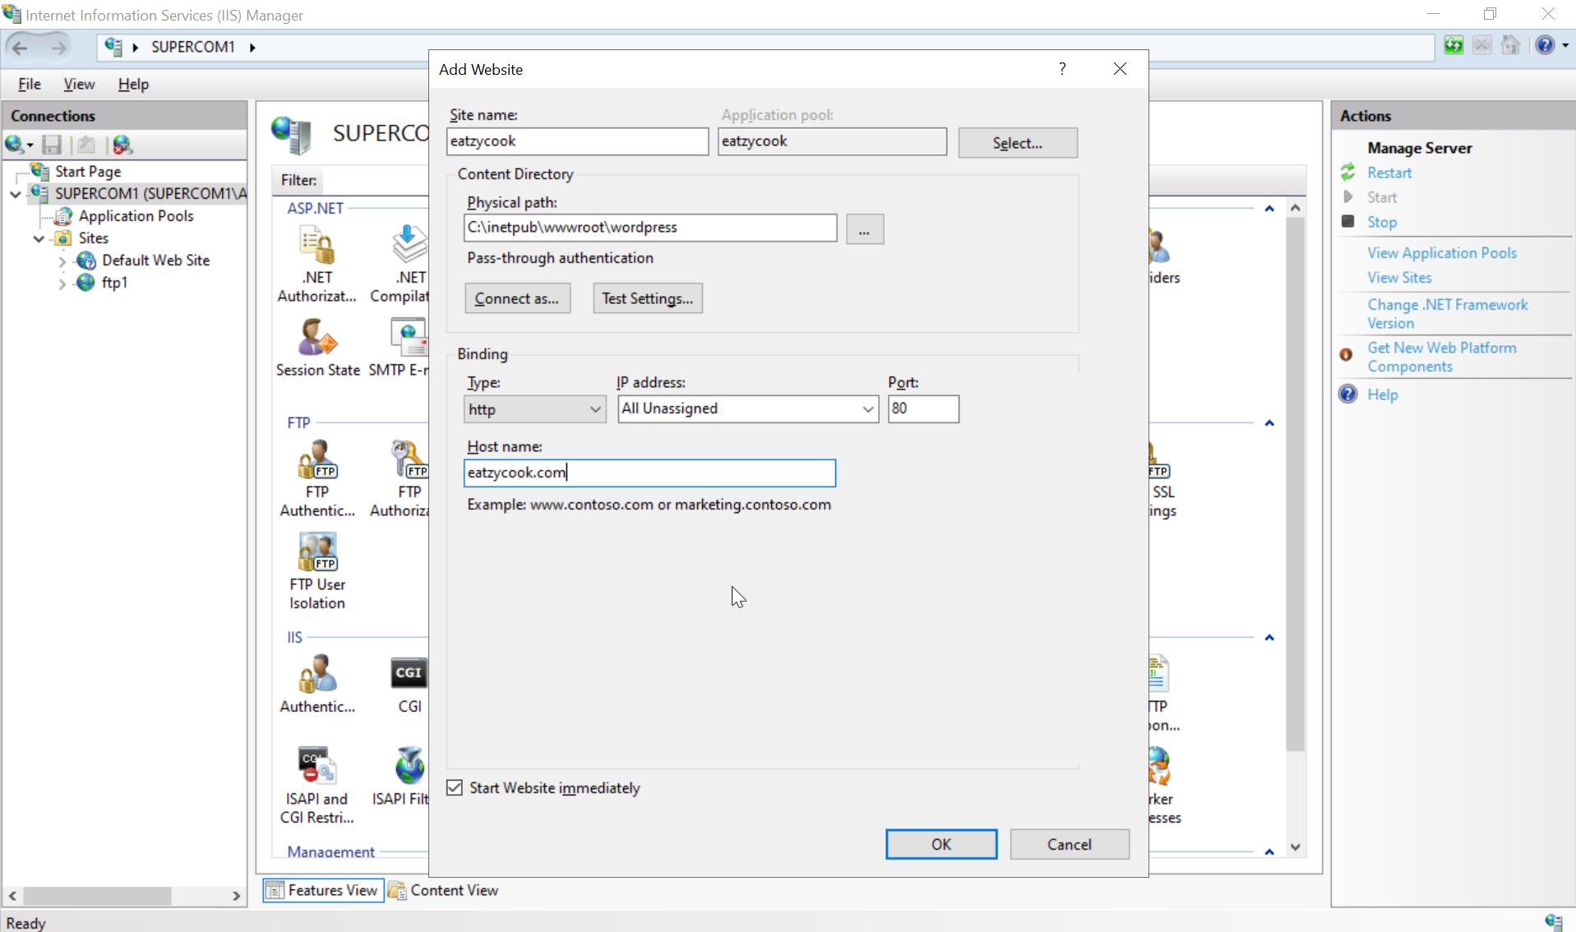

Add bindings for www as well:-
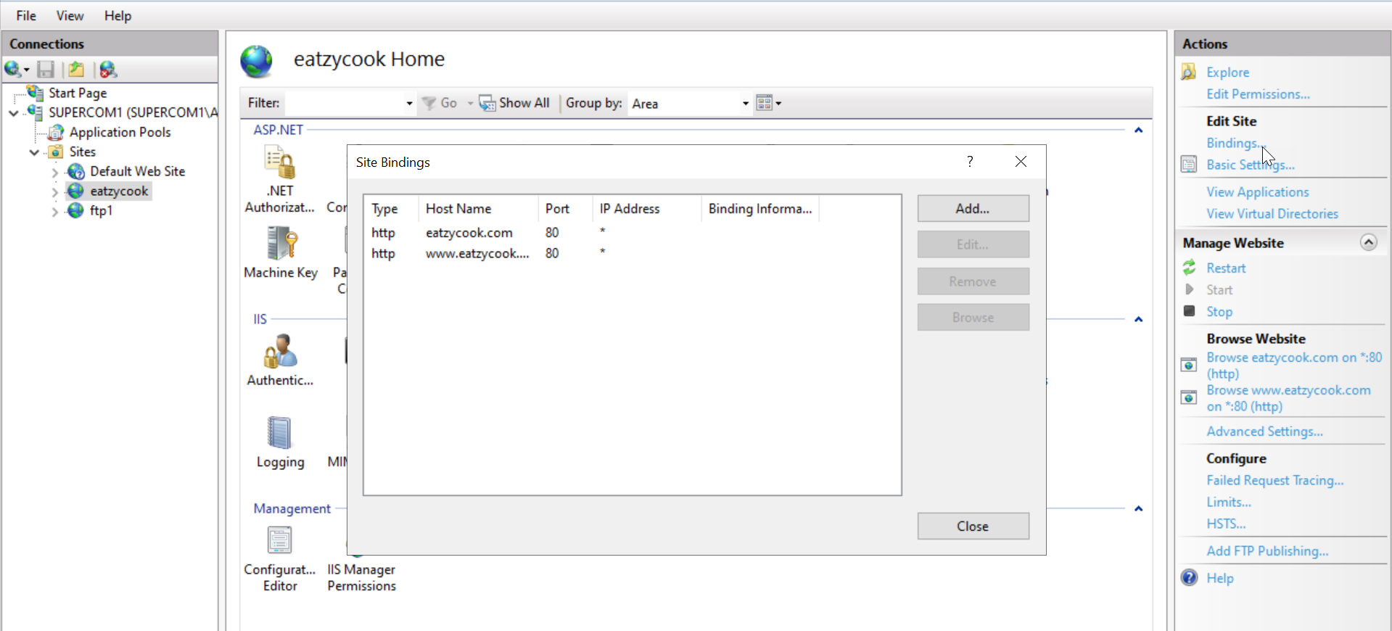

Install windows server plugins
requestRouter_amd64.msi
rewrite_amd64_en-US.msi

Setup application request (one-off setting)
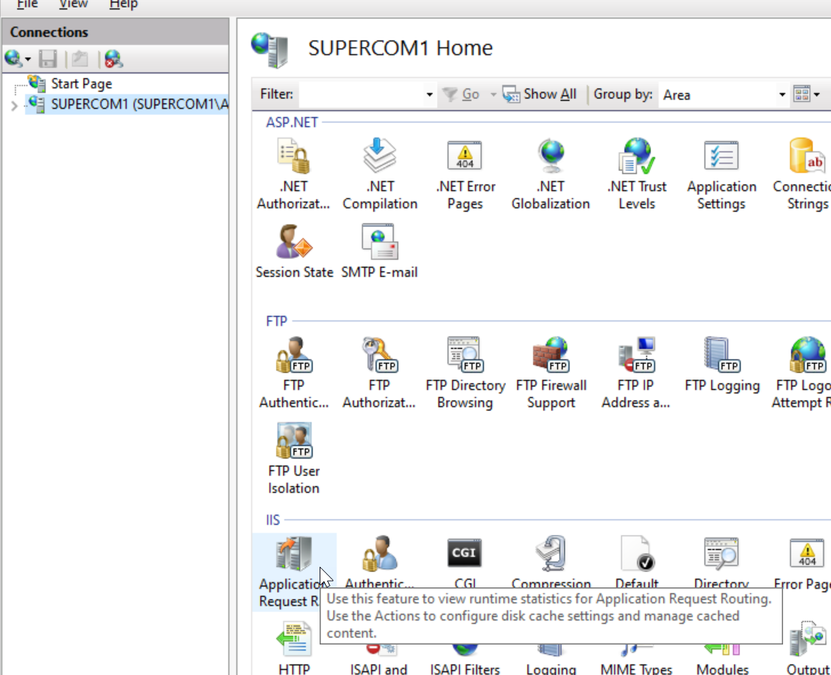

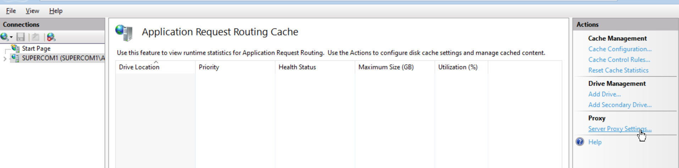
Enable proxy
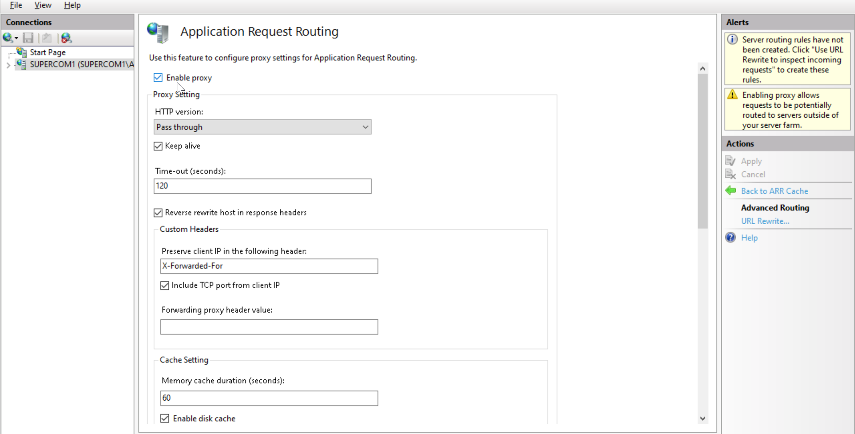

Setup URL rewrite
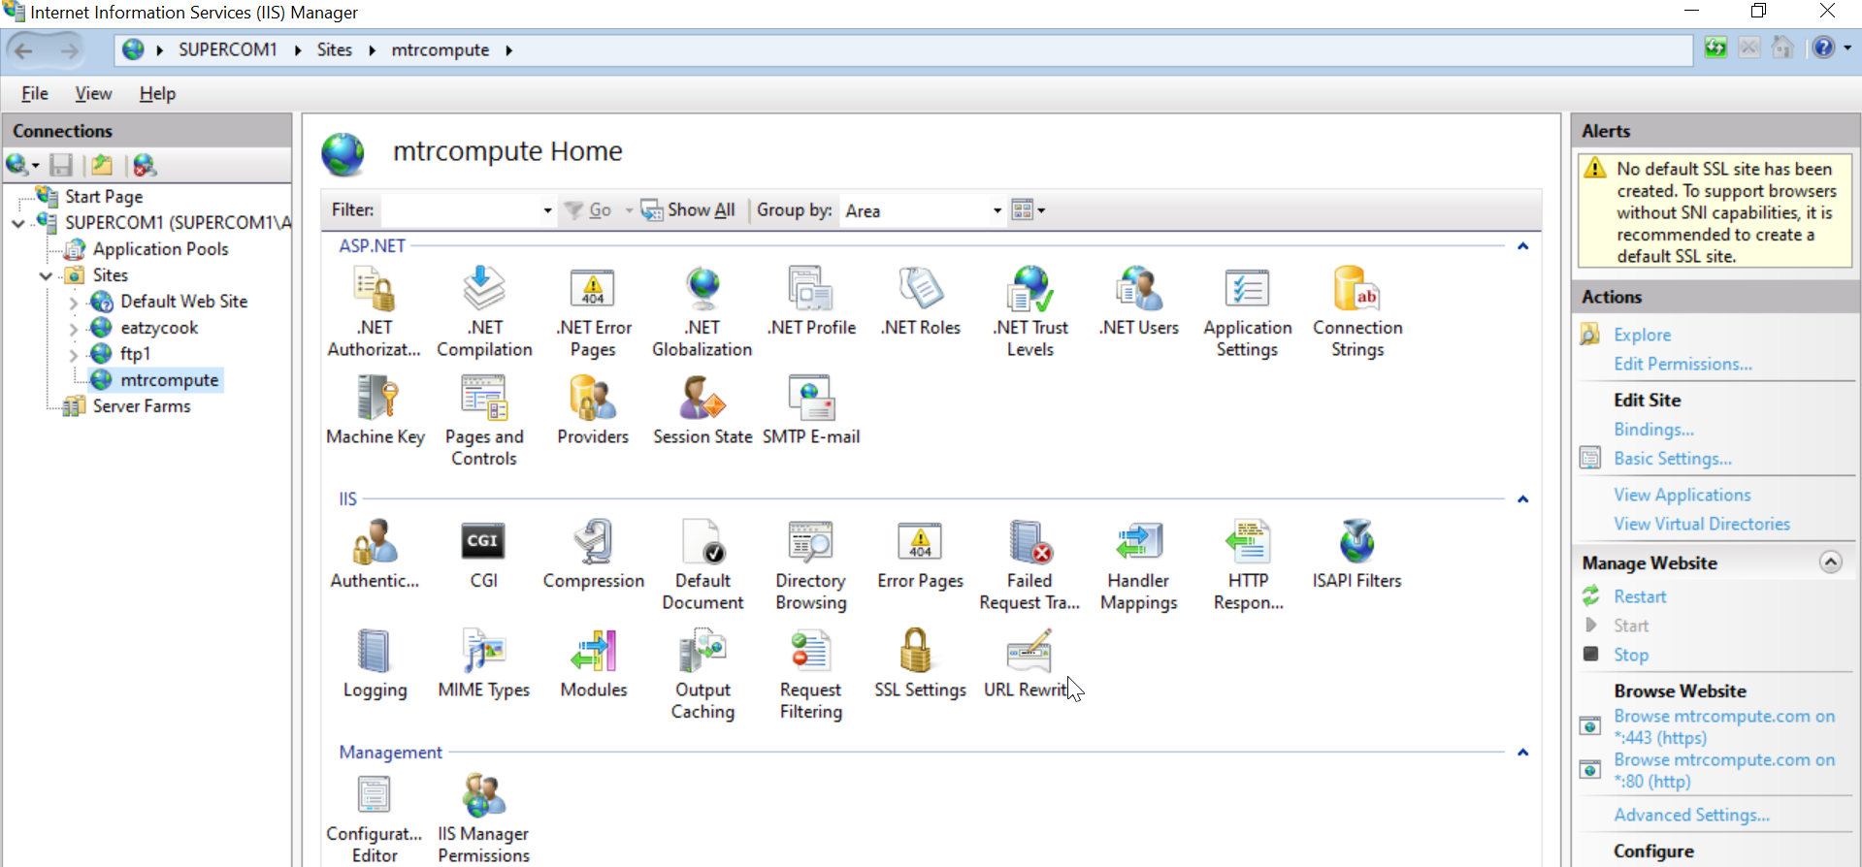
Add rule -> reverse proxy
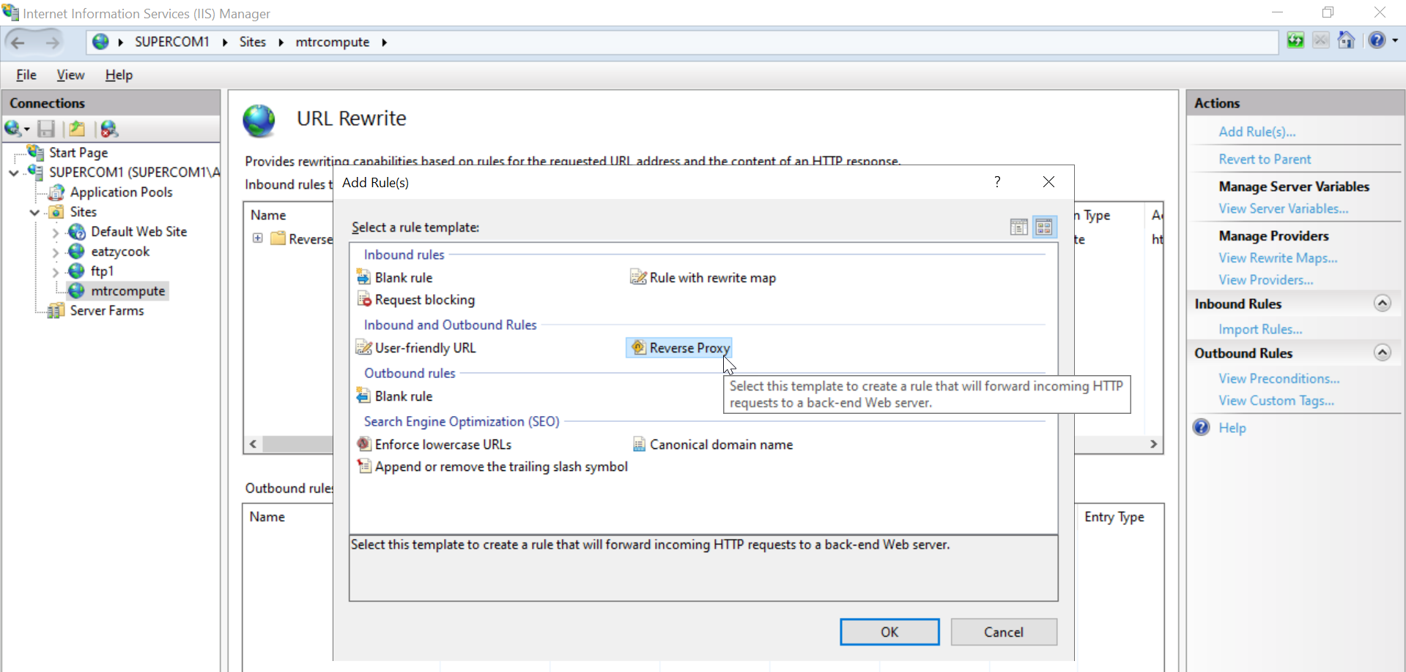

Set inbound rule only:
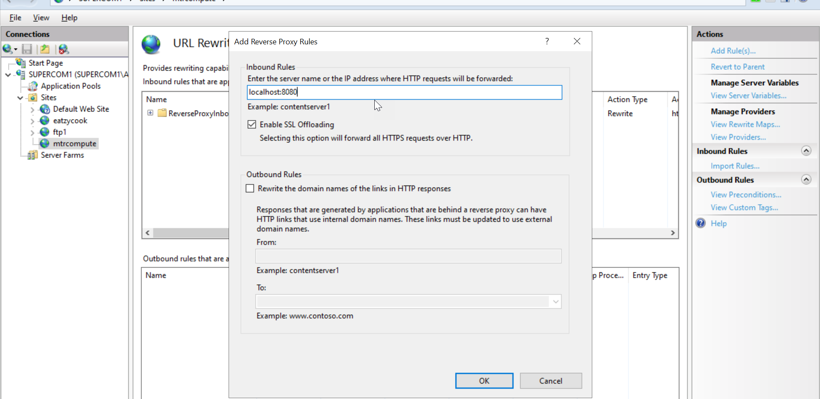

Restart the website
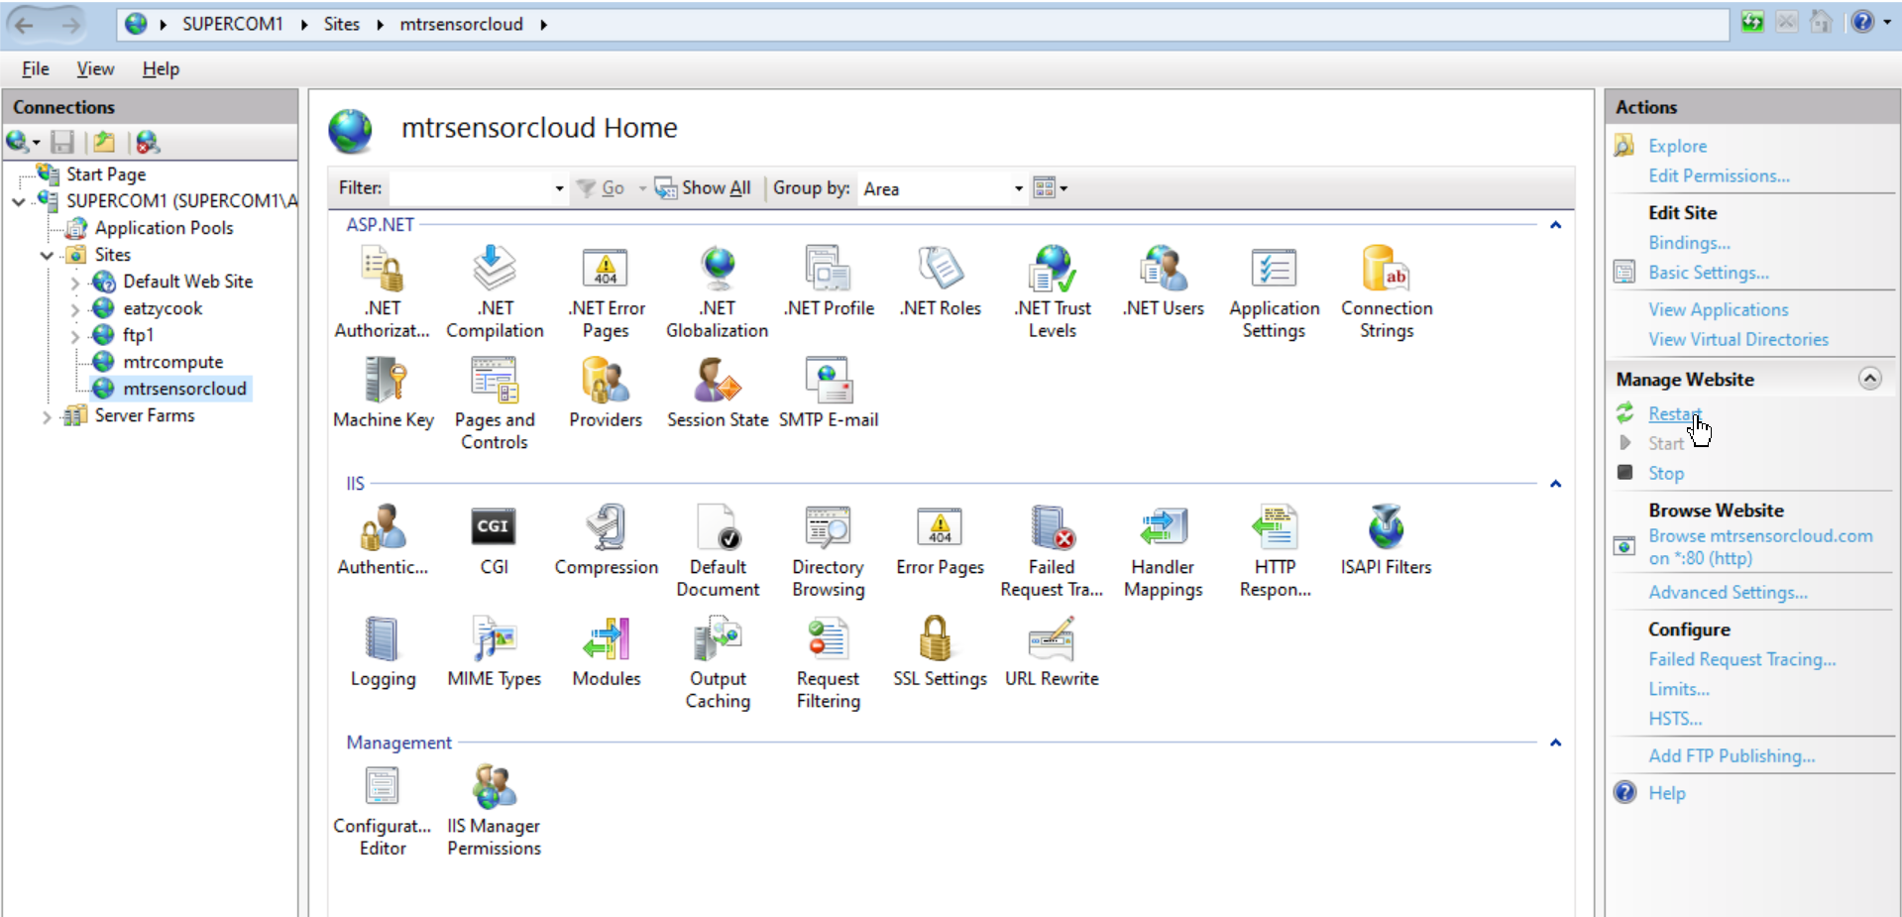

Wait a few minutes for propagation

Test url
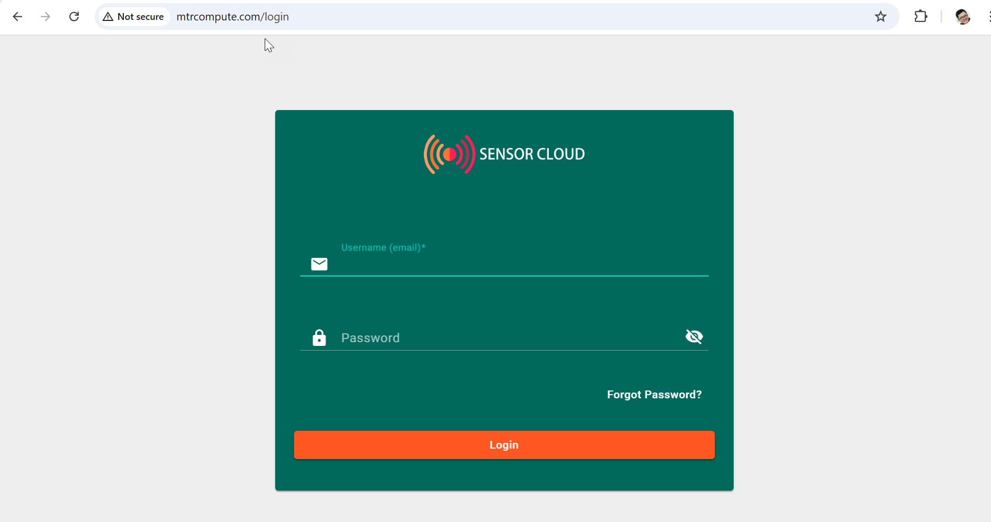

Add https security certificates to domain name

Firewall setting
Allow port 443 in firewall and port forwarding.

Install encrypt (one-off)
Download win-acme and download the latest version.
Extract the contents of the zip file to a directory on your server (e.g., C:\win-acme).
Run wacs.exe as administrator.
Windows Defender will prevent it from running but just click More info and Run Anyway.
Choose N
Choose the number of the site you want to create SSL for. If you have multiple sites, hit Enter.
Choose A
Follow through

Option 1 – for Nginx
Refer to Nginx instructions.

Option 2 – for windows server IIS

Check bindings
Go back to your Windows server and go to IIS Manager. Select your domain and click Bindings on the right panel. You should be able to see an https with your domain at port 443.
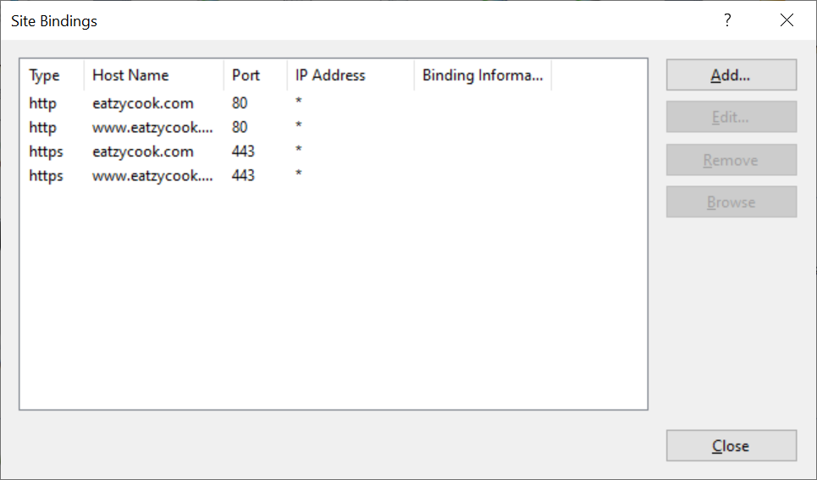

Check the bindings have 443 registered in iis
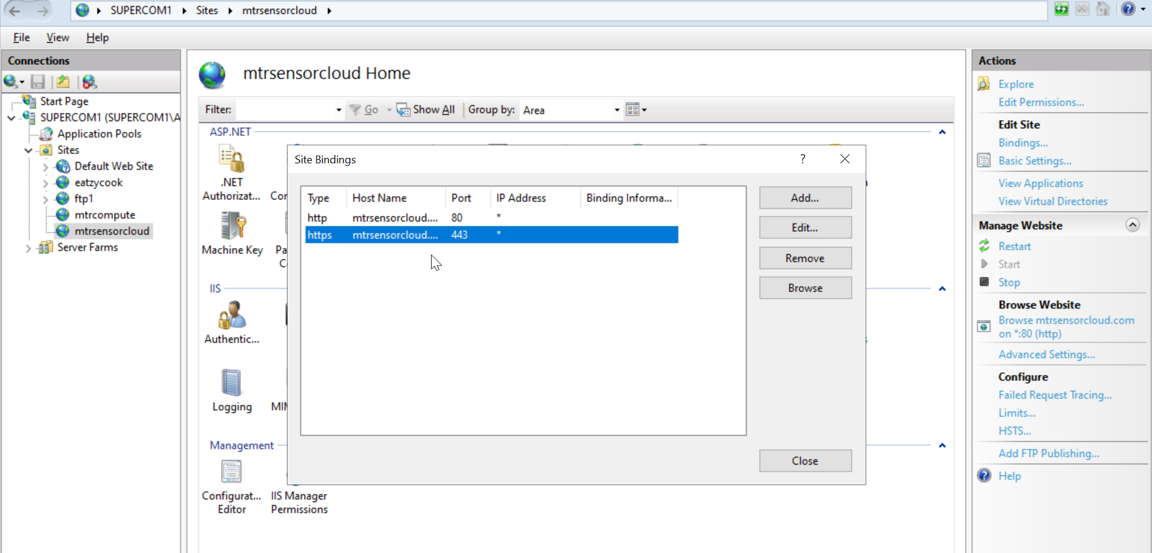

Check renewal
Check that renewal is registered in the task scheduler in windows.
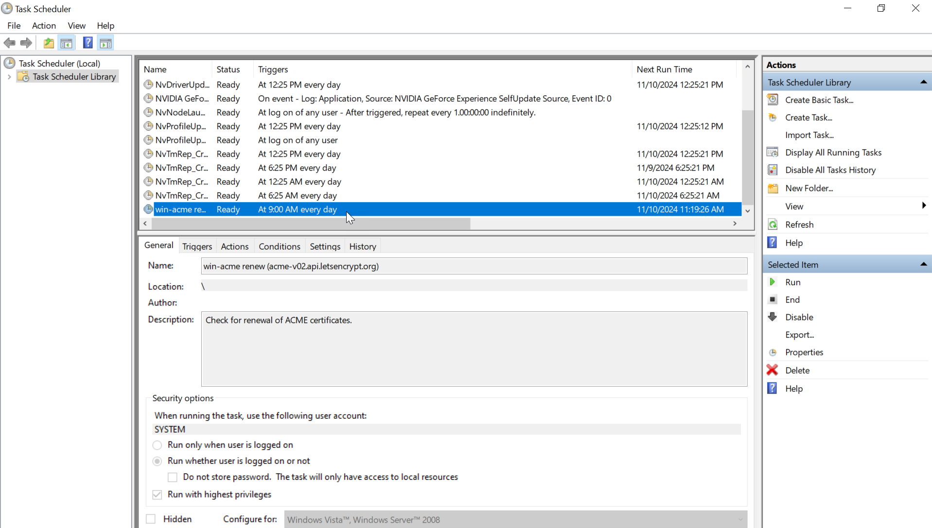

Troubleshooting

Server cannot be accessed from outside even though the firewall and port forwarded

Server cannot be accessed after rebooting server

- Check if the port is being blocked by ISP
windows -> powershell, copy and paste this code, change the port test range:

for ($i=1; $i -le 65535; $i++) {
Write-Output "Checking port $i"
try {
$tcpconnection = Test-NetConnection -ComputerName portquiz.net -Port $i -WarningAction SilentlyContinue
if($tcpconnection.TcpTestSucceeded) {
Write-Output "Port $i is open"
}
else {
Write-Output "Port $i is closed"
}
}
catch {
Write-Output "Port $i is closed"
}
}

https://superuser.com/questions/10903/is-there-a-simple-way-to-detect-isp-port-blocking

- Check that the port forwarding internal IP address did not change:

windows -> cmd -> ipconfig -> copy the IPv4 address:
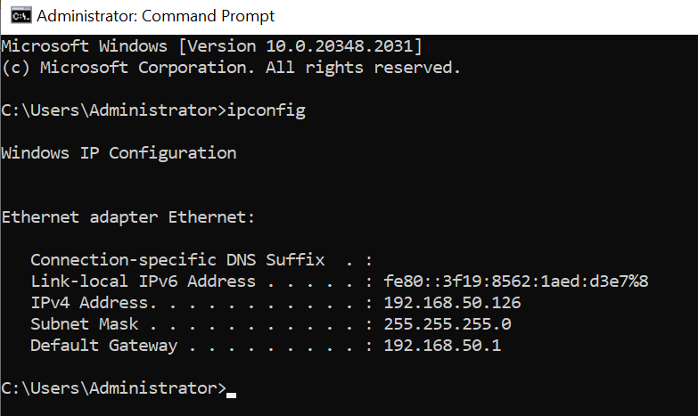

login to the router -> WAN -> port forwarding tab -> edit the internal IP address if they changed
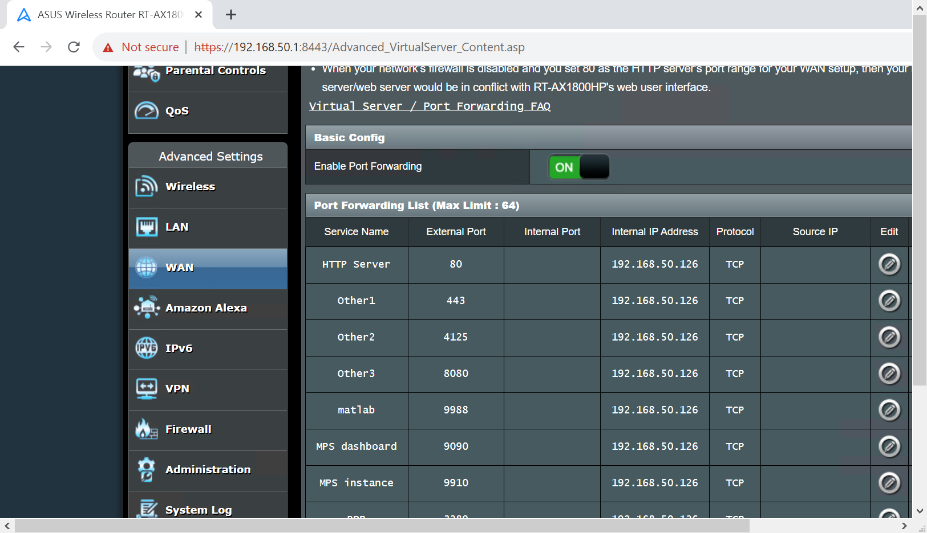
Test to see if the server works now

- Reset the network settings to default:
https://ugetfix.com/ask/how-to-fix-website-online-but-isnt-responding-to-connection-attempts/
2. Turn off the Proxy Settings
- Press Winkey + I to open Settings.
- Go to Network and Internet.
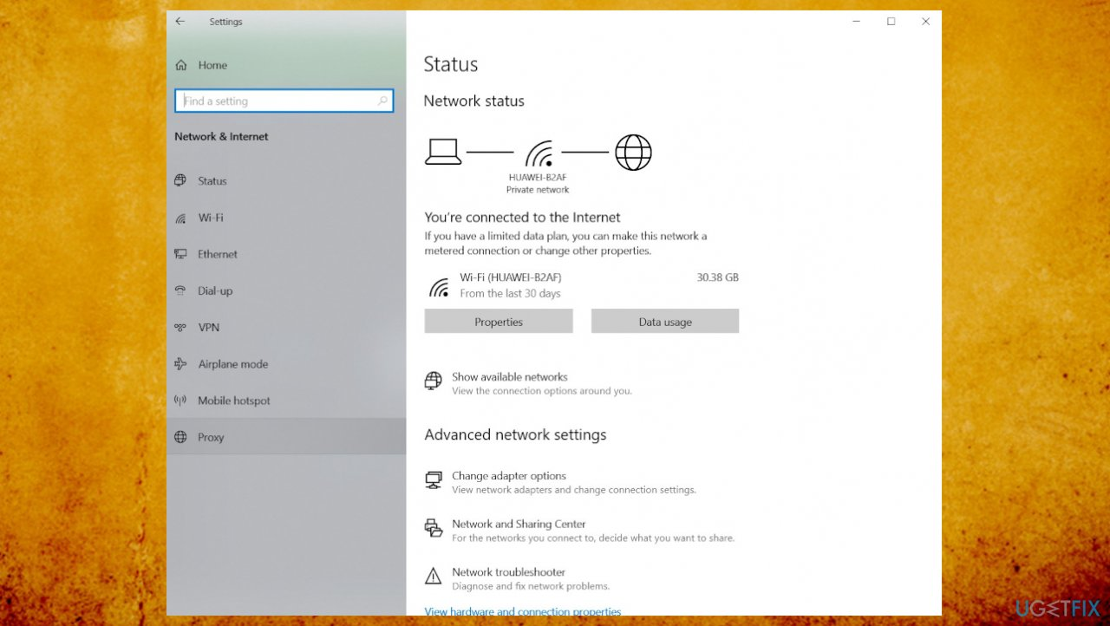
- On the left-hand side pane, click Proxy.
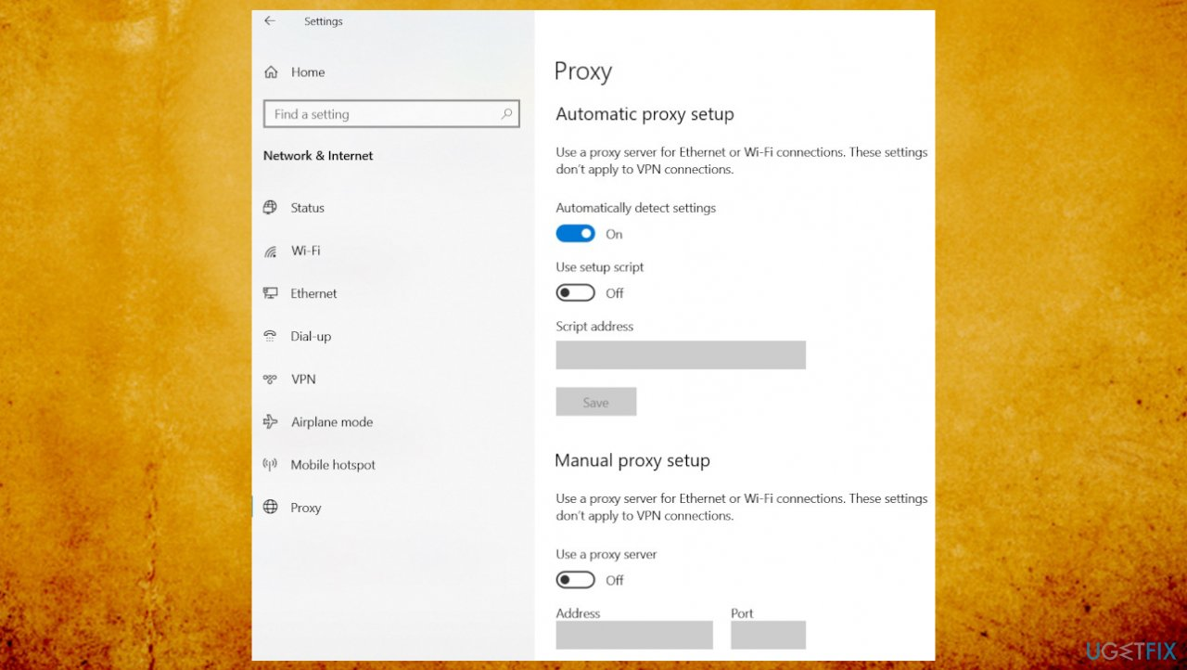
- Turn off Automatic proxy setup and then scroll down to turn off Manual proxy setup.
- Reconnect to your network. This should solve your problem.
3. Reset the TCP/ IP and DNS
- Press Winkey + X and select Command Prompt (Admin) from the list to open an elevated cmd.
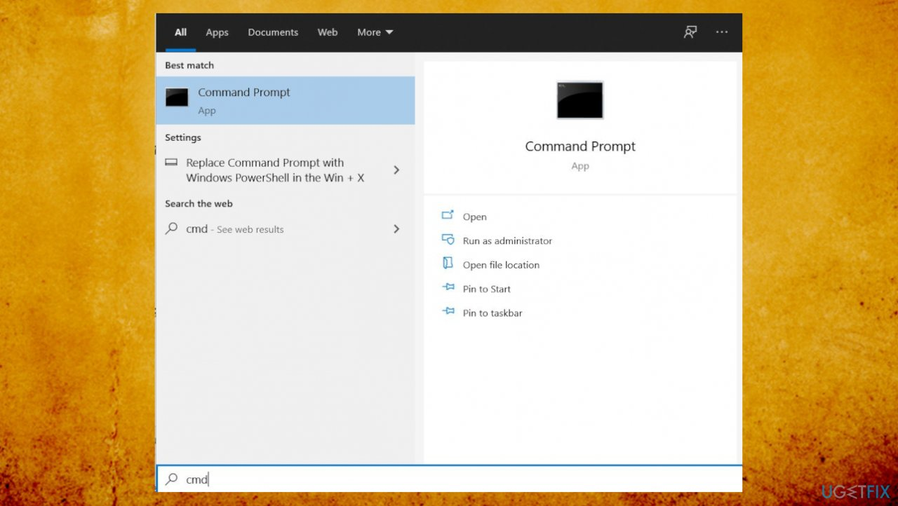
- Enter the following commands:
netsh int IP reset
ipconfig /flushdns
- Wait for the end of the process.
4. Reset the Network
- Press Winkey + I to open Settings./
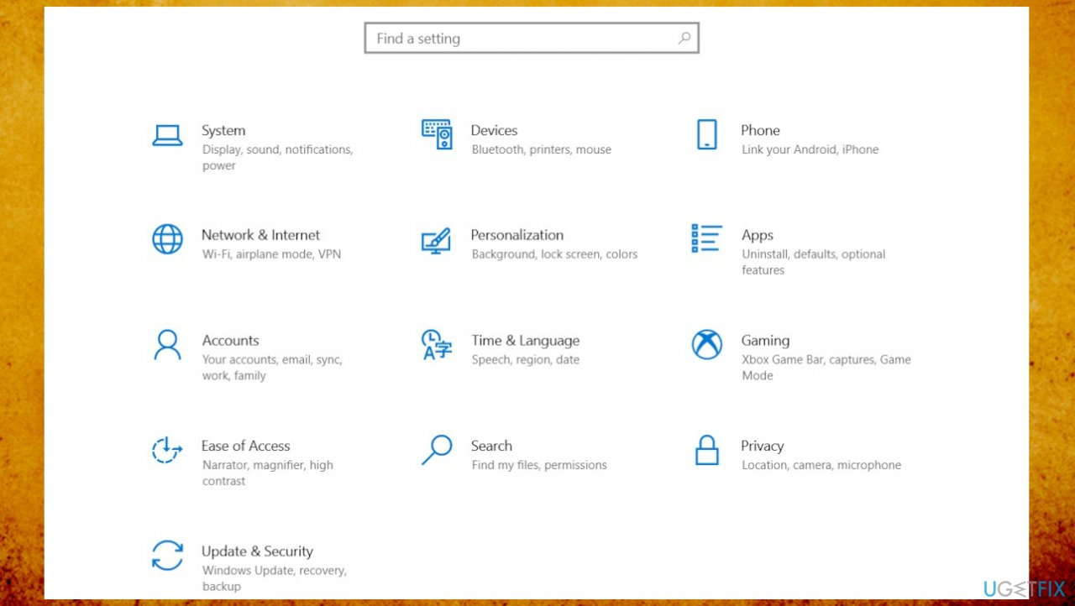
- Go to Network & Internet.
- Scroll down to locate Network reset option.
- Click it. A new tab will be opened, hit Reset now.
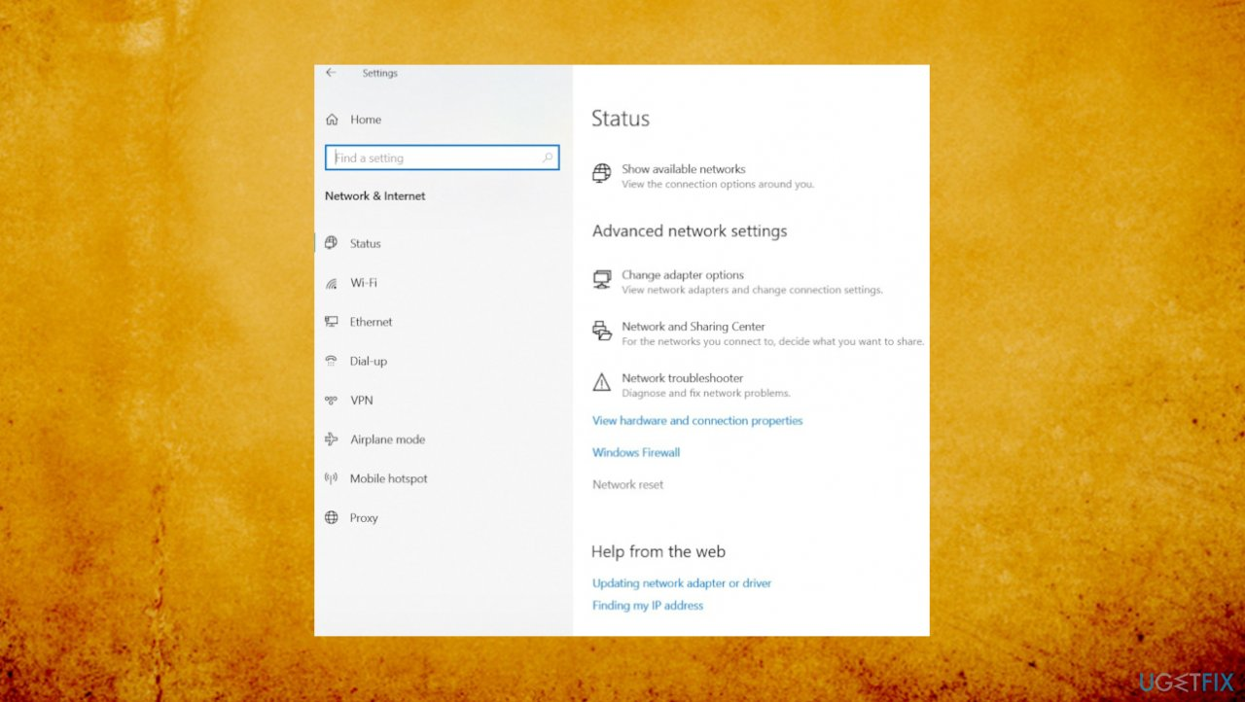
5. Uninstalling Network adapters
- Press Windows Key + X and then click Device Manager.
- Expand Network adapters.
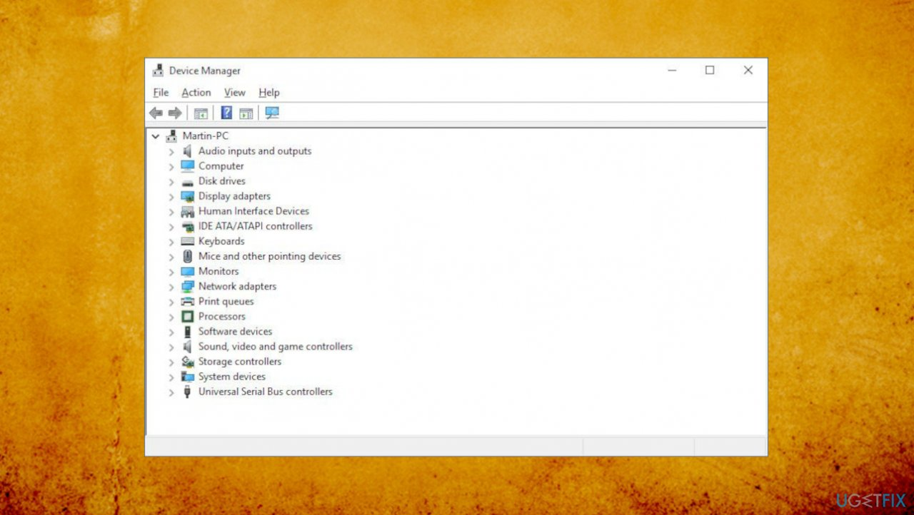
- Right on the Network Adapter and select Uninstall.
- Restart the computer.

