[Restricted]
Form No.: EC16 | Ref.: WI/RS/COM/014
Issue: 4/0 | Date: 09/09/2022

Technical Investigation Report
Technical Investigation Report of SIL S-Train A513 TS07 ODDS Obstacle Detected on 28 Nov 2025

Report No. : TIR/EWS/2025-XXX
Equipment : ODD sensor (RHS)s/n: TBA
Date report : 29 Nov 2025
Date received : N/A
Failure symptom : Derailment System
Location : SOH to LET
Delay : 7’/14’
Withdrawal/Changeover : Withdrawal
URN : XXX

1. Background
- At 06:38:11, IOS096 alarm (Mc1 track Obstacle/Derailment Detection activated) when the train was heading to LET in speed 47.6kph, with EB triggered. TS07 car Mc1 car (A513) right side ODDS sensor detected obstacle signal.
- Cab front CCTV footage was reviewed. No observable obstacle was found at trackside when ODDS alarm triggered.
- At 06:45:52, ODDBS was operated, EB released, and ODDS alarm cleared.
- The train then departed in FAO mode at 06:46:08 to LET.

2. Depot Initial Finding

- Cab front CCTV footage was reviewed. No observable obstacle was found at trackside when ODDS alarm triggered.
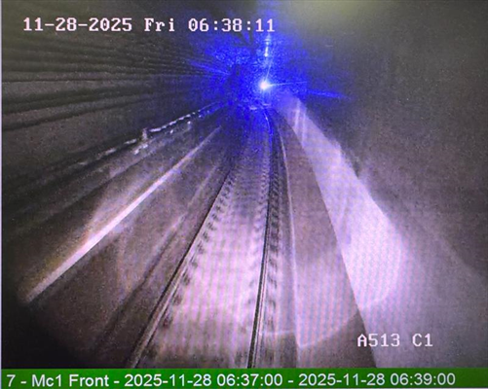

- Depot reported the ODDS bar was inspected without any hit mark.
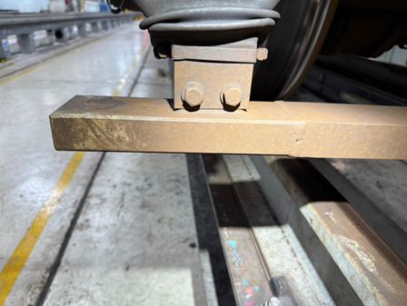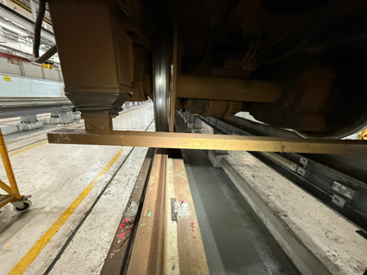

3. Circuit review / fault path analysis

- The circuit shows that when an obstacle is detected, a fault current between 14mA to 17mA value will be issued to the TCMS via junction box, and the sensor will also break the brake loop internally. The TCMS will detect both the fault current and brake loop status to decide which fault code to display.
- Therefore, if either or both the brake loop was broken or the fault current was displayed in TCMS, this means the ODDS sensor considered an obstacle was detected.
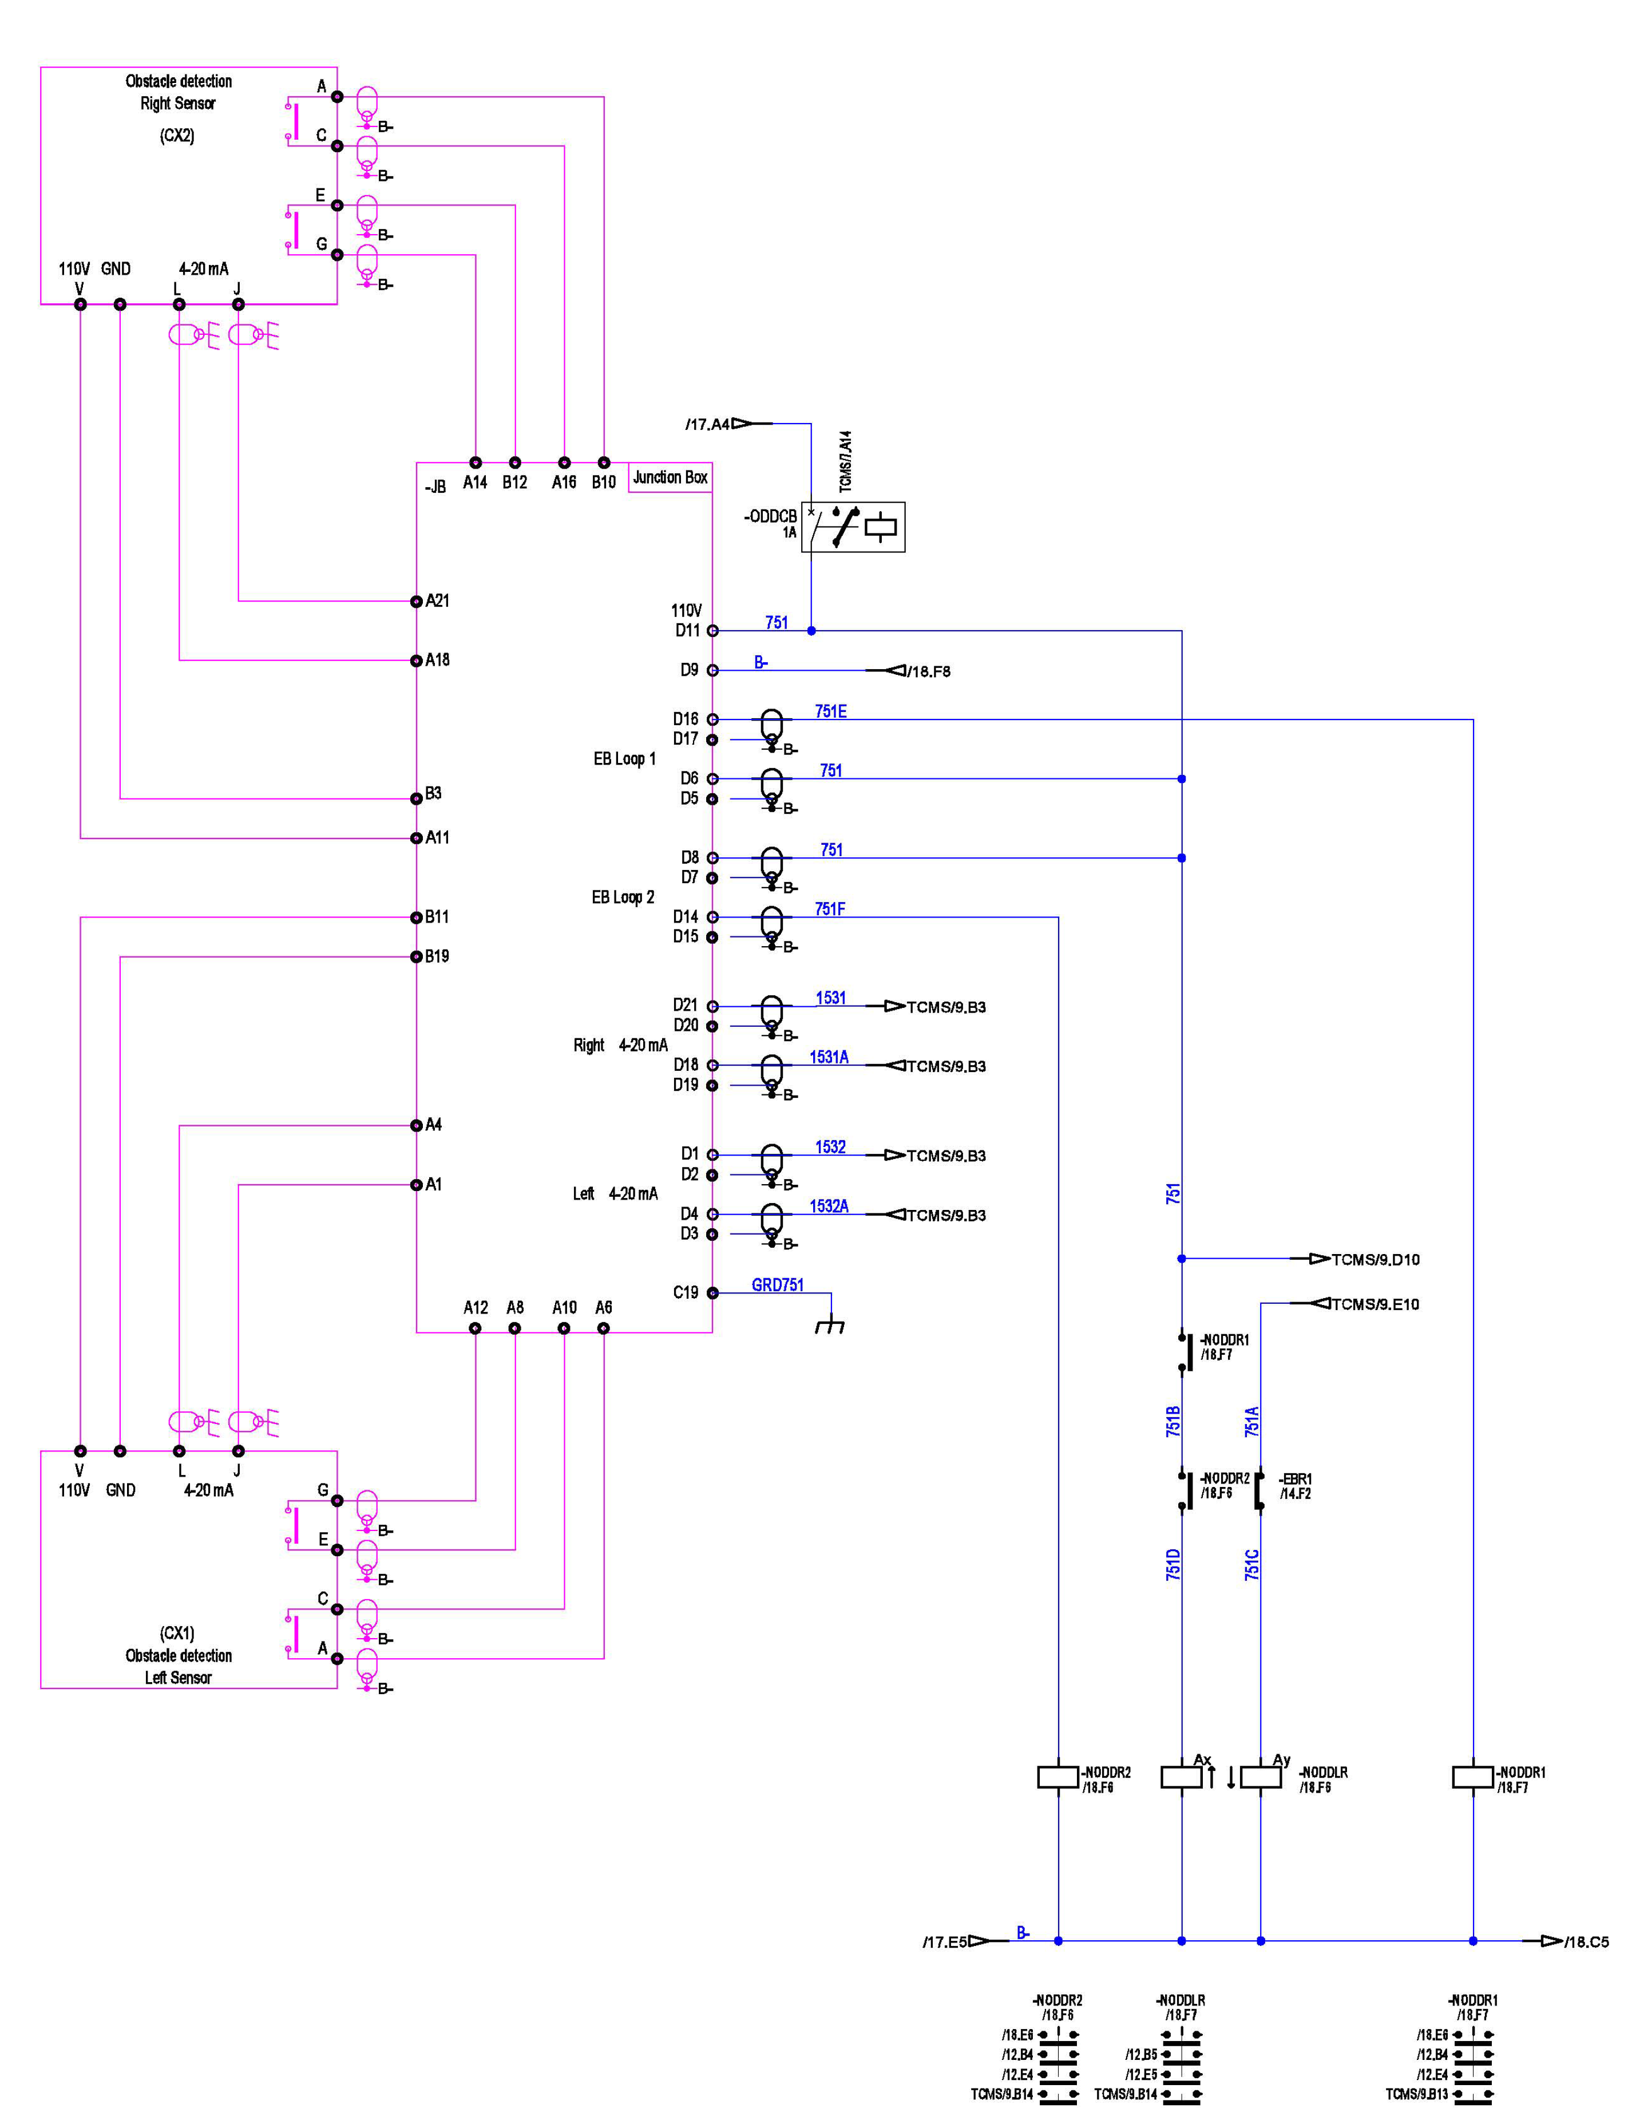

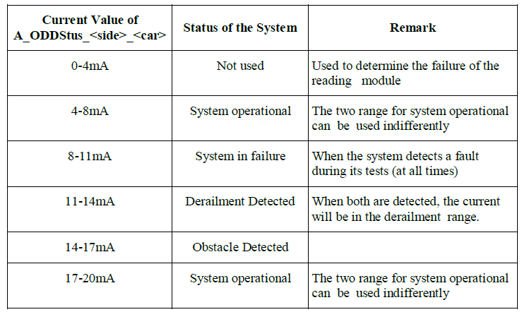

3. CEWS Joint Onsite Investigation (WCD, T&ES, CEWS, workshop and CRRC)_

PHM log review

- First obstacle detection alarm (false alarm). At 06:38:11, IOS096 alarm (Mc1 track Obstacle/Derailment Detection) was activated when the train was heading to LET in speed 47.6kph, with EB triggered. The RHS ODDS current level was dropped to obstacle detection level momentarily.

- Second obstacle detection alarm (false alarm). At 07:10:18, the incident train A513 arrived to depot at RM1 stable inside depot. Without train movement or other known equipment operation signals, the RHS ODD current value dropped to 15.556mA (obstacle detected range) again. However, no brake signal was triggered as the ODDS bypass was already activated. The train power was not cut or reset prior to when this ODDS signal was triggered.

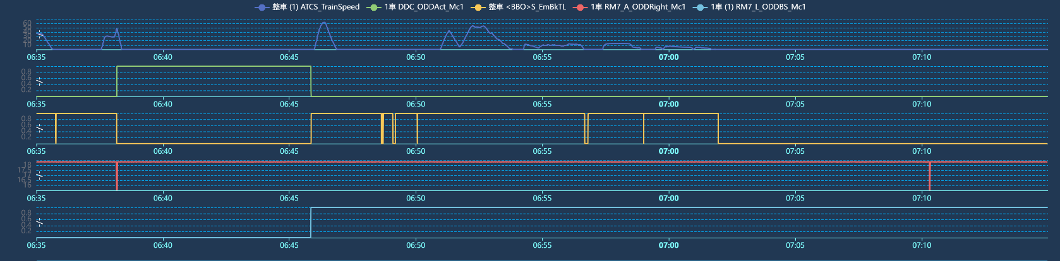

RHS ODDS sensor current dropped again when stabling in depot
Speed: 47.6 kph

ODDS activated
ODDS bypass
Mc1 car (A513) RHS ODDS sensor current (obstacle detection signal)

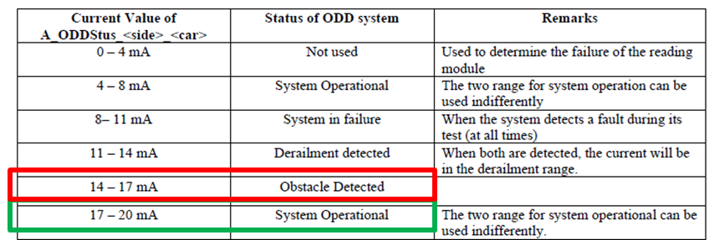

Onsite measurements
- Train power was then turned off for inspection/measurement of the train cables.
- Cables, support bracket fasteners were checked without misalignment.
- T&ES carried out noise measurement on associated shielding and other related cables and had nil findings.
- Geometry profile of ODDS bar was compared with spare bar and found no visible abnormality.
- Depot reported the incident ODDS had missing damping rubber element (as many other SIL trains had as well).
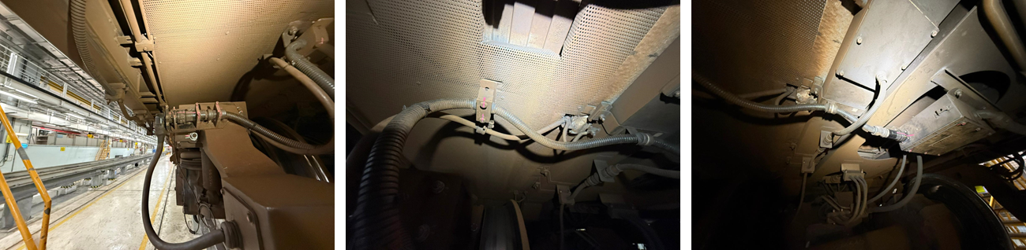

- Continuity test, noise measurement and shielding conduction was carried out for all related ODDS wires.

Within the Junction box (plug to junction box terminal)  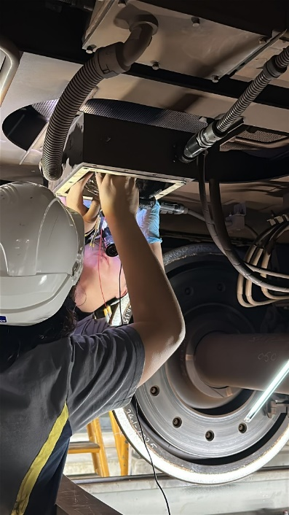 | Junction box terminal to RIOM7  

On-train Simulation Tests

As this was the third repeated case of ODDS false alarm which occurred on the same car/cab, and same RHS side but with different ODDS sensor, this was proof that the problem was related with train side and not only sensor side. Therefore, it was decided to carry out tests that simulate the injection of momentary noise into the sensor and validate whether the same false positive symptoms as that of the incident could be recreated.

- Fast ODDS power off and resume. The RHS ODDS 110Vdc power was cut off and resumed within 1s time using a pushbutton attached to the junction box. The result was that the IOS181 obstacle detection fault code was triggered, ebrake was permanently triggered and not self-resumed by ODDS, but the fault current of 0mA was issued by the ODDS sensor until reset completed (not the 15mA obstacle detection current level).

- Force injection of obstacle detection current to RIOM7 (analog to digital module) by using a variable resistor to simulate a 15A ODDS detection current, while actual sensor current was normal (5mA or 18mA). The result was no IOS096 alarm, and no EB was triggered.

- Fast NODDR relay (EB loop) cut-off and resume using a switch to momentary interrupt the NODDR relays. The result was IOS096 alarm and EB was triggered, but ODDS detection current remained in normal operating condition of 18mA (instead of obstacle fault detection current of 15mA). Note that slow cut-off (i.e. longer than 5s) and resume of the relay resulted in 9mA hardware fault current being issued instead of 18mA.

- Heavy force hammering test was carried out to simulate a momentary force on the right side of the detection bar. No fault code or fault current was generated after around all 10 hits. This was expected behavior.

- Fault triggering test was carried out by pushing the bar. Fault current, fault code, and EB trip occurred suggesting normal positive test behavior.

The conclusion of these tests was as follows:
- Unintended software behavior was detected. Simulation of noise by fast trigger of the power line or EB loop relay line of the ODDS caused false positive behavior obstacle fault alarm IOS096 + EB being issued by the ODDS sensor while no actual object applied force was present, further supporting that external noise injected into ODDS could trigger such an alarm.
- Fault current output by the sensor during tests was not the same as the incident. However, the relay fast off/on test displayed normal operation current of 18mA despite issuing obstacle detected fault code. This suggests:
  - The software had entered an undefined state whereby false positive fault code will be issued, train will be tripped by ODDS but fault current failed to be generated. This semi-failure type of symptom indicates a significant flaw in the software design when subjected to noise or debouncing effects.
  - The exact profile of noise simulation was not identical to that of the incident noise trigger hence the 15mA obstacle detected fault current could not be simulated onsite due to limitation of test capabilities.
- The fault was unlikely related with mechanical load trigger.
- The fault was unlikely related with hardware failure.

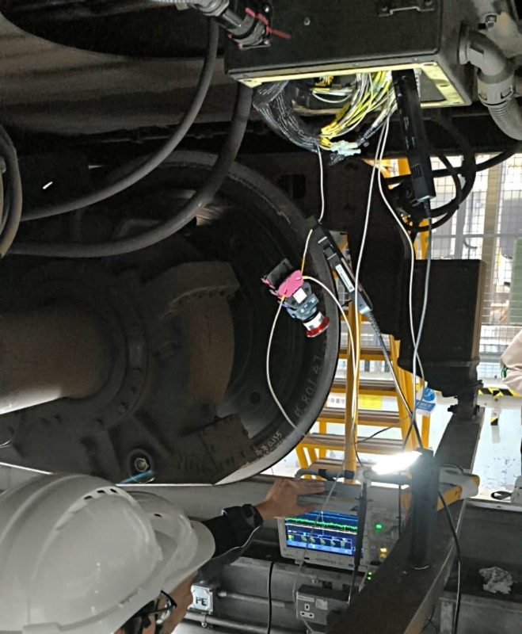 | 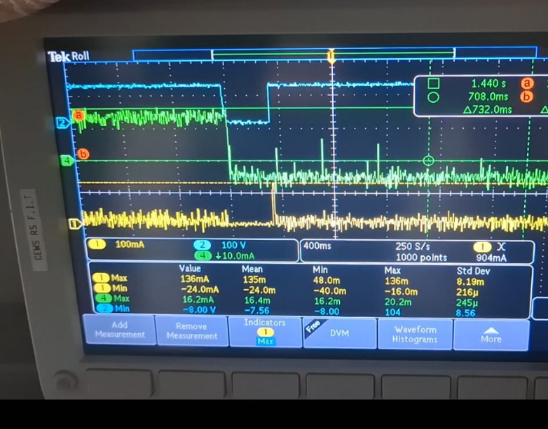  ODDSRHS  110V  ODDSRHS  Sensor current
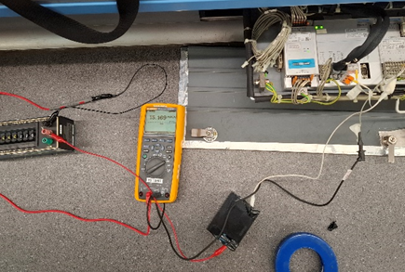 | 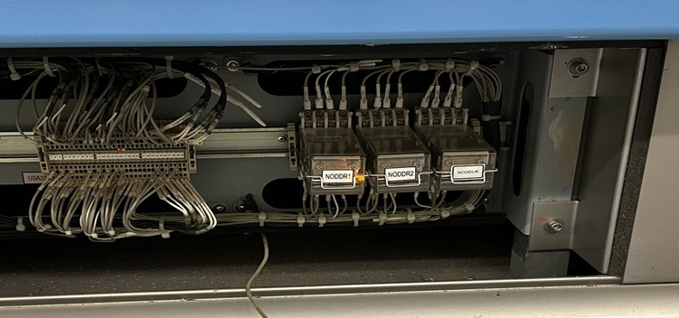

Scenario | ODD sensor current | Relay  ODDR1 & ODDR2 | Fault alarm | Remarks
Normal | ~5mA or ~18mA | Both ON | Nil
Incident | 15mA | Both open momentarily | IOS 096
ODDS 110V supply off (momentary) | 0mA | --- | IOS181 | ODD is resetting
Externally input 15mA to RIOM | --- | Both ON | Nil | No fault prompted
ODDR1 or ODDR2 or simultaneously open (momentary) | Keep as 5mA or 18mA | ON>Off>ON | IOS 096 | Sensor current not 15mA
ODDR1 or ODDR2 or both open (>5s) | 9mA hardware fault current | --- | IOS 096  IOS 181 | ODD self-test fail, not 15mA

CEWS Benchmark Simulation Tests

- Identical tests carried out on the train were replicated on separate ODDS sensor at workshop on 29 Nov 2025. The results showed identical replicable results as that of the on-train test simulations i.e. a fast relay cut-off and resume will cause IOS096 to be issued along with E-brake loop broken, however retaining a normal current output level (not fault current level).

5. A513 Maintenance History:

21 Apr 2025 | A513 ODDS activated, RHS detected, at OCP/UT (10'/12’ mins delay). RHS ODDS sensor was replaced.
17 Jun 2025 | Replacement of ODDS elbow connector pins and installation of ODDS support bracket (YCL21006).
7 Jul 2025 | Last B1 check, inspection of ODDS bracket + inspection & cleaning of ODDS sensor.
17 Oct 2025 | A513 ODDS activated, RHS detected, at OCP/D (10’/10’ mins delay), replaced RHS ODDS sensor, cable assembly and RIOM7 analog module.
25 Nov 2025 | ODD function test fleet check.
28 Nov 2025 | A513 ODDS activated, RHS detected, at LET Dn (7’/14’ mins delay).

6. Conclusion:

No electronic hardware failure was identified. Initial tests showed normal ODDS operation. The same fault happened 4 times (in different timeframes) on the same cab & side but different ODDS sensor. This proves the fault trigger was related to train-side and/or a combination of ODDS software design inadequacies rather than ODDS hardware permanent failure.

Most likely root cause was car-side EMC and poor noise handling by the ODDS software/hardware. Past history showed the IOS096 was spuriously triggered during various train starting movement, coasting, as well as train stationary scenarios. Simulation tests in depot & CEWS showed consistently & repeatably the sensor “thought there was a real obstacle detection” when one of its EBloop relays were broken and resumed quickly (within 5s), hence the sensor self-tripped the EBloop. No current output from the sensor was detected (i.e. remained in normal operation mode of 18mA output) which suggests the sensor entered an unintended state or semi-hang state. The cause of EMC was not identified but from maintenance history, EBloop relay intermittent failure was possible since they were not replaced during the period in which the 3 incidents occurred.

Junction box and cable noise coupling issues were not proven by measurement but could not be ruled out. While all adjacent cables were measured for impedance and connection quality (showing nil high ohm), noise coupling could be due to intermittent events during dynamic operation or high frequency signals not measurable by standard low frequency equipment.

Eliminated mechanical related triggering issues. Even without the rubber damper element installed, a relatively high force hammering test was carried out and did not manage to trigger any alarm. This was inline with the sensor specification whereby a much larger force was needed to trigger the alarm. Secondly, the second trigger alarm occurred during when the train was at a complete standstill indicating the fault was not triggered by force at all. CCTV video coverage also supported the finding that no obstacle was detected in all incident cases.

7. Follow-up actions

- Static test. Depot & CEWS installed a datalogger for further monitoring (carried out on 28^29 Nov 2025) when the train was static and energized at depot maintenance pit overnight. Update on 29/11: No abnormal triggering of ODDS device overnight.

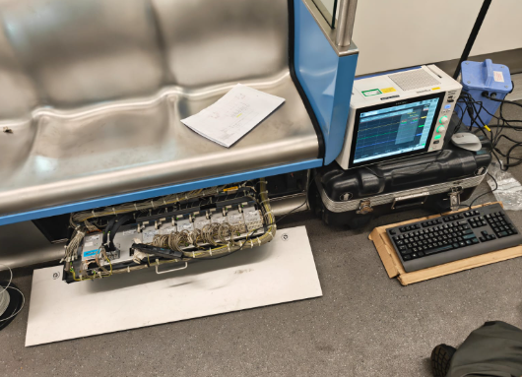

- Dynamic test. On 29 Nov 2025 & 30 Nov 2025, depot test with data logger installed will be carried out by depot staff. Update: no triggering of ODDS was observed during the depot test run.

- Replacement works. On 1 Dec 2025 or afterwards, if still no abnormality logged, depot will replace the ODDS bar, ODDS junction box, NODDR relays + socket – eliminating the possible root causes as reviewed above.

- OEM report. CEWS will chase for OEM ODDS root cause report from previously incident although ODDS sensor hardware failure was unlikely.

- Longterm design out. In future, project team /design team is recommended to work with CRRC to develop an improved sensor / software with noise immunity considerations.

Prepared by: | Hin Lam (CEWS-TO) |  | Date: 29/11/2025
Checked by: | Michael Fung (CEWS-Sr.EWE) |  | Date: 29/11/2025
 | John Leung (CEWS-Sr. ESM) |  | Date: 29/11/2025
Approved by: | Ken Li (CCEWM) |  | Date: 30/11/2025

Revision History

Revision | Date | Remark | Approved for distribution
R1 | 29/11/2025
R2 | 30/11/2025 | Corrected typos

Distribution Group 1 (please delete): COEM (KH Lee), GM-EM Gateway Segment (Aiken Tam), GM-EM O&MS (Frankie Ng), GM-RSM (Ivan Cheung)
Distribution Group 2 (please delete): LTSEM (Alison Suen), CDM-LR&Bus (Andrew Tam)

Appendix 1- not used

Appendix 2 - Wiring Diagram AFTER modification (which is identical for both MC1 and MC3)
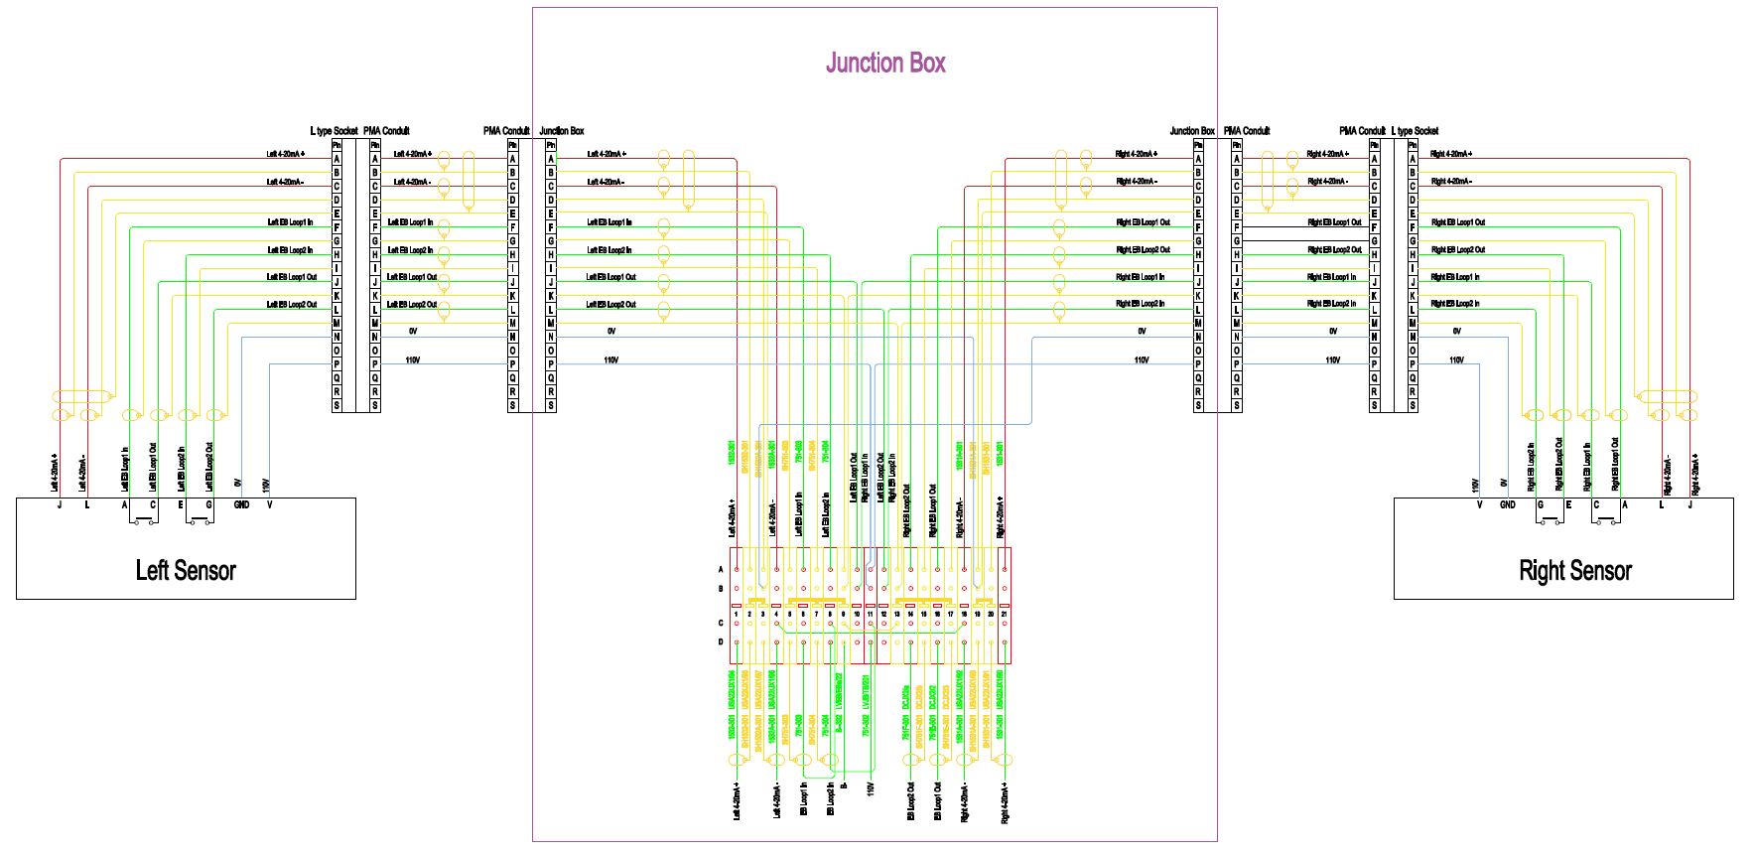

Appendix 3 Block Diagram
