

Docker for windows
Docker is used for installing linux software into windows.

Install Docker Desktop on Windows (separate tutorial).

Setup docker to start on windows login:
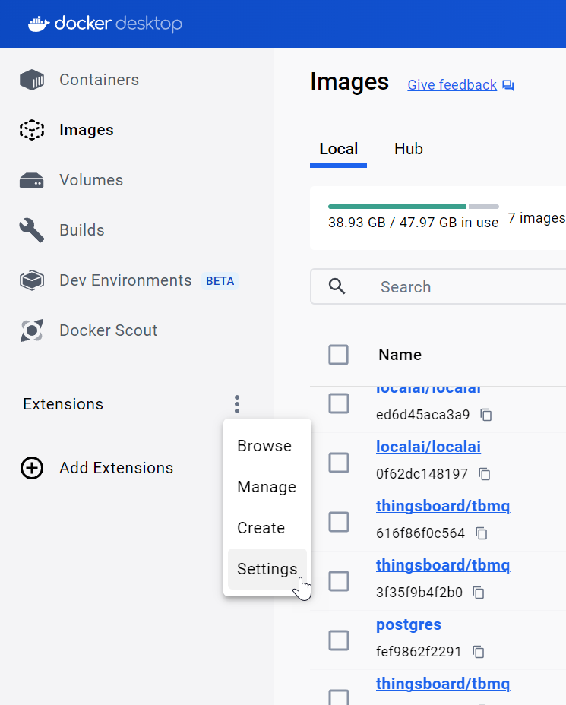
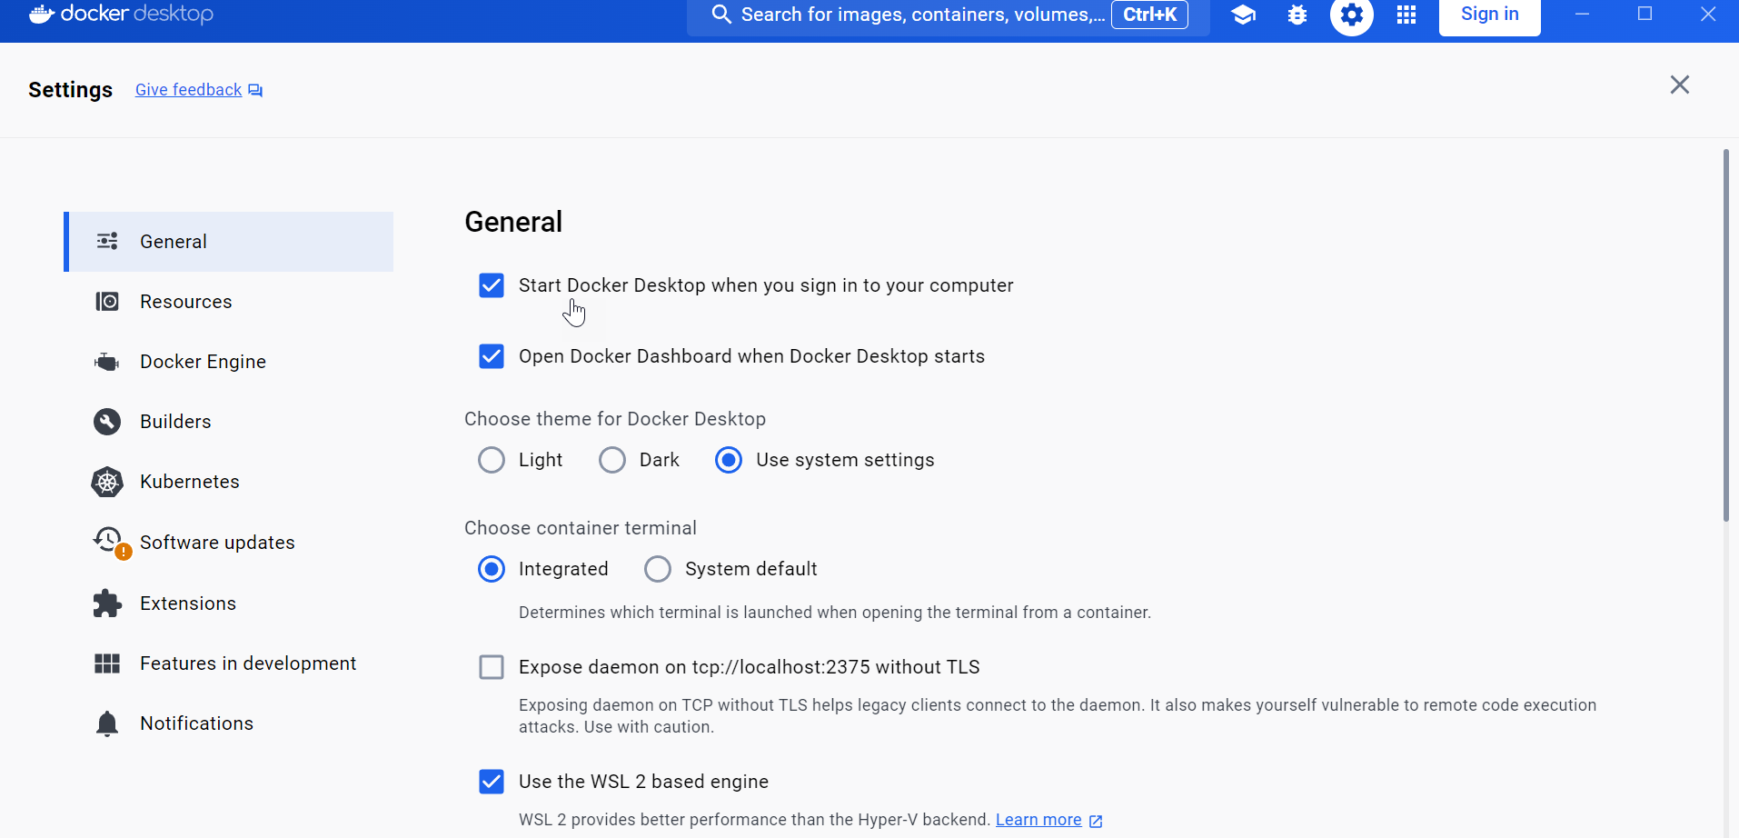

Problem: Docker windows could not run unless somebody has signed in and run the docker for windows.
Solution:
Creating another local admin user
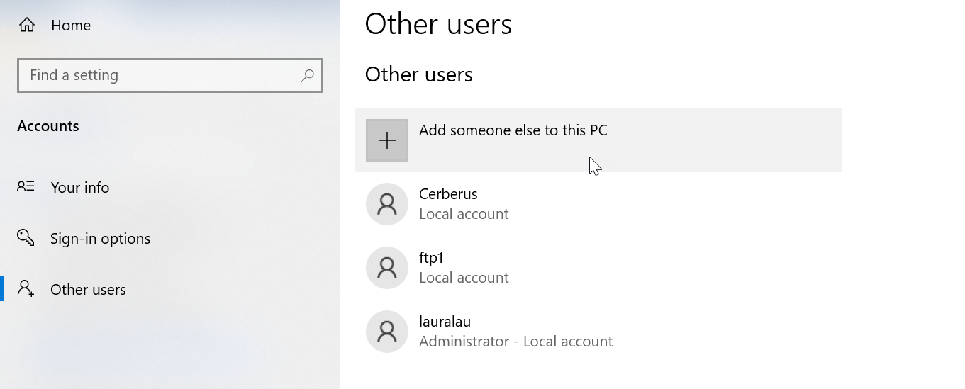
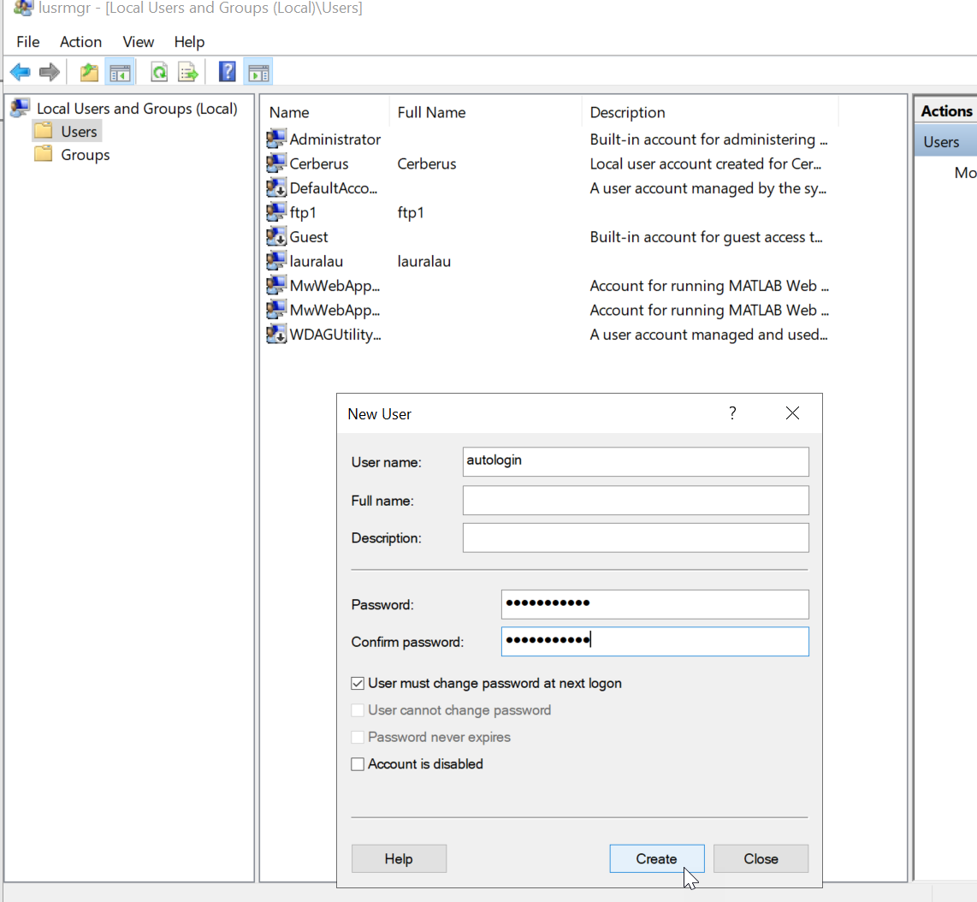
autologin
@Jleu121212

https://github.com/docker/roadmap/issues/515
https://learn.microsoft.com/en-us/windows-server/identity/ad-ds/manage/component-updates/winlogon-automatic-restart-sign-on--arso-

Go to group policy -> path: Computer Configuration > Administrative Templates >Windows Components->Windows Logon Options
Enable these 2 settings:
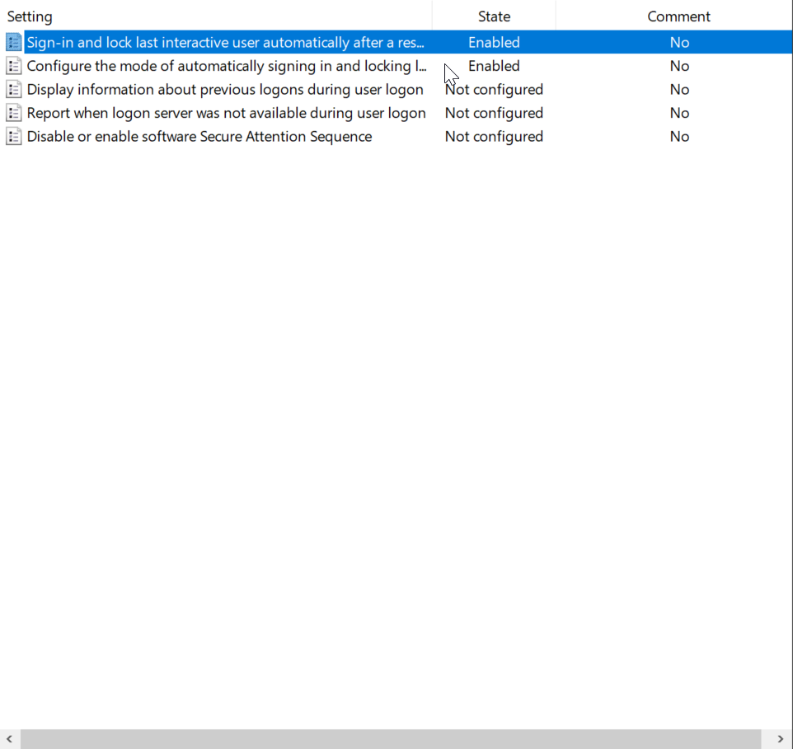
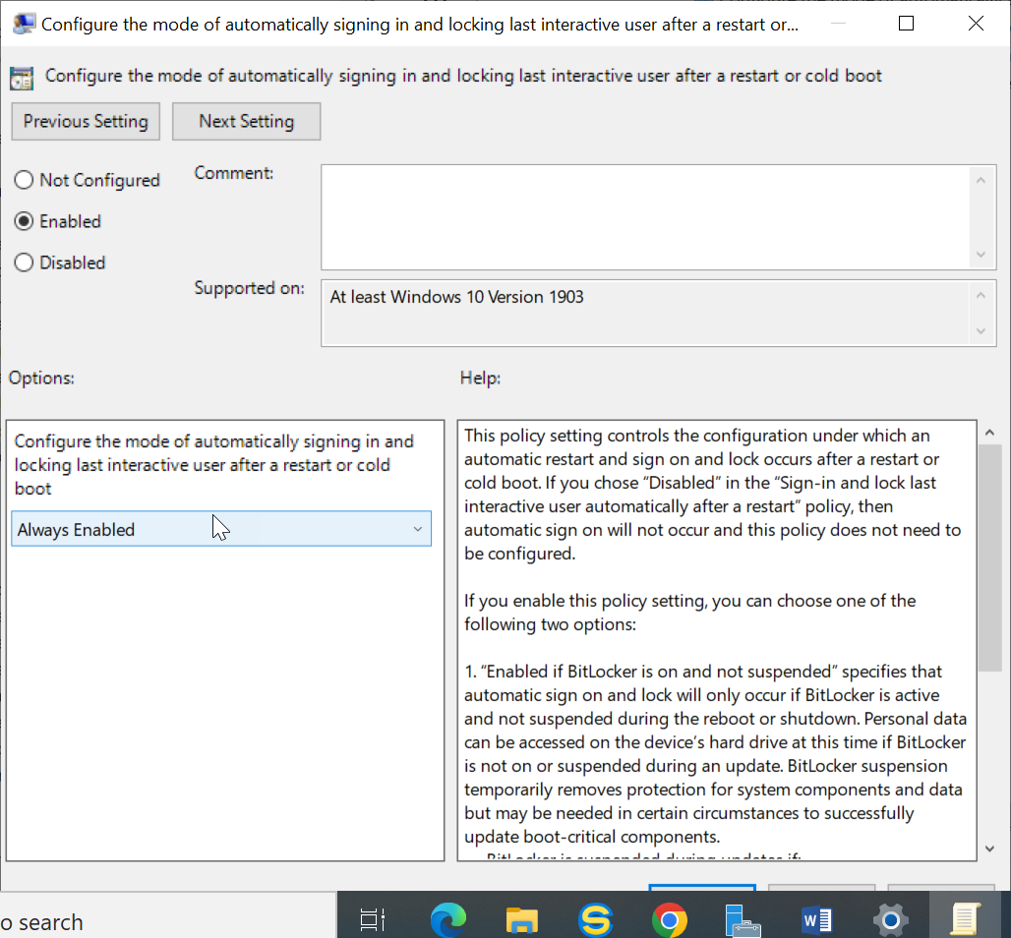

Warning
It doesn't work if last login was made via RDP.
After physically logging into server, it started working.

Testing
Now restart your PC to try out the automatic login. Windows will automatically log in the last user.
Event Viewer Logs:
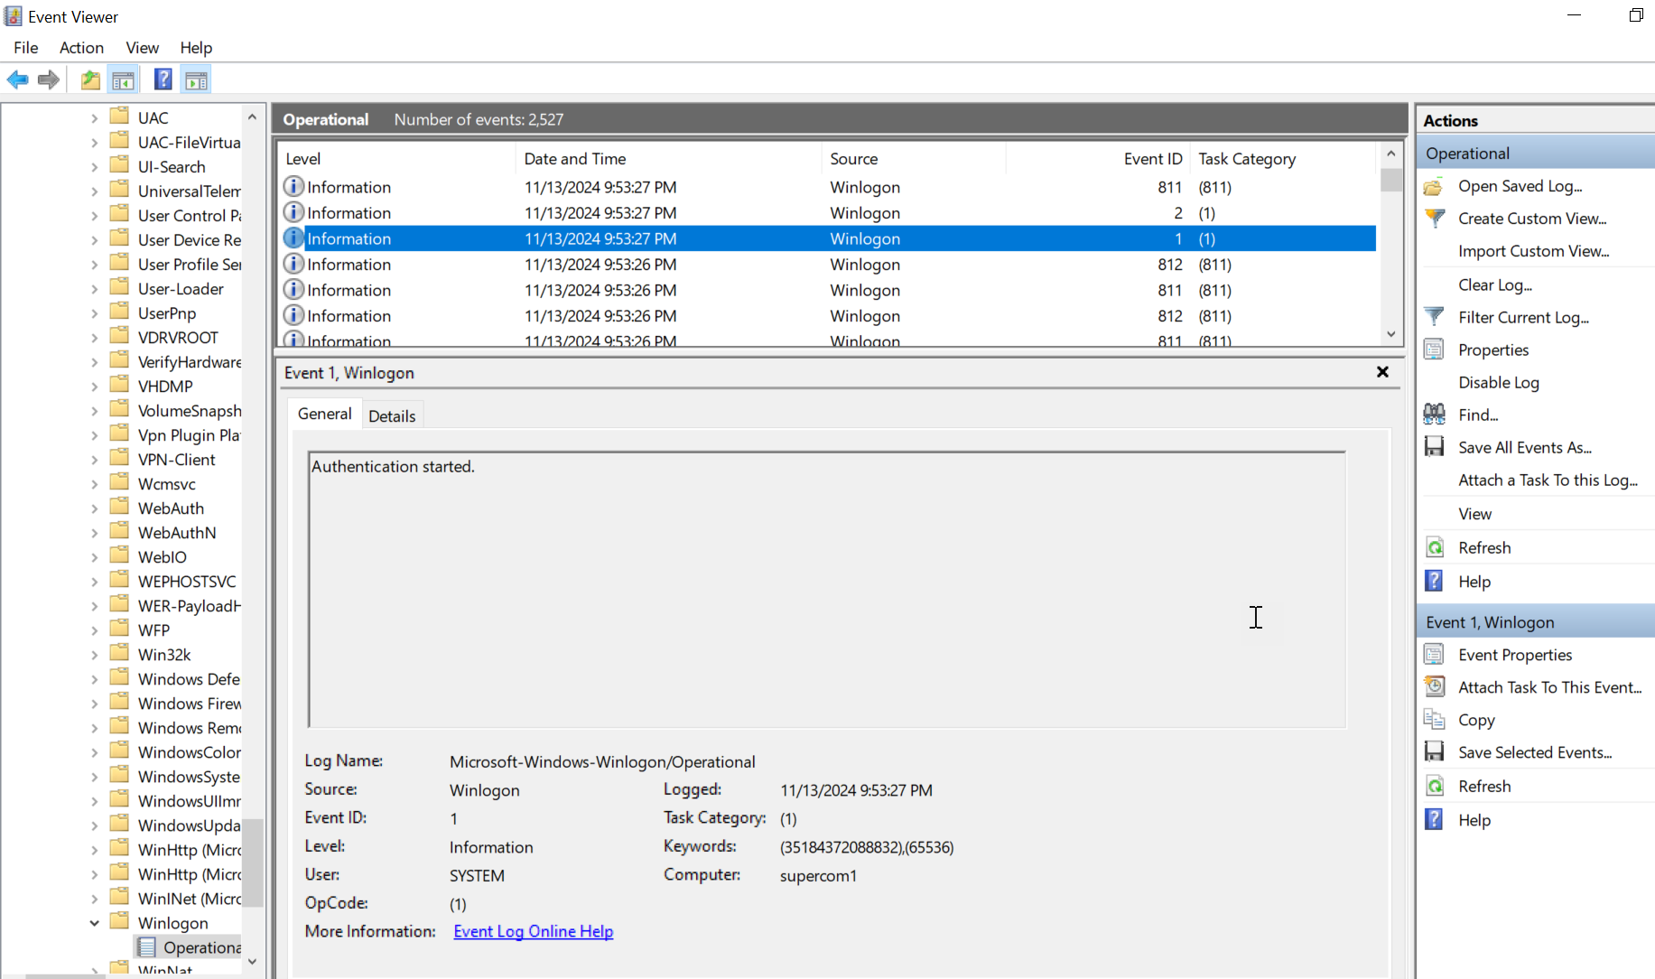
Check Applications and Services Logs > Microsoft > Windows > Winlogon > Operational in Event Viewer for the following Winlogon events:
Expand table
Event ID | Event description | Event source
1 | Authentication started. | Winlogon
2 | Authentication stopped. Result 0 | Winlogon
The status of an ARSO configuration attempt is stored in the LSA event log. Check Applications and Services Logs > Microsoft > Windows > LSA > Operational in Event Viewer for the following LSA events:
Expand table
Event ID | Event description | Event source
320 | Automatic restart sign on successfully configured the autologon credentials for: Account name: <accountName> Account Domain: <accountDomain> | LSA
321 | Automatic restart sign on successfully deleted autologon credentials from LSA memory | LSA
322 | Automatic restart sign on failed to configure the autologon credentials with error: <errorText> | LSA

